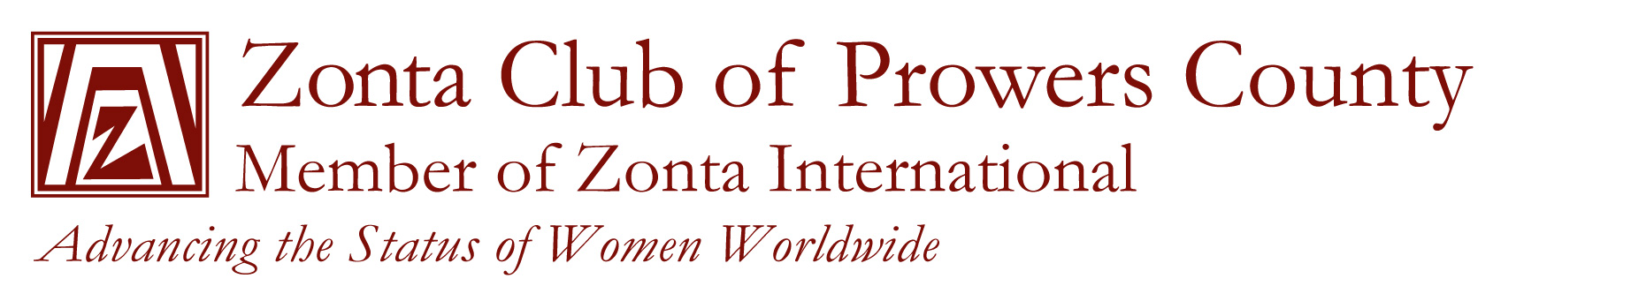

Open Award

The Zonta Club of Prowers County has established the following requirements for successful applicants:

- Applicant must be a female student from Prowers, Kiowa, Baca, or Bent County, Colorado.
- Applicant must be a full-time student working toward a degree which will advance the status of women.
- Applicant must show commitment to women’s development and has maintained a Grade Point Average (GPA) of 3.0 or better.
- Applicant must be willing to attend one Zonta Club meeting and briefly speak about her goals.

The open award is payable to the college/university of the applicants choice.

The deadline for applying for the award is April 1st, 2026.

The following items must be submitted:
- Attached application
- Two letters of recommendation
- Your personal letter stating qualifications and career goals
- A list of all activities during high school or college, awards, honors, volunteer work, and offices held.

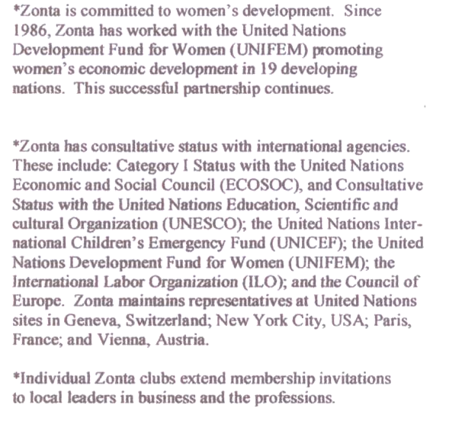
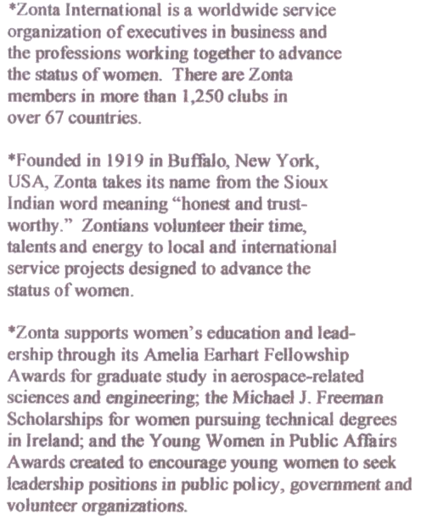

ZONTA CLUB OF PROWERS COUNTY

OPEN AWARD APPLICATION

Last Name First Name Middle Name

Address City State Zip

Email address

Telephone Cumulative GPA ACT Score SAT Score

High School/College last attended Graduation Date

Intended Major or Area of Academic Interest

Any additional information you would like us to know in considering your application for a Zonta Award:

