

L.C.C. AWARD

The Zonta Club of Prowers County has established the following requirements for successful applicants:

- Applicant must be a female student from one of these Colorado Counties:
Prowers, Kiowa, Baca, or Bent.
- Applicant must be a full-time student working toward a degree which will advance the status of women.
- Applicant must be committed to women’s development and have a Grade Point Average (GPA) of 3.0 or better.
- Applicant must be willing to attend one Zonta Club meeting and briefly speak about her goals.
- Applicant must be planning to attend Lamar Community College.

The recipient may only use this Award at Lamar Community College.

The deadline for applying for this award is April 1st, 2026.

The following items must be submitted:

- Attached application
- Two letters of recommendation
- Your personal letter stating qualifications and career goals
- A list of all activities during high school or college, awards, honors, volunteer work, and offices held
- A copy of your current transcript

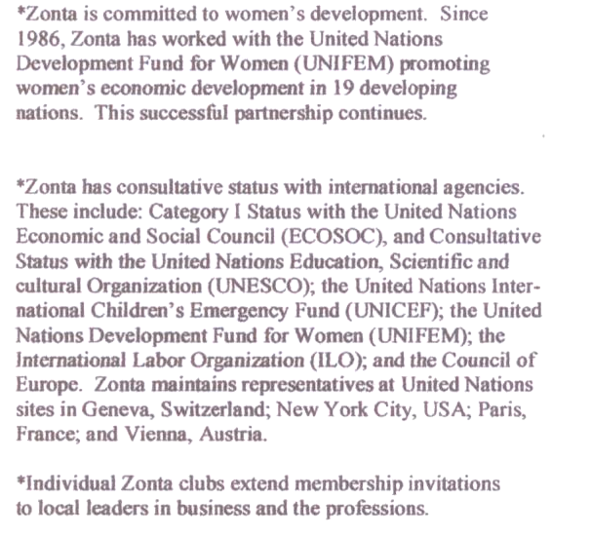
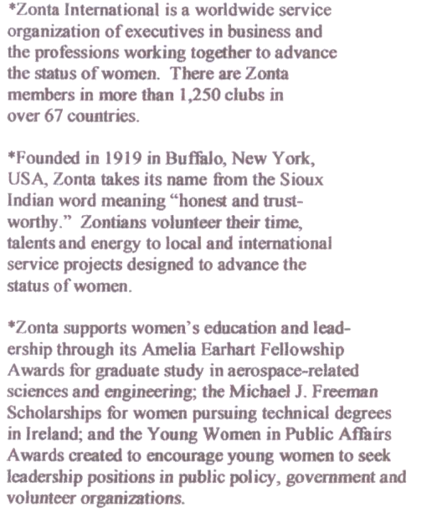

ZONTA CLUB OF PROWERS COUNTY

L.C.C. APPLICATION

Last Name First Name Middle Name

Address City State Zip

Email address

Telephone Cumulative GPA ACT Score SAT Score

High School/College last attended Graduation Date

Intended Major or Area of Academic Interest

Any additional information you would like us to know in considering your application for a Zonta Award:

