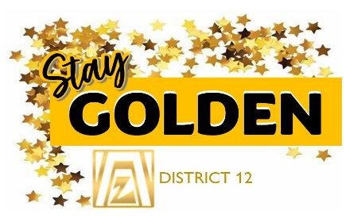

2025 Calendar of Dates
District 12 Press Releases to Clubs:
Oct: International Year of the Child and Domestic Violence
Nov: 16 days of Activism
Nov 25- Dec 10 -16-Days of Activism – All clubs in District and Worldwide Awareness
Dec 15 – Club STEM Award applications due to District 12, Kelly Christy chair
2026 Calendar of Dates
District 12 Press Releases to Clubs:
Jan: Amelia Earhart and ZONTA Fellowships
Mar: Zonta Rose Day/ Intl Women Day – CELEBRATION OF WOMEN
Apr: Climate Justice
Importance of Volunteering (Membership)
May: United Nations
****Then new schedule to come
Mar 8th – Zonta Rose Day and International Women's Day –All clubs celebrate
April 1 Zonta Young Women in Leadership Award – Michelle Medal
Area Meeting THEME for 2026 is STAY GOLDEN
Area 1 – April 25-26 Wyoming Big Horns in Sheridan, WYO
Area 2- April 10-11 Greeley, CO
Area 3 – Jan 17th DENVER II (3x Amelia Earhart Fellows presentation)
Area 4 – April 17-18 Pikes Peak
June 1 – Membership dues due to District and Zonta International
July 11-14, 2026 - Zonta International Convention – Vancouver, BC Canada
Fall 2026 - District 12 Governors Seminar –in Royal Gorge/Canyon City, CO
Sept. 1 Zonta Women in Leadership Award due to district
Nov 25- Dec 10 - 16-Days of Activism –All clubs in District and Worldwide Awareness
Dec 15 – Club STEM Award applications due to District 12
2027 Calendar of Dates
June 25-27, 2027 - North American Inter-District Meeting – Rapid City SD
2028 Calendar of Dates
July 2028 - Zonta International Convention – Copenhagen, Denmark

