**Call to Conference**

September 19-21, 2025

**Zonta District 12 Conference**

**COME JOIN US!!**

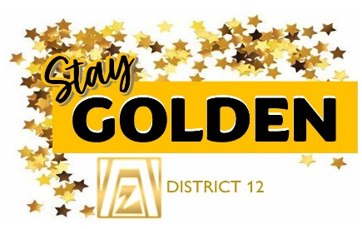

**Denver Marriott West**

1717 Denver West Boulevard

**Golden, CO**



** ** 

Greetings District 12 Zontians,

The District 12 Leadership Team is excited to invite you to the 67th Zonta International District 12 Conference. The Conference will be held September 19-21, 2025, in Golden CO at the Denver Marriott West, 1717 Denver West Boulevard. All Zontians are encouraged to attend this inspiring gathering of Zontians from across District 12. It will be an eventful, fun filled weekend. Under the motto **"Stay Golden"** this conference offers a unique opportunity to connect, learn, and celebrate our shared commitment to Build a Better World for Women and Girls. We will be celebrating the fabulous clubs and members of our district that have worked alongside District 12 and Zonta International as we Speak up in a BOLD way to be the voice for women in our communities, states and around the world.

Experience a dynamic program featuring workshops, an open forum with our next ZONTA INTERNATIONAL President, Fernanda Gallo-Freschi, inspiring keynote speakers and networking events with fellow Zontians and awardees. The members of the ZONTA Club of Denver are your hostesses and they are all aglow with enthusiasm as they create a conference that you won't want to miss. Hotel and registration details are coming soon.

Please refer to the conference and business links for all the necessary information and to secure your place at this unforgettable event. We encourage you to bring a friend and experience this event together. We look forward to welcoming you to Golden and to a conference filled with friendship, inspiration, golden opportunities and lasting impact.

In the Spirit of ZONTA,

Debbie Sundberg

Governor District 12



**Conference Agenda** *Attire is business casual except where noted.*

**Friday, September 19, 2025**

1:00 – 4:00 PM Set Up time for Zonta Store and "Shining Like GOLD" Club Displays

2:00 -5:00 PM Early Registration and UN Sustainable Development Goal Puzzle FUN

2:30 – 5:00 PM ZONTA Fun at the Rolling Hills Golf Course (Meet in hotel lobby to carpool & rides)

Optional outings to enjoy in GOLDEN if you wish (Reserve on your own)

4:30- 5:30 PM **Zonta Store Open**

4:30- 5:15 PM First Timer Orientation with the Board and Leadership Team

6:00 PM "It's a GOLD Rush" Welcome Party (Costume and Conference Bag Contests)

**Saturday, September 20, 2025**

6:30- 7:45 AM Breakfast on your own at the Hotel restaurant

7:30-8:45 AM Registration & Credentials Check-In - UN Sustainable Development Goal Puzzle FUN

7:30- 8:30 AM **Zonta Store Open**

8:00- 8:30 AM Instructional Meeting for Delegates/Alternates/Voting Board Members

9:00 AM Business Session I

10:30 AM Break **Zonta Store Open**

10:55 AM Business Session I - Voting – Budget/Treasurer's Reports

10:55 AM Non- Delegate Workshops 1) Human Trafficking/ Domestic Violence or 2) Climate Justice

11:35 AM **KEYNOTE SPEAKER:** **Harnessing Artificial Intelligence to Protect Women and Girls: the LAAHA**

**Approach (Our Zonta International Service Project)- *Renée Coppock***

12:05 PM Lunch Awards and Presentations- Installation of Officers for USA-7 E-Club

1:30 AM Break **Zonta Store Open**

1:45 PM Business Session I: Nominating Committee Report & Candidate Introductions and Speeches

1:45 PM Non- Delegate Workshops 1) Human Trafficking/Domestic Violence or 2) Climate Justice

2:30 PM Elections VOTING, **Zonta Store Open (last chance)**

3:00 PM **KEYNOTE SPEAKER: "Strong Men Speaking Up against Violence toward Women"** ***Bob Vines***

3:45 PM Election Results

4:05 PM Workshops For ALL: 1) Leadership 2) Advocacy 3) Membership *(Repeat on Sunday)*

5:05 PM Zonta Store Closed and baskets moved to Main Meeting Room

6:15 PM SPIRIT of ZONTA Reception and Cocktails (Cocktail Attire)

7:15 PM SPIRIT of ZONTA Gala Dinner –**"Sharing your SHINE"**

9:15 PM **GOLDEN GLOW Fellowship** ***with Governor, Debbie Sundberg and Zonta Int'l Pres. Elect- Fernanda***

10:15 PM Zonta After Hours

**Sunday, September 21, 2025**

7:30 – 8:45 AM Registration and Credentials Check in

7:45- 8:45 AM **Memorial Service**

9:00 AM Workshops for ALL: 1) Leadership 2) Advocacy 3) Membership

10:15 AM Business Session II and **Brunch** and Basket Drawings

10:40 AM **"Zonta's Shining Future" featuring ZI Pres. Elect Fernanda Gallo-Freschi in an OPEN FORUM**

11:35 AM GOLDEN MOMENTS * Invitation to 2026 ZI Convention in Vancouver BC Canada and

2026 Governor’s Seminar by Zonta Club of Royal Gorge and Area 4

Closing Comments

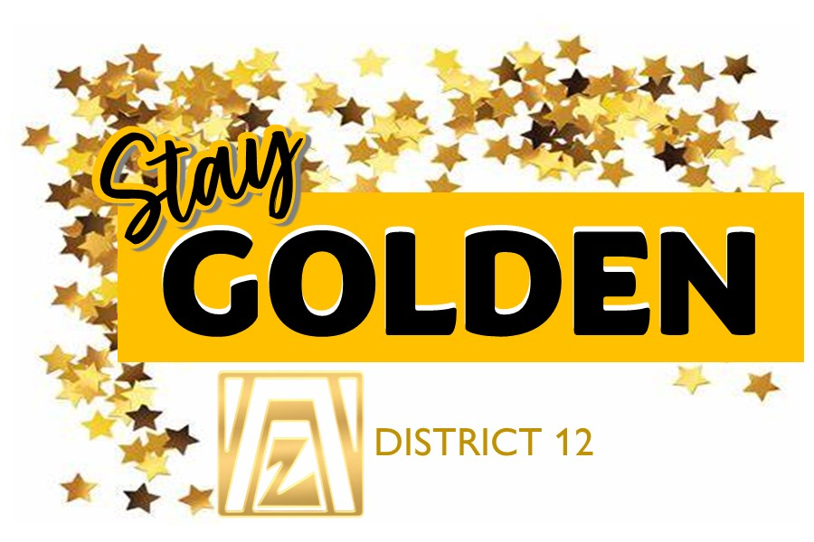12:30 PM Adjournment

12:45 PM District 12 Board/Leadership Team Meeting

**Zonta Store**

All clubs are invited to participate and sell! Sell! Sell! The Zonta Store is a great place to make a little money for your club. **Set up is open Friday starting at 1:00.** *Mary Benoit,* at [mary@mathias1901.com](mailto:mary@mathias1901.com) will be contacting club presidents in a few weeks to let you know how much table space each club will be allotted. We have increased the amount of time available compared to the Governor Seminar, giving you plenty of opportunity

to sell. Start thinking now about what your club will bring.

**CLUB Displays "Shining Like GOLD"**

All clubs are invited to prepare a 36"x48" tri fold board that shares the fun and activities that you have engaged in in during the past few years. Share your service, advocacy, membership and fundraising successes with the district members. **Set up is open Friday starting at 1:00.** *Penny Burke* at [penny_burke@hotmail.com](mailto:penny_burke@hotmail.com) will be contacting club presidents in a few weeks to answer any questions that you may have. Start working on your design early so it can really SHINE on display.

**Memorial Service**

We will hold a memorial service on Sunday morning to honor and remember club members who have passed away in the period since the 2023 District 12 Conference**. Please send a photo of your former member along with an obituary** to *Deb Beatty* at [debbeatty423@comcast.com](mailto:debbeatty423@comcast.com) **by AUGUST 15th.** Deb will be leading the service on Sunday and will have a prepared memorial program for all.

**2025 Club Zontian of the Year**

If your club honors one of your members with a ZONTIAN of the YEAR award, we would like to celebrate the member as well. Please send your winner's name and a brief outline of WHY the winner shines in your club, to *Deb Beatty* at [debbeatty423@comcast.com](mailto:debbeatty423@comcast.com) **by AUGUST 15th.**

**"It's a GOLD RUSH" Special Bag and Costume Contest**

**Friday night** is all about the GOLD RUSH of GOLDEN and ZONTA DISTRICT 12.

We are talking fringe, boots, women of the west costume, bold lipstick, shining GOLD and unforgettable conversations under the fall Colorado sky with some of the boldest women in our district--plus, exclusive experiences to begin our conference. Join the FUN with two special events:

1. **Bring your own conference bag**. We all have plenty of conference and other tote bags; therefore we are NOT supplying you with another one. Instead, we are asking you to bring to the conference one of your own favorite tote bags. You will use it to carry the conference information given to you at the "Stay Golden" District 12 Conference registration desk. **Bring your special bag**-- one you have designed or one that you have always found to be your favorite. On FRIDAY night we will have a Special BAG contest with several different categories. We will vote and prizes will be awarded for,

1) most creative BAG, 2) best ZONTA theme BAG, 3) funniest BAG, 4) can you believe this BAG, and 5) this is an "OLD BAG" and so much more.

1. Come **dressed in your Western attire or just pure GOLD.** It's a GOLD RUSH for District 12 where many famous women of the WEST have made their mark. (MT * WY *CO* SD) Dress as your favorite western legend, or let your imagination run wild and come as a future WOMAN of the WEST – someone who embodies the GOLDEN opportunities that lie ahead for women in our world. Make it your look with your own shine. We will Vote for best costumes in several categories: 1) Most original, 2) this is the look of the West, 3) Shines like GOLD and 4) the future shines great. There will be prizes in each category.

**District 12 Scholarship Fund Basket**

This year we're asking **each club to bring an item that is locally made in their community to include in the raffle basket.** The district will provide the basket and raffle tickets. Please leave your basket item at the registration table when you check in. Many thanks in advance for choosing items that embody on your community spirit.

**District 12 Education Fund Basket**

In memory of past Governor, Bev Augustine and her historic saying "I like the Boys". You will have a chance to increase our District 12 Education Funds by buying tickets for a "I Like the Boys" bottle bouquet with all kinds of liquor from "the boys", donated by the District 12 Leadership Team. Chances will be sold at breaks during the meeting and a winner will be drawn on Sunday morning. That person wins the entire liquor basket and the earnings from the ticket sales will be placed in the District Education Fund for future conferences and educational events. THANK YOU in advance for your support.

**Zonta Foundation for Women Fundraiser**

Don’t miss an opportunity to meet Mollie Kathleen Gortner the first woman in the Cripple Creek Gold Camp to discover gold and strike a claim in her own name.  Take a chance at finding your own golden nugget and strike it rich! All proceeds will go to the Zonta Foundation for Women.

**District 12 SILENT AUCTION for Conference Funding**

Watch for a very robust SILENT Auction with some amazing items for you to bid on in the ZONTA Store. Items have been provided by the District Leadership Team. All proceeds will go to the District 12 Conference Fund. Please stop by and bid often.

**District 12 SERVICE Project (Please bring donations)**

Beginning as a Christmas Outreach program from the Southeast Christian Church in Parker, CO, offering food and gifts to those who might not otherwise have a Christmas, [**SECOR Cares**](https://www.secorcares.com/about) has grown into a year-round outreach program providing food and hygiene products to families in need. The organization has indicated a dire need to provide menstrual products to their community. Period poverty continues to impact individuals and families across the United States, especially in rural and under-resourced regions like Colorado, Wyoming, Montana, and South Dakota. The inability to access affordable and adequate menstrual products leads to missed school and work, health risks, and ongoing stigma. We are conducting a drive for these products at the District 12 Conference. [**Secor Cares**](https://www.secorcares.com/about) **prefers small quantity boxes, no combo packages, and all donations must be in unopened packages. Items Requested for you to BRING to the conference. (Please do not buy in bulk**.) 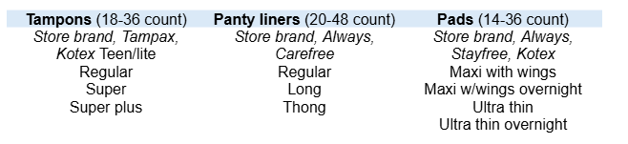

*The organization will also accept gift cards where items may be purchased (e.g. Walmart, Target, King Soopers, etc.)

**SATURDAY WORKSHOPS: Offered twice for non-delegates**

**Action for Gender Equality and Climate Justice –**

The Action for Environment and Gender Equality committee (AEGE) was developed with support from District leadership and has created resources addressing gender-equal climate action with specific resources for each state in our district. These resources have been used by schools, NGOs, and Zontians. They can be found at: Zonta District 12 Zonta Says NOW webpage on the district website and on the Zonta Says NOW webpage at Zonta International. This year the AEGE committee has created a new resource for clubs to become proactive advocates for gender-equal climate action in their communities. This resource is the District 12 Action for Environment and Gender Equality Project Award. This award was generously funded by a family foundation of one of our AEGE members. There will be two $1000 awards per year for four years starting in 2024. The applications and awards will be managed by the AEGE committee. If you have any questions about how your district can form a Zonta Says NOW committee and/or offer project awards please contact Julie Trone, Chair of the committee. At [julie.trone@hotmail.com](mailto:julie.trone@hotmail.com).

Julie Trone -is a member of the Zonta Club of Fort Collins, the North/South American Representative of the international committee of Zonta Says NOW to Gender-Equal Climate Action**,** Co-chair of the Zonta USA Caucus Zonta Says NOW to Climate Justice, and our own District 12 AEGE (Action for Environment and Gender Equality) chair and Zonta USA Caucus representative.

**Human Trafficking- Domestic Violence must STOP –**

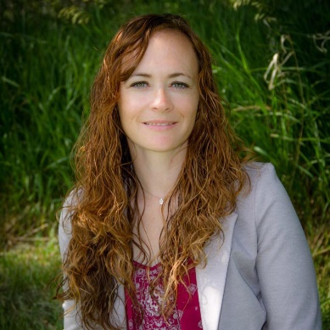 **Presented By Mary Beth Holzwarth**. Human Trafficking & Online Exploitation: Attendees will be trained on indicators to look for as well as how to report through this example driven and discussion-based training. Attendees will learn how to be empowered to safeguard themselves and others in the digital world. Some topics include identifying trustworthy individuals, developing safety plans, recognizing potential threats, empowering bystanders to intervene and support victims, creating an overall culture of safety and awareness, handling a disclosure and more! You will not hear a better speaker on this issue than Mary.

****Mary Beth Holzwarth a member of the Zonta Club of Pierre-Fort Pierre, is the Human Trafficking State Coordinator & Analyst for the South Dakota Division of Criminal Investigation and the South Dakota Attorney General. Mary Beth began her career combatting child sexual assault after two of her sons disclosed sexual assault in 2009, at the ages of 8 and 5. She created her organization, Endeavor 52, to educate adults, children, and professionals on how to keep children safe and improve response efforts after disclosure. She was involved in the passionate group of professionals who drafted Jolene’s Law which led to the Center for the Prevention of Child Maltreatment and more efforts around the state. Years later she became the Re-Entry Coach at the South Dakota Women’s Prison, guiding women through the Moving On program to heal from trauma and recreate new lives prior to being released. That led her to truly begin to understand the correlation between childhood trauma and the ties of human trafficking on some of the most vulnerable populations, leading her to the position she is now in, combining both areas of expertise and joining with others to change the scope of South Dakota. She is master trainer for ACEs, Enough Abuse, and Moving On; an avid backpacker and outdoorswoman; and mother to four amazing sons.

**SATURDAY & SUNDAY WORKSHOPS: for all (offered each day)**

**Leadership: Leading with Purpose –**

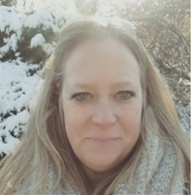**Present****ed by Melissa Martin, Zonta Club of Cheyenne**

*This guided discussion will help Zontians recognize their purpose, review past successes and pitfalls to develop a measurable set of goals to achieve throughout the year. This session will set up checkpoints and accountability needed to keep members on track during these shifting times. Special attention will be given to identifying your leadership style and how to best work with others in your club. The first day in your role is the day you start planning for your replacement. Understand what active succession planning looks like, why it's important, and how you can develop a culture of leadership continuity in your club to increase capacity, reduce stress, and help your club flourish.* Melissa Martin lives to communicate; it is through communication that she continues to be a life-long learner. Melissa uses her degrees in Communication Theory to guide both workplace development workshops and college courses. She delivers relevant, engaging content to professionals and students. Her areas of expertise include team building, communication, conflict management, workplace success, strategic planning, visioning, and professional development. Melissa is a certified facilitator for DiSC Personality Assessment, Bridges Out of Poverty, Getting Ahead, Crucial Conversations, Five Behaviors of a Cohesive Team, Workplace Stability and The Happiness Advantage Orange Frog Workshop. She volunteers at church and is a Zontian. She lives in a multi-generational household where she enjoys Sunday dinners with family and friends. When she’s not teaching, she likes road trips, walking her dog and cooking for her family. Come to Melissa’s workshops expecting to learn, communicate and engage.

**Advocacy: Clotheslines and Promises: Preferred Pragmatic Projects**

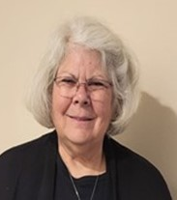Presented **by Denise Parrish, Zonta Club of Cheyenne-D12 Advocacy Chair This workshop will discuss two advocacy projects that are recommended to the District 12 Clubs for the upcoming year.**To implement the *Clothesline Project,* a public display of shirts (and only shirts) is hung on a clothesline to create a visual display that bears witness to the violence against women.  The shirts are decorated: (a) to represent a particular woman's experience of violence, (b) by the survivor herself, or (c) by someone who cares about her. The project will be explained further, examples will be provided, and there will be an opportunity for some hands-on activity. The second project involves creating a pledge wherein women - and men - are asked to publicly affirm that they will help to end violence against women. We will examine the wording of various pledges and decide how to compose our own so that it is simple but meaningful.  We will then discuss ways to implement the pledge project in a way that will be impactful on your local community.

Denise Parrish has been a Zontian since 2009 and Zonta District 12 Advocacy chair since 2016.  She is persistent in looking to change the world to make it a better and more equitable place for women.  Her current passion is to end violence against women by breaking the cycle and changing societal behaviors.   Before she retired in January 2020, she spent more than 40 years in the field of utility regulation and advocating on behalf of the public interest.  However, she began her rabble rousing in high school when she found out that women were not allowed to vote on her church's congregational issues; she got that changed.  She was also the first female to wear slacks (as part of a pant suit) to the dime store where she worked starting at age 16.  She continues to believe that the world can be changed one person at a time.

**Membership: Your Club Shines: Succeed, Flourish & Grow!**

**Presented by Deb Beatty, Zonta Club of Denver II and Betty Abernethy, Zonta Club of Cheyenne**

The Future is NOW- Let's look at the passions that bind us together in our work to Build a Better World for Women and Girls. Move forward with BOLD ideas and allow new ideas to flow and have engaging conversations to make the club shine in every area of membership, service, advocacy and fundraising. Deb and Betty will lead a discussion with Club presidents about ways to increase and retain members. This is an interactive panel to gain insight on growing the membership of our District. And includes Betty Abernethy's- 9 square ZONTA activity

Lt. Governor, Deb Beatty 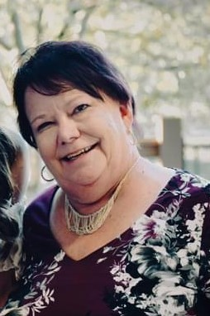 -is a member of the Zonta Club of Denver II and is a Courtroom deputy for the past 36 years. She has served on the District 12 leadership team in many capacities, including Area Director, Bylaws Chair and Parliamentarian.

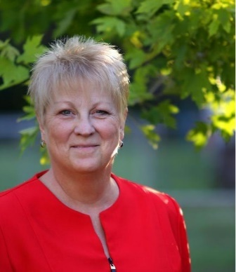Betty Abernethy -is a member of the Zonta Club of Cheyenne and is the current president of her club and has served as the Membership Chair for the past 6 years. Their club is now 51 strong and thriving. She also serves our district as the ZONTA SPIRIT Enthusiast on the Leadership Team. She has spent a lifetime connecting with people through her work as a hair salon owner and educator.



**KEYNOTE SPEAKERS**

**"Strong Men Speaking up against Violence toward Women"**

**"Invite, Not Indict": A New, Effective Way to Engage Men in Violence Prevention**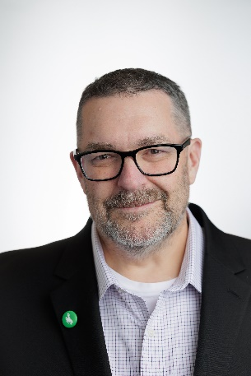

Bob Vines is the Violence Prevention Coordinator at the University of Wyoming where he works with students and staff in reducing power-based and sexual violence on campus. Formerly, he was a prevention specialist at the Wyoming Coalition Against Domestic Violence and Sexual Assault, focusing on engaging men in violence prevention, teen dating violence, and childhood trauma. He has also worked as a court room advocate, preparing survivors and witnesses for court hearings and trials. He is a member of the Wyoming Sexual Violence Prevention Council and works with Futures Without Violence's CATAPULT Initiative addressing male engagement in violence prevention on U.S. college campuses. He was a 2018 recipient of the NSVRC Visionary Voice Award for his work with Wyoming high school athletics coaches in violence prevention. He has presented at numerous state, regional, and national conferences as well as other campuses. Bob also hosts storytelling events across the state of Wyoming called "Men Speak" where male-identities tell stories that challenge masculine gender norms, and co-facilitates the SAFE Men Project in Laramie, Wyoming. Bob and his partner Mary have raised two boys to adulthood and enjoy spending their free time attending concerts, grilling barbecue, and making frequent trips to Buc-ee's, the happiest place on earth.

Description: American men are hurting. According to the new State of American Men 2025 report released by Aquimundo Center for Masculinities and Social Justice, American men are anxious about their economic security, have increasingly restrictive views on masculinity, are feeling increasingly isolated, and feel that no one cares about them. This anxiety is fueling their increasingly narrow views of their worth in the world. In this workshop, Bob Vines will examine the information from this report and discuss how taking an "inviting men" instead of "indicting men" approach in violence prevention is a far more effective strategy. On the bright side, other research has shown that men are ready to be part of the solution in reducing incidents of gender-based violence, but what they are looking for is a framework. Bob will introduce you to two programs that have been effective in providing that framework for Wyoming men, including the SAFE Men program in Laramie, and Men Speak and "Unscripted" Storytelling events across the state.

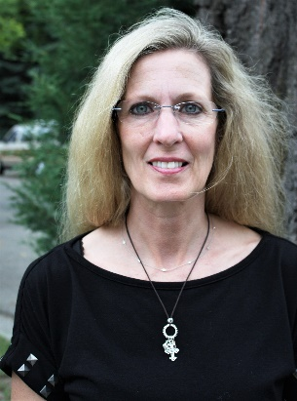**Harnessing Artificial Intelligence to Protect Women and Girls: the LAAHA Approach (Our ZONTA International Service Project)**

Renée Coppock, a member of the Zonta Club of Billings, is a strong advocate for Zonta’s collaboration with UN agencies. Renée has attended 15 UN Commissions on the Status of Women and has actively participated in NGO CSW panels and workshops for the past 8 years, as well as the UN Summit of the Future. Renée’s past leadership within Zonta includes serving as a director on the Boards of Zonta International and the Zonta Foundation for Women, governor of District 12, and Chair of the Zonta International Bylaws and Resolutions Committee. She currently serves on the ZI Bylaws and Resolutions Committee, is the Membership Director for the US Women’s Caucus, and is an active member of NGO CSW/NY.

Description: This presentation will examine the dangers of artificial intelligence (“AI”) and explore how AI can be harnessed to protect women and girls, aligning with Zonta’s mission to end violence against women. It will highlight UNICEF’s Laaha platform, a Zonta International service project, as a powerful example of technology used ethically to identify, prevent, and respond to risks faced by women and girls globally. The session will also explore how Zonta members can advocate for responsible AI use to advance gender equality and ensure safety for women and girls in their communities and beyond. Experience first hand how Zonta is building a better world for women and girls.





**Conference Venue**

**Denver Marriott West**

**1717 Denver West Boulevard**

**Golden, CO**

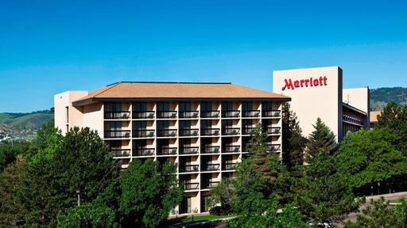

**Your registration and booking information will be coming to you soon.**

**Parking is Free**

**Saturday Breakfast is on your own. The hotel restaurant opens at 6:30 AM**

