**16 DAYS OF ACTIVISM**

**Day 8 –** International Day for the Elimination of Slavery

Labor Trafficking

**_____________________________________________________________________________________________**

Labor trafficking is the recruitment, harboring, transportation, provision, or obtaining of a person for labor or services through the use of force, fraud, or coercion for the purpose of involuntary servitude, debt bondage, or slavery. It is a fundamental violation of human rights. It occurs throughout the world and is often found in industries such as agriculture, construction, landscaping, garment manufacturing, hotels, domestic and custodial work, restaurants and food service, carpet weaving, and entertainment clubs. Traffickers exploit people with little or no social safety net by finding individuals in vulnerable situations because of economic hardship, immigration status, political instability, natural disasters and other causes.

The International Labor Organization estimates that there are currently over 27.6 million people in forced labor. Victims can be any age, any gender, and from anywhere in the world. According to the UN’s 2022 Global Report on Trafficking in Persons, female victims continue to be the primary targets. The Report shows that in 2020, over 42 percent of detected victims were women and 18 percent girls. The Report also states that the share of [children among detected trafficking victims](https://www.unodc.org/documents/data-and-analysis/glotip/2022/GLOTiP_2022_chapter_1_Global_Overview_230123.pdf) has tripled in the past 15 years.

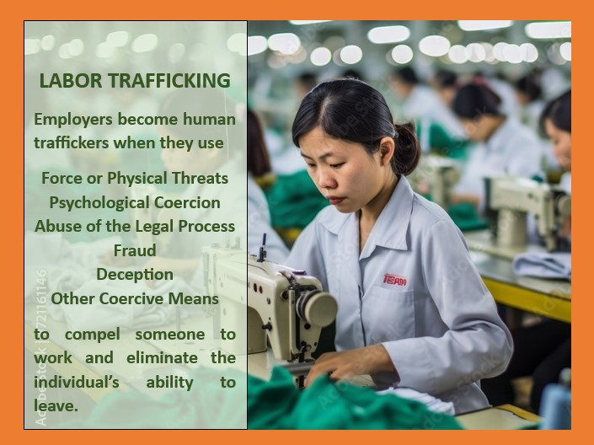Employers become human traffickers when they use force or physical threats, psychological coercion, abuse of the legal process, fraud, or deception, or other coercive means to compel someone to work and eliminate the individual's ability to leave. Worldwide, over $236 billion US is the annual profit generated from forced labor. This profit is why it is so difficult to eradicate this human rights violation.