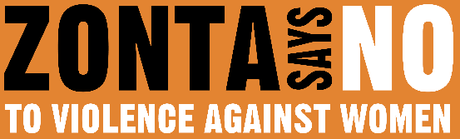
16 DAYS OF ACTIVISM
Day 7 – Sex Trafficking
_______________________________________________________________________________________________
Human trafficking persists as a grave human rights violation, with a disproportionate impact on women and girls. According to the United Nations, sexual exploitation continues to be the most common form of trafficking experienced by women and girls, with nearly 64% of the victims women and 27% girls. Factors that make women more vulnerable to violence and abuse – gender discrimination, harmful gender stereotypes and discriminatory social norms, poverty and economic insecurity, and the lack of access to social protection, education and health services – are also factors that make women and girls vulnerable to trafficking.
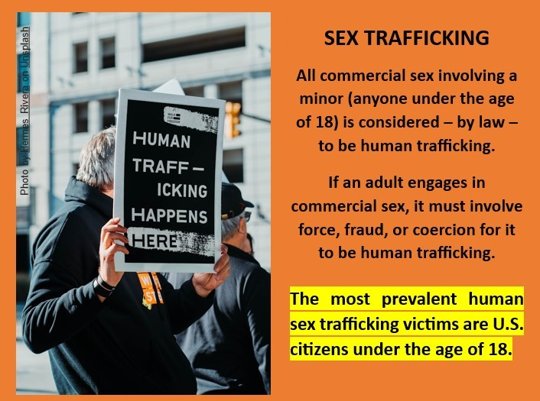
According to a 2024 report by the United Nations, since 2022, there has been an increase in the number of detected victims of trafficking, reflecting a return to trends before the COVID-19 pandemic. Detected victims identified by national authorities do not reflect the true scale of trafficking. The use of technology continues to expand the scope and severity of trafficking at every stage of the process, including advertising, recruitment, exploitation and control of victims, and concealment and transfer of the profits of traffickers’ criminal activities. Technology allows traffickers to be able to operate more anonymously and across multiple locations simultaneously.
As the UN Secretary-General outlined in a 2024 report, the multiple and interlinked crises around the world are intensifying the factors that make women and girls more vulnerable to trafficking, specifically their poverty and economic insecurity, displacement, and the violence and discrimination against them. These factors are exacerbated in situations of crisis, intensified weather events, disasters, and conflict.
What can you do? If you suspect a person is being trafficked, call the national human trafficking hotline 1-(888) 373-7888. Advocate for longer sentences and more severe penalties for both the traffickers and the “customer.” Say NO to trafficking in your community.

