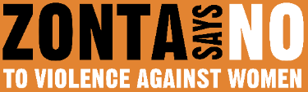

16 DAYS OF ACTIVISM
Day 16 – Human Rights Day
______________________________________________________________________________________________

Today, we celebrate the last day of the 16 Days of Activism, recognizing the Universal Declaration of Human Rights and its promise of dignity, freedom, and justice for all people. Yet, for women and girls everywhere, this promise still remains unfulfilled. There is a stark gap between global norms and standards and women’s practical enjoyment of their human rights. This accountability gap is unacceptable—and it demands urgent action.

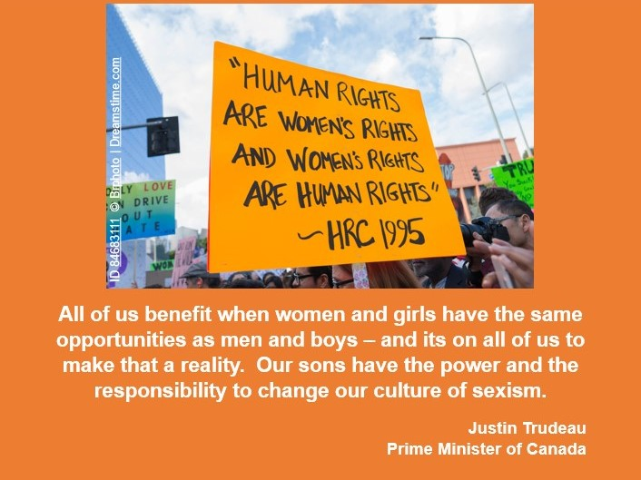
More than 600 million women and girls live amid conflicts that expose them to grave human rights violations, including sexual violence. At current rates, it will take 137 years to eradicate extreme poverty for women and girls, 68 years to end child marriage, and 39 years to achieve gender parity. How can this be acceptable to anyone?

Upholding women’s human rights unlocks dividends for all. The evidence is clear: advancing women’s and girls’ human rights is not only a moral imperative but a strategic one. It is the path to equality, justice, sustainable economies, and a healthy planet. Peace lasts longer when women are included in peace processes. Economies grow faster and become more sustainable when women have equal access to economic opportunities. Governance improves with equal representation. Families and communities thrive when women and girls are free from all forms of violence. Only by ensuring the human rights of women and girls—in all their diversity—will we achieve equality, justice, inclusion, peace, economies that work for all, and protection of our shared environment.
Zonta welcomes the growing momentum to reaffirm women’s human rights. From equal pay to freedom from violence, we must ensure that laws protecting the rights of women and girls are not only enacted but implemented and upheld. Women’s courage in defending human rights and leading transformative change must be amplified and supported.
In 1995, the Beijing Declaration and Platform for Action recognized women’s rights as fundamental human rights and created a powerful framework for action worldwide. As we mark its 30th anniversary in 2025, we must act on its rallying call. We must push forward towards a future where all women and girls, everywhere, realize their human rights and thrive. Join Zonta in its mission to build a better world for women and girls.

