

16 DAYS OF ACTIVISM
Day 15 – Victim Blaming
_______________________________________________________________________________________________
LET SURVIVORS KNOW THAT IS NOT THEIR FAULT
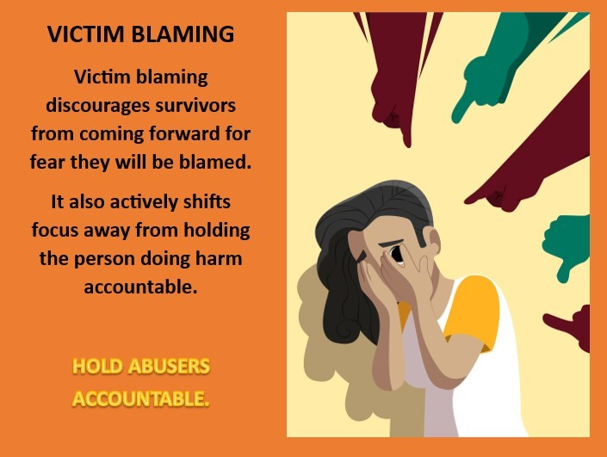
One reason people blame a victim is to distance themselves from an unpleasant occurrence and thereby confirm their own invulnerability to the risk. By labeling or accusing the victim, others can see the victim as different from themselves. People reassure themselves by thinking, "Because I am not like her, because I do not do that, this would never happen to me." We need to help people understand that this is not a helpful reaction. In fact, it is unacceptable.
Victim-blaming is dangerous. Victim-blaming attitudes marginalize the victim/survivor and make it harder to come forward and report the abuse. If the survivor knows that you or society blames her for the abuse, she will not feel safe or comfortable coming forward and talking to you.
Victim-blaming attitudes also reinforce what the abuser has been saying all along; that it is the victim’s fault this is happening. It is NOT the victim’s fault or responsibility to fix the situation; it is the abuser’s choice. By engaging in victim-blaming attitudes, society allows the abuser to perpetrate relationship abuse or sexual assault while avoiding accountability for her actions.
How Can We Combat Rape Culture and Victim Blaming?
- Avoid using language that objectifies or degrades women.
- Speak out if you hear someone else making an offensive joke or trivializing rape.
- If a friend says they have been raped, take your friend seriously and be supportive.
- Think critically about the media’s messages about women, men, relationships, and violence.
- Be respectful of others’ physical space even in casual situations.
- Let survivors know that it is not their fault.
- Hold abusers accountable for their actions: do not let them make excuses like blaming the victim, alcohol, or drugs for their behavior.
- Be an Active Bystander!

