

16 DAYS OF ACTIVISM
Day 14 – Strangulation
_______________________________________________________________________________________________
The numbers are familiar but never fail to shock. 1 in 3 women will experience violence at the hands of their partner. Homicide is a leading cause of death for women younger than 44 years old, and nearly half of female homicide victims are killed by a current or former partner. African American and Indigenous women are at even greater risk than others.
These horrifying statistics are not new, but what you may not know is that researchers have identified an important predictor of increased violent behavior in perpetrators of intimate partner violence.
“The most dangerous domestic violence offenders strangle their victims. The most violent rapists strangle their victims.
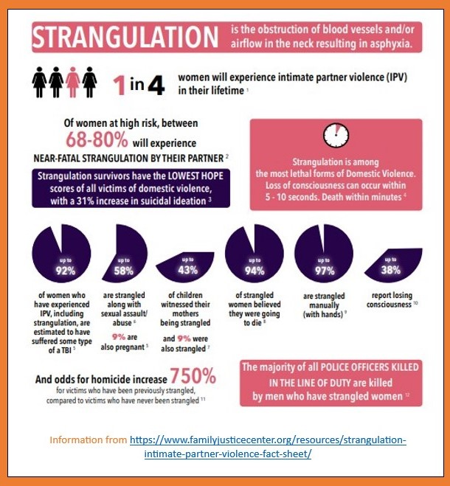
We used to think all abusers were equal. They are not.
Our research has now made clear that when a man puts his hands around a woman’s neck, he has just raised his hand and said, ‘I’M A KILLER.’ They are more likely to kill police officers, to kill children, and to later kill their partners. So, when you hear ‘He choked me,’ now we know.
YOU ARE AT THE EDGE OF A HOMICIDE.”
—CASEY GWINN, Co-Founder, Training Institute on Strangulation Prevention
3 Facts about Strangulation and Domestic Violence
1. Death from strangulation can occur days or weeks after an attack from carotid artery dissection, blood clots, or stroke. It is important to advocate for CT and MRI scans of the neck and brain.
2. Often people underestimate the risk of a delayed fatality from strangulation. Some hospitals may not have a protocol in place for strangulation or they may not have the equipment needed for the recommended screening. Some medical professionals may be reluctant to order extra imaging for a patient with no visible injury. While at the same time, 50% of fatal strangulations had no physical signs.
3. The odds of homicide increase 750% for victims that have been previously strangled by their partner. If an abuser has access to firearms, the odds of female homicide increase by 1,100%.
Strangulation is serious. Know the facts.

