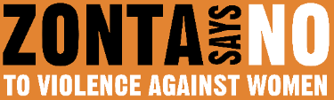

16 DAYS OF ACTIVISM
Day 13 – Stalking
_____________________________________________________________________________________________________
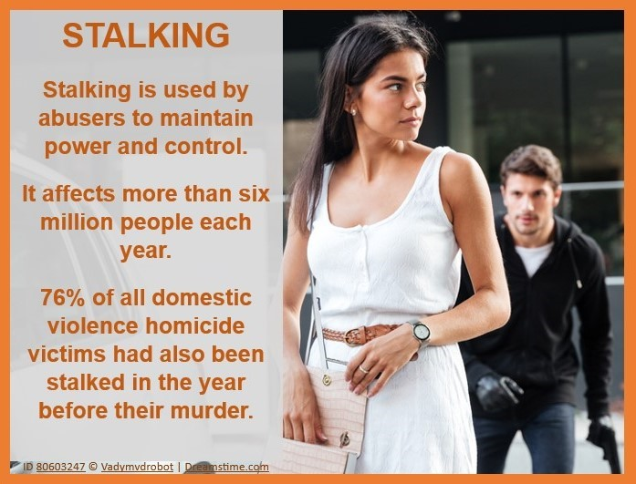
There is a real and frighteningly significant connection between stalking and intimate partner violence. Stalking can be a way to exert power and control during or after an abusive relationship. Here are the shocking statistics:
40% of stalking victims are stalked by current or former intimate partners.
57% of intimate partner stalking victims are stalked during the relationship.
74% of those stalked by a former intimate partner report violence and/or coercive control during the relationship.
81% of women stalked by a current or former husband or cohabitating partner were also physically assaulted by that partner.
31% of women stalked by an intimate partner were also sexually assaulted.
41% of victims stalked by a current intimate partner and 35% stalked by a former intimate partner experience threats of harm, compared to 24% stalked by a non-intimate partner.
The average length of partner stalking is 2.2 years (longer than the average of just over 1 year for nonintimate partner cases).
Stalking increases the risk of intimate partner homicide by three times.
The most common use of the criminal justice system prior to attempted or completed intimate partner homicide was reporting intimate partner stalking.
85% of attempted and 76% of completed homicide victims were stalked.
91% of attempted and 89% of completed homicide victims who had been physically abused during the relationship had also been stalked.
Some common examples of stalking behaviors used by abusers include:
- Persistent, unwanted contact toward a victim through phone calls, texts, or social media.
- Sending a victim unwelcome gifts or items.
- Showing up repeatedly at a victim’s home, school, or workplace.
- Using technology to monitor a victim.
- Threatening or harming a victim or their loved ones, pets, or property.
Survivors need support and resources to respond to these dangerous behaviors before they escalate. Advocate for support and resources in your community. It could mean the difference between life and death.

