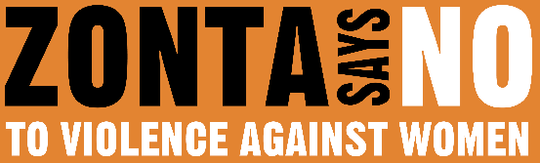

16 DAYS OF ACTIVISM
Day 13 – Sexual Harassment in the Workplace
_____________________________________________________________________________________________________
Workplace sexual harassment is a form of sex discrimination that occurs when someone is treated in a hostile or offensive way based on their sex. It can include:
- Unwanted sexual advances, requests for sexual favors, or other verbal or physical conduct of a sexual nature.
- Offensive remarks about a person's sex.
- Leering, gestures, or displaying sexually suggestive objects, pictures, cartoons, or posters.
- Derogatory comments, epithets, slurs, or jokes.
- Threats of sexual violence.
- Stalking, sending unwanted letters or notes, placing unwanted phone calls or emails, or repeatedly asking a person out on a date.
- Spreading rumors about a person's sexuality or sex life.
Unfortunately, sexual assault, harassment, and abuse are widespread societal problems that impact workers across race, gender identity, sexual orientation, income, disability status, and many other factors. Workplace sexual harassment is seldomly reported:
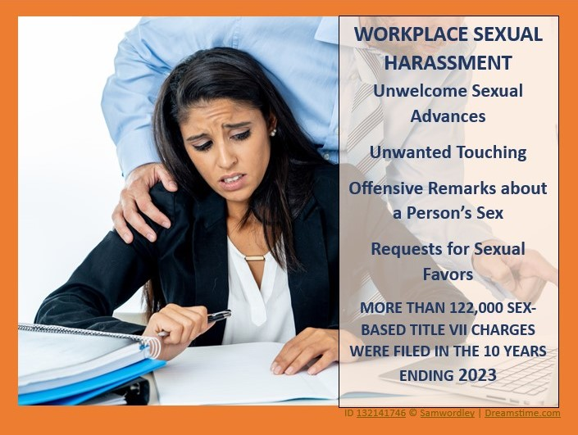
  - 1 in 7 women have sought a new job assignment, changed jobs, or quit a job because of sexual harassment and assault.
  - Sixty percent of women say they have experienced unwanted sexual attention, sexual coercion, sexually crude conduct, or sexist comments in the workplace.
  - In some industries, more than 9 in 10 women say they have been sexually harassed.
  - Over 85 percent of people who experience sexual harassment never file a formal legal charge, and approximately 70 percent of employees never even complain internally.
The impact of sexual harassment in the workplace is real and damaging. Employees that experience sexual harassment are more likely to report psychological symptoms of posttraumatic stress disorder, depression, stress, and anxiety, as well as physical problems such as headaches, sleep problems, gastric problems, weight loss/gain, etc. We need to support women who are subjected to sexual harassment in the workplace. Prioritizing policies to help create modern workplaces that envision women’s participation as the norm and not the exception is crucial. Are you ready?

