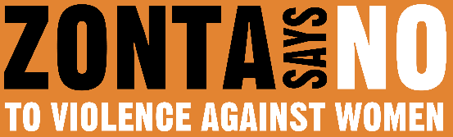

16 DAYS OF ACTIVISM

Day 11 – Missing and Murdered Indigenous Women

**_______________________________________________________________________________________________**

Of all groups in the United States, Indigenous women face the highest rates of violence. According to data collected by the US Department of Justice, in some US communities the murder rates of Indigenous women are 10 times the national average. The same report reveals that Indigenous women are almost three times as likely to experience rape or sexual assault compared to other women.

Worldwide, there are over 126 million missing women. A large percentage of these women and girls are indigenous. These statistics are not just numbers. The statistics represent real people; they are people’s sisters, mothers, aunts, grandmothers, and friends. They are Hanna Harris, Loretta Saunders, Savanna LaFontaine-Greywind, Shirley Soosay, Phebe Oregon, Kimberly Iron, Selena Not Afraid, Sabrina Rosette, Olivia

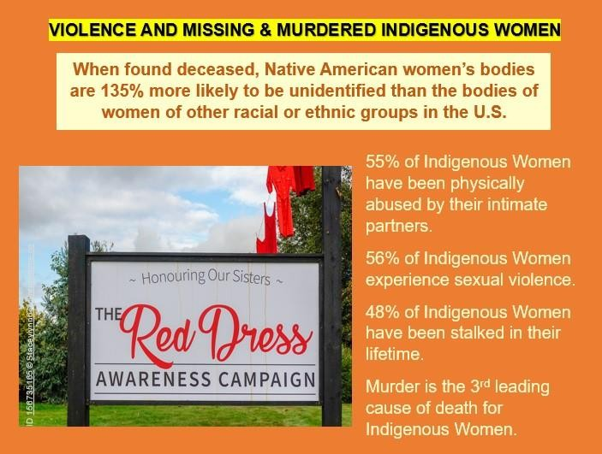Lone Bear, Ashly Loring Heavyrunner, …..and tens of thousands more.

We all need to become allies to stop this violence. However, being a genuine ally involves a lot of self-reflection, education

and listening. It means knowing we are often coming into this

space from a position of power and privilege. Privilege that we have gained through unjust

systems that marginalize the groups with which we seek to advocate.

It’s not enough to show up in

solidarity and speak out against the unjust system; we have to do what is within our power to dismantle the system and differentiate ourselves from the opponents of these groups. We have to change our own behaviors and consider our own internal biases and judgments. We must be mindful that we are not contributing to the continuance of the system. We can contact government officials and demand funding for improved reporting and immediate action. We can also host community projects that raise awareness, such as REDress Project, Walking with Our Sisters, or Faceless Dolls and then use the awareness to take action.

Are you up to the challenge?