

16 DAYS OF ACTIVISM
Day 10 – Ending Child Marriage
_______________________________________________________________________________________________
Globally, 1 in every 5 girls is formally married or in an informal union before reaching 18 years of age. Child marriage is a form of gender-based violence and a human rights violation. In addition to physical and emotional abuse, it puts minors at higher risk for poverty and exploitation and denies them educational and economic opportunities. It is the leading cause of adolescent girls dropping out of school worldwide. Health crises, conflicts and climate change are increasing the risks of child marriage for millions of girls worldwide:
- A tenfold increase in conflict-related deaths correlates with a 7% increase in child marriage.
- A 10% change in rainfall due to climate change is associated with a 1% increase in child marriage.
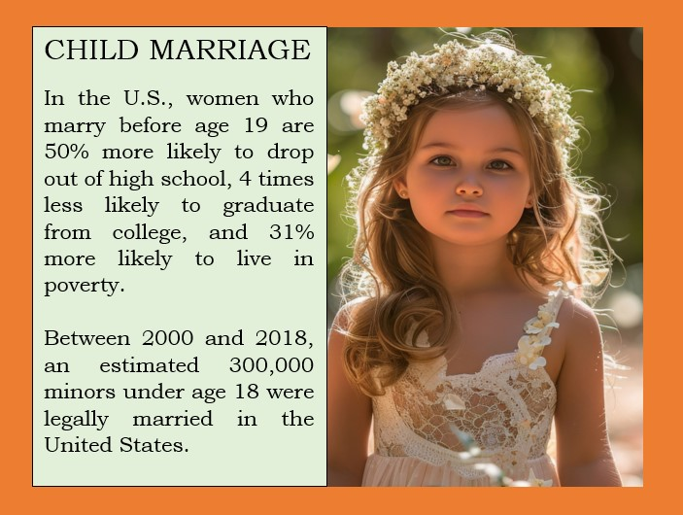
Child marriage is a truly global problem. It happens across countries, cultures, religions, and ethnicities. It is fueled by gender inequality, poverty, social norms, and insecurity, resulting in devastating consequences all over the world. That is why Zonta International has worked to end child marriage for over a decade by providing educational opportunities to young women and girls and partnering with UN agencies such as UNICEF and UNFPA in the Global Programme to End Child Marriage.
Though Americans often view child marriage as a “foreign” problem, it is surprisingly widespread throughout the US. According to a new Population Institute study titled, “Behind Closed Doors: Exposing and Addressing Harmful Gender-Based Practices in the United States,” between 2000 and 2018, an estimated 300,000 minors under age 18 were legally married in the US. California, for example, does not specify any minimum age for marriage, and more than 8,000 children are married there each year.
In the US, women who marry before age 19 are 50 percent more likely to drop out of high school, 4 times less likely to graduate from college, and 31 percent more likely to live in poverty. The consequences reverberate throughout their lives, perpetuating cycles of intergenerational poverty. Call on your state elected officials to end child marriage with zero exceptions by supporting legislation in your state legislature.

