
16 DAYS OF ACTIVISM
Day 6 – Gaslighting
_____________________________________________________________________________________________________
Does your partner repeatedly say things that confuse you? Because of this, do you often start questioning your own perception of reality within your relationship? Do you question your sanity altogether? If so, your partner may be using what mental health professionals call “gaslighting.”

Origination of term.
The term “gaslighting” comes from the 1938 stage play Gas Light and 1940 film, Gaslight, in which a husband attempts to drive his wife crazy by dimming the lights (which were powered by gas) in their home, and then he later denies that the light changed when his wife points it out. The husband manipulates his wife into thinking she’s delusional so he can keep her inheritance.
Today, gaslighting is a documented manipulation technique. It is an effective form of emotional violence that causes a victim to question their own feelings, instincts and sanity. As a result, the abusive partner has a lot of power and control. Once an abusive partner has broken down the victim’s ability to trust their own perceptions, the victim is more likely to stay in the abusive relationship. Although it happens to men, women are the most frequent victims.
Here are some examples of gaslighting:
- Denying facts - A gaslighter might deny facts, the situation, or the victim's feelings.
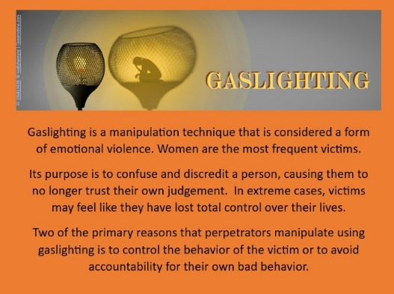
- Creating doubt - A gaslighter might plant seeds of uncertainty in the victim's mind, causing them to question their reality.
- Flipping stories - A gaslighter might flip stories or lie about details to make the victim believe something happened differently.
- Downplaying concerns - A gaslighter might downplay the victim's medical concerns or blame their symptoms on other conditions.
- Using outside factors - A gaslighter might claim that outside forces are watching, such as the police or immigration authorities.

Gaslighting can cause victims to become confused, anxious, isolated, and depressed. It can also lead to long-term mental health effects, such as paranoid thoughts.

