
16 DAYS OF ACTIVISM
Day 5 – Affirmative Consent
_______________________________________________________________________________________________
Affirmative consent is a knowing, voluntary, and mutual decision among participants to engage in sexual activity. Consent can be given by words or actions, as long as those words or actions create clear permission regarding willingness to engage in the sexual activity.
- Consent is not passive
Silence, lack of resistance, or absence of protest does not indicate consent.
- Consent is not implied
A past sexual relationship does not imply future consent, and consent to one sexual act does not imply consent to another.
Consent cannot be implied by how someone is dressed or inferred from the giving or acceptance of a gift, ride, money, or other items.
- Consent cannot be obtained by force
Consent cannot be obtained through threats, intimidation, coercion, or physical violence.
- Consent cannot be given when incapacitated
Incapacitation can be caused by a number of factors, including alcohol or drug use, unconsciousness, illness, sleep, or mental disability.
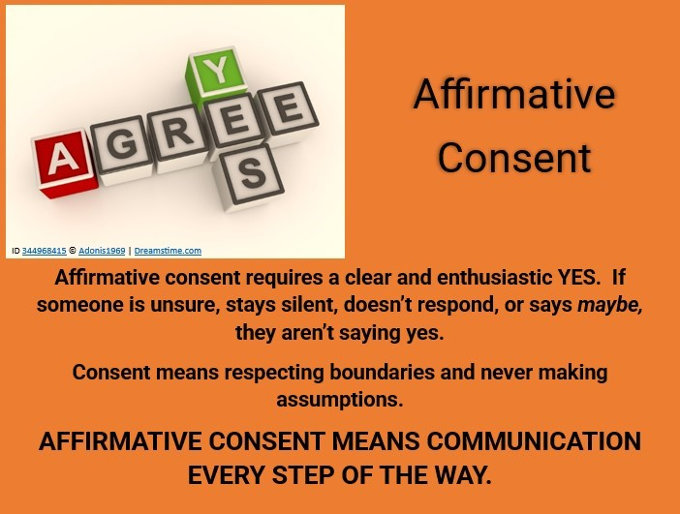
- Consent is a ongoing process
Consent can be withdrawn at any time.

