
16 DAYS OF ACTIVISM
Day 4 – Men as Agents of Change
_______________________________________________________________________________________________

Historically, violence against women has been viewed as a “women’s issue.” While women and female identified individuals are disproportionally impacted gender-based crimes, there has been a growing movement in the field of violence prevention to reframe this narrative and identify domestic and sexual violence for what it is; everyone’s issue- but particularly, a men’s issue.
Zonta International has long recognized that men and boys play a crucial role in ending violence against women. Gender-based violence cannot be addressed when half the world’s population is absent from the discussion. There are many key ways that men and boys can contribute to ending violence against women:
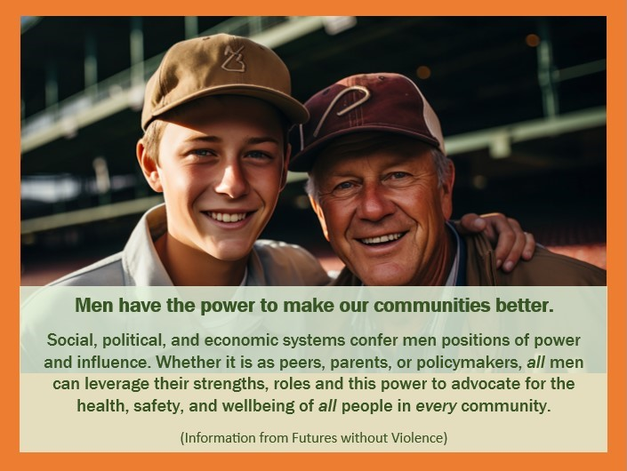
- Challenge harmful stereotypes:
Confront sexist jokes, comments, and attitudes in their social circles and actively push back against harmful ideas about masculinity that perpetuate violence against women.
- Be active bystanders:
Intervene safely when witnessing potentially violent situations, whether in public or within personal relationships.
- Educate themselves and others:
Learn about gender-based violence, its causes, and how to prevent it, sharing this knowledge with peers and family members.
- Support survivor advocacy:
Believe survivors, listen to their experiences, and advocate for their needs.
- Promote gender equality:
Actively work towards policies and practices that promote equal opportunities for women and girls in all aspects of life.
- Engage in community activism:
Participate in campaigns and initiatives aimed at preventing violence against women, working with organizations focused on men's engagement.
- Be positive role models:
Demonstrate healthy relationships and respectful behavior towards women, setting a positive example for younger generations.
It is clear that all genders must be allies and partners in the fight against gender-based violence. Let’s work together and end the epidemic.

