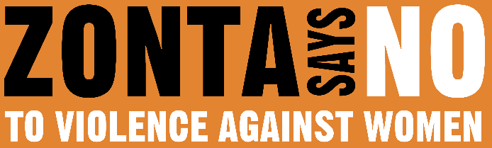
16 DAYS OF ACTIVISM
Day 3 – Verbal Abuse
_______________________________________________________________________________________________

Verbal abuse, also known as emotional abuse, is a range of words or behaviors used to bully, frighten, manipulate, intimidate, and maintain power and control over someone. These include insults, humiliation and ridicule, the silent treatment, and attempts to scare, isolate, and control. Yelling and verbal abuse do not always go hand in hand – verbal abuse can be quiet, insidious, and subtle. For example, it can be hurtful comments in the form of jokes or small remarks that make a person question their self-worth or abilities. Verbal abuse can even be delivered with a hug and a smile.
Emotional and verbal abuse also include violence that is not directed specifically at people but is used to intimidate, like slamming doors, throwing things, destroying belongings, or harming pets. This psychological violence is estimated to be the most common form of intimate partner violence in both the U.S. and Europe, affecting up to 49% of women.
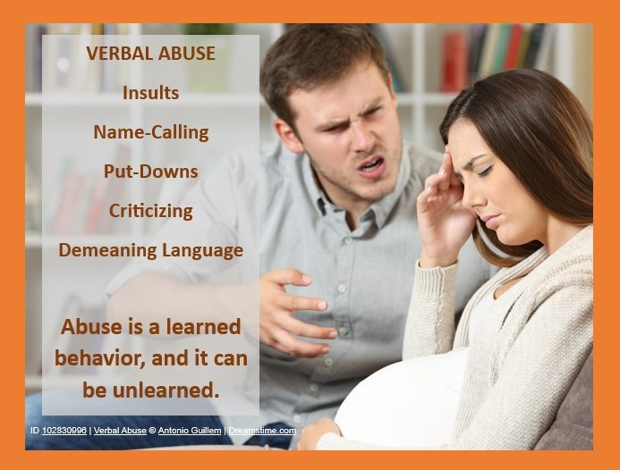
Those who use verbal abuse are engaging in purposeful, deliberate behaviors that cause harm to gain and maintain power and control. These behaviors are just as serious as other forms of abuse and may damage self-worth and well-being. According to research, being on the receiving end of persistent verbal abuse can also lead to health challenges, such as depression, anxiety, chronic pain, traumatic stress, and thoughts of suicide. However, it may be difficult to recognize abuse if a person is not being physically hurt.
To "unlearn" verbal abuse, a person first needs to recognize that they are being verbally abused and understand the harm it causes. The person must practice assertive communication skills to respond appropriately when faced with verbal abuse. When it is safe to do so, the easiest way to call out abusive behaver is to calmly let the person know that something they said is hurtful. Using “I feel….” statements is a way to clearly explain feelings without making them defensive. An abused person must also work on building self-awareness and setting and enforcing healthy boundaries. This may involve seeking support from a therapist or support group. Setting and enforcing boundaries helps a person take their power back from the abuser.
If you find yourself being verbally abusive, acknowledging that behavior is the first step toward change. Remember, taking responsibility for your actions and seeking help from a personal support group or professional is a sign of strength, not weakness. The next step is probably the most difficult. You need to sincerely listen to the person you hurt. Listen to their emotions, experiences, and feelings. Do not interrupt, do not minimize, do not deflect. Take responsibility for your actions with no ifs, ands, or buts. Do not make excuses.
Most importantly, make a conscious commitment to change. It is very easy to fall back into old toxic patterns of behavior. It is normal to slip up, especially at the beginning. By committing to change and reminding yourself that you can and will do better, you can work through those setbacks. Be patient with yourself and remember that you are capable of change.

