**16 DAYS OF ACTIVISM**

**Day 2 –** Words Matter

**___________________________________________________________________________________________**

As a society, we talk about how many women were raped last year, not about how many men raped women. We talk about how many women in college were harassed, not about how many men harassed women. We talk about how many teenage girls in the country got pregnant last year, rather than how many men and boys impregnated teenage girls.

We speak with a passive voice. We speak as if the men and boys do not exist. Dr. Jackson Katz summed it in his presentation hosted by the Zonta Club of Billings. He wrote 4 sentences on a white board:

Mary was beaten by John.  
Mary was beaten.  
Mary was battered.  
Mary is a battered woman

The first sentence, Katz explained, “is a good English sentence -- a subject, a verb, and an object.” The second sentence is the first sentence written in the passive voice, and according to Katz “a whole lot has happened. The focus has shifted from John to Mary. John is now at the end of the sentence, which means that John is very close to dropping off the map of our psychic plane. So, it’s not just bad writing to use the passive voice, it’s also political. And the political effect has been to shift the focus from John to Mary.”

In the third sentence John is gone. In the fourth, the term “battered” is substituted for “beaten,” and in the final sentence of the sequence “you can see that Mary has a new identity. She is now a battered woman and John is no longer part of the conversation.”

The language we use to describe abuse, domestic violence, rape, child marriage, and sexual harassment completely erases men and boys, the very people who are, in most cases, the perpetrators of the violence. Why do we continue to use language that absolves them of responsibility?

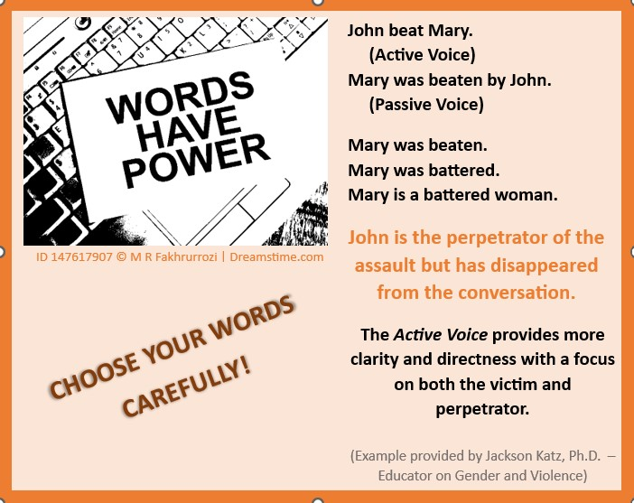Pay attention to passive verbs, especially when talking about women. Shine the spotlight where it belongs – on the perpetrators of the violence. If we pay attention to the way we address the violence against women and girls by men and boys, perhaps we can create a more just and equitable society, one word at a time.