**16 DAYS OF ACTIVISM**

**Day 1 –** International Day for the Elimination of Violence Against Women

**___________________________________________________________________________________________**

The International Day for the Elimination of Violence Against Women will mark the launch of the Zonta Says No to Violence Against Women campaign, which runs during the [16 days](https://www.unwomen.org/en/what-we-do/ending-violence-against-women/unite/16-days-of-activism) of Activism and concludes on International Human Rights Day (Nov. 25 – Dec. 10).

Violence against women and can manifest in physical, sexual, and psychological forms, such as:

* intimate partner violence (battering, psychological abuse, marital rape, femicide);
* sexual violence and harassment (rape, forced sexual acts, unwanted sexual advances, child sexual abuse, forced marriage, street harassment, stalking, cyber- harassment);
* human trafficking (slavery, sexual exploitation);
* female genital mutilation; and
* child marriage.

2024 marks 25 years since the UN Declaration of the International Day for the Elimination of Violence against Women. During this 25 years, the UN and human rights organizations like Zonta International have brought much attention to this epidemic and have been successful in advocating for the implementation of laws holding perpetrators accountable. Unfortunately, during the Covid pandemic, gender-based violence increased and continues to stay above pre-pandemic levels. Worldwide, every 10 minutes a woman killed. This is unacceptable. Perpetrators must be held accountable.

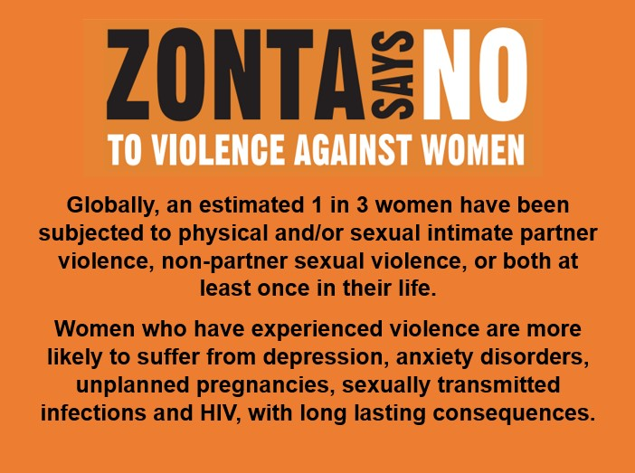During the 16 Days of Activism, Zontians all over the world will draw attention to the alarming escalation of violence against women to revitalize commitments to end gender-based violence and continue the call for accountability and action from decision-makers. Join Zonta and Say NO to violence against women.