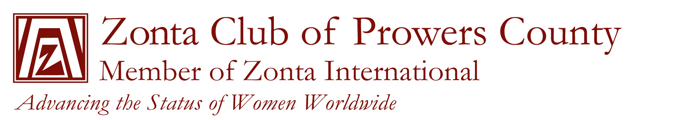

***Open Scholarship***

The Zonta Club of Prowers County has established the following requirements for successful applicants:

1. Be a female student from Prowers, Kiowa, Baca, or Bent County, Colorado
2. Be a full time student working toward a degree which will advance the status of women
3. Be committed to women’s development
4. Be willing to attend one Zonta Club meeting and briefly speak about her goals.
5. Have a Grade Point Average (GPA) of 3.0 or better

The open scholarship is payable to the college/university of the applicants choice

The deadline for applying to the scholarship is April 30, 2013.

The following items must be submitted:

1. Attached application
2. Two letters of recommendation
3. Your personal letter stating qualifications and career goals
4. A list of all activities during high school or college, awards, honors, volunteer work, and offices held.

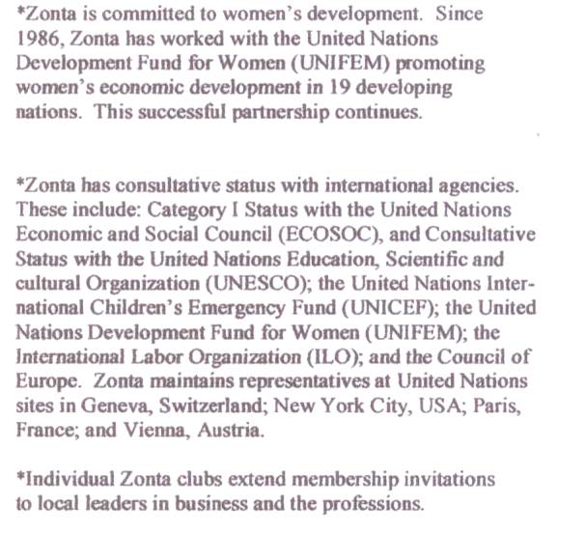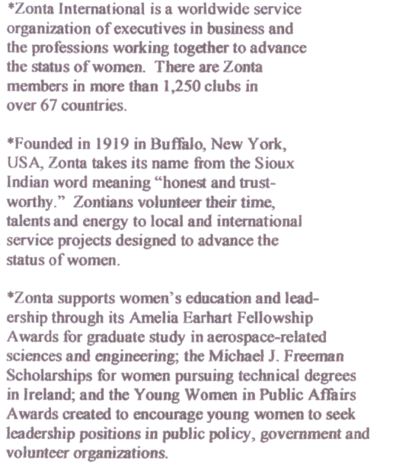



ZONTA CLUB OF PROWERS COUNTY

OPEN SCHOLARSHIP APPLICATION

Last Name First Name Middle Name

Address City State Zip

Email address

Telephone Cumulative GPA ACT Score SAT Score

High School/College last attended Graduation Date

Intended Major or Area of Academic Interest

Any additional information you would like us to know in considering your application for a Zonta Scholarship: