**Zonta International -- District 12**

**CLUB ANNUAL REPORT**



**Reporting Period: June 1, 2021—May 31, 2022**

***Please email to Governor Ann Hodgson (johnannhodgson@att.net) by May 15, 2022 with a copy to your Area Director.***

|  |  |
| --- | --- |
| Area 1 Director: Debbie Sundberg  (dsunnyone11@gmail.com) | Area 2 Director: Tasha Bauman (tlbauman84@gmail.com) |
| Area 3 Director: Deb Beatty  (debbeatty423@comcast.net) | Area 4 Director: Sonya Bergeron  (sjbergeron@comcast.net) |

**Club Administration 2021-2022:**

Zonta Club of Denver Today’s Date: 31 May 2022

Area: 3

President: Dawn Bali President-Elect (if appropriate): Linda Rhea

Vice President: Kathy Hyzer Secretary: Pam Staves

Treasurer: Julie Bradley

**Incoming Club Officers 2022-2023:**

President: Linda Rhea President-Elect (if appropriate): Mary Benoit

Vice President: Andrea Howell Secretary: Pam Staves

Treasurer: Julie Bradley

Board of Directors: Sheila Davis, Cynthia Herndon, Veronica Hoegler

**Membership:**

*Please describe your club’s recruitment and retention efforts for 2020-2021. Including new member orientation and mentors.*

ZCD relies primarily on members inviting prospective members to meetings for recruitment. This year we offered a membership to our grantee organizations. We have yet to see if any take us up on our offer. Retention was supported by a variety of efforts:

* A drawing for a bottle of wine was held among those who paid their renewal dues by April 1 this year.
* We award a Zonta, You Rock! Award monthly in a drawstring jewelry bag. The recipient of each month chooses the recipient for the next month. The person is chosen to be recognized for their contribution to Zonta Club of Denver. Recipients can keep their “rock” as a memento.
* Quarterly optional social meetings were held for members for fellowship and to support our other interests.
* We also host book club where we discuss inspirational books on women as well as current/relevant social topics.
* New members and existing members are offered to be featured in the Member Spotlight section of our monthly newsletter.

New members are initiated at our May meeting and will be offered a mentor, who is a volunteer from the club.

*How does your club measure membership satisfaction?*

We measure member satisfaction by attendance and renewal of membership.

**Fundraising:**

Please list the major fundraising events your club held during 2020-2021.

Our 14th Annual Day of Film was held in person this year at the Tivoli Center, Metro State University. This was a champagne brunch, silent auction, and screening of The Untold Story: I Was A Child Bride. Net proceeds were $10,555.21.

The second part of our Day of Film was a screening of LUNAFEST’s 8 short films written, produced, and directed by women. Net proceeds were $1,821.

Total Funds Raised this year: $12,376.21

**Local Service & Scholarships Dollars Given:**

Please list the contribution amounts given by your club during 2020-2021.

*Local Service Organizations:*

* Center for Work Education Employment (CWEE) - $10,000 - to purchase 40 laptops for women in their program
* Blue Bench - $8,500 Continuing Safe Bars Program
* Open Door Ministries - Te Veo House - $5,000
* Heart and Hand - $10,000 - Furnishing new Family Center

*Local Scholarships:*

Edna Jean Hershey Trust Scholarship at MSU Denver is awarded to single mothers who meet specific criteria. Each year MSU announces the scholarship winners and hosts an event for ZCD and students to meet. This year, four $1,500 scholarships were awarded.

Total Local: $6000 (Hershey) + $1500 (JMK) = $7500

**Zonta International Foundation (ZIF) Dollars Given:**

Please list the total club & individual contributions given to the Zonta International Foundation during 2020-2021.

(Carol Leffler lefflergc@comcast.net can provide this information to you). ZI recommends that one third of the money your club raises be contributed to ZI to support the international service projects.

Total Club Contributions: $17,371

Total Individual Contributions: Several members have automatic donation. We would have to confer with the District Foundation Ambassador to get that information. We give at least $2000 annually.

Total Club & Individual Contributions: $17,371 + ??

***The information below will be used to determine the District Service Award to be given out at the District 12 Conference.***

**Local Service:** (Hands on work to help women & girls in the local community)

Please name and briefly describe your local service projects, including for each item:

(a) category: improved the status of women in general (legal, political, economic, educational, health and/or professional) or helped prevent and fight violence against women and girls (VAW).

(b) % of club members involved in the project.

(c) visibility and credibility to Zonta created by the project

(d) sustainability of the project (long lasting results, and could the project continue for a certain period of time)

The Delores Project

We serve Saturday lunch once a month.  We have supported the shelter for woman many times in the past and are happy to resume providing food and social time to the residents.

a) Improves status of women in general by protecting residents from danger caused by living on the streets.

b)  30% of our club participates.

c) ZCS has a long and positive partnership with the directors and staff.

d) Delores is an established and vital participant in the effort to protect women from homelessness.

The Blue Bench

a) Health, Education.

b). 15% of our members participated.

c) Promotion of Safe Bars Program and Poster program in partnership with the Advocacy Committee.

d) ZCD is recognized in the Safe Bars training and poster project.  In addition, members have personally visited bars to determine success and viability of training.  The visits were hampered by COVID shutdowns but will continue in the coming year.

e)  The Blue Bench has a long and successful history in Denver with sound community support and progressive programs.

Santa Claus Shop

a).  Health, Education.

b). 15% of our members participated in sorting items by age and gender, packaging and delivering toys to families at no cost.

c)  In 2019 more than 10,000 local children were provided with Christmas gifts.

d) Promotion of Zonta in the community

e)  Santa Clause Shop has celebrated over 90 years of providing toys and gifts to qualifying families.

Friends of the Haven

Five members participated in a gift-wrapping party as part of the Christmas holiday tradition at the Haven.  Because of COVID concerns, we were unable to provide our traditional Holiday dinner and instead provided gift bags for the 30 women in residential treatment. The bags included numerous personal items, coloring books, hats, gloves and scarves and $20 Target gift cards.

a) Health, Educational, and helped prevent VAW.

b) 40% of our club participated

c) Promotion on Zonta.

d) ZCD has a long and productive partnership with the Haven, directors and staff.

e) The haven has a 30 year history of exceptional service to the community and almost 90% success rate in their residential treatment.

Volunteers of America - Homeless Women Veterans Program

ZCD has supported this program for many years at our Nov meeting when we honor veterans.  Our club is proud to currently have 4 veterans as members.  This year we collected an entire carload of personal items, blankets, warm socks and other items for the residents at the 3 houses that VOA has set aside for this project.

a) Helped prevent VAW and status of women in general.

b) 30% of members participated in the collection.

c) Promotion of Zonta

d) The VOA program houses women veterans in 3 beautiful new homes as part of their residential treatment program.

COVID continued to prevent us from meeting in person with organizations that we would have otherwise supported with service activities.

Afghan Refugees

We partnered with the International Relief Committee to support Afghan refugees that were relocating to the Denver area.

a) all of the above.

b) It is difficult to know how many participated as our assistance included 3 carloads of donated goods from our club and ordering from an Amazon Wish List.  In addition, our President (Dawn Bali) collected numerous items from Area 3 clubs to be delivered to the organizations assisting in the re-settlement of the Afghan women. Dawn also volunteered with IRC, providing language services at an immigration workshop

c) Promotion of Zonta among various organizations assisting in the efforts.

d) Unknown, but we plan to follow up with a diaper drive in the near future.

CWEE

We provided personal items for the women participating in their business and employment program.  In addition to the purchase of 40 laptops previously noted, we collected a car full of personal items, including diapers, for the participants.

a) Health and Education.

b) 20% of our club participated.

c) Promotion of Zonta.

d) CWEE just celebrated 40 years of helping women become self-sufficient with job training.

Te Veo House

We hosted a pizza and game night for Te Veo House, one of our grant recipients.  Ten members provided food and/or participated in an evening of relaxation and socialization, which is so important for these traumatized women.  A and d

**Other Service Questions:**

What like-minded organizations have you partnered with for service and/or advocacy? Please list and briefly describe how you partnered with them.

Truckers Against Trafficking

This great organization provided ZCD with an informative presentation of their work to combat local trafficking. WE looked at how we could assist their efforts at local truck stops.

Blue Bench Project partnering with Advocacy as detailed above.

**Z-Club or Golden Z-Club:**

Does your club sponsor a Z Club? Yes No Does your club sponsor a Golden Z Club? Yes No

If yes, please describe key events held during the year.

**Zonta International Scholarship Information:**

* **YWPA-Young Women in Public Affairs Awards**

Did your club participate in the YWPA program? Yes  No

Please list the name of the candidate(s) forwarded by your club to the district for this award*.*

* **Jane M. Klausman Women-in-Business Scholarships (JMK)**

Did your club participate in the Jane M Klausman program? Yes  No

Please list the name of the candidate(s) forwarded by your club to the district for this award.

Anna DiSaverio, a graduate student math the Daniels College of Business ad DU. She is majoring in Applied

Qualitative Finance. WE awarded her $1500.

* **Amelia Earhart Fellowships**

Did your club celebrate Amelia Earhart Day?  Yes No

If yes, please describe how your club celebrated this year.

We joined the Area 3 meeting, which focuses specifically on the fellowships.

* **Women in Technology Scholarship (WIT)**

Did your club participate in the Women in Technology program? Yes  No

Please list the name of the candidate who received an award from your club.

**Local Scholarship Information:**

**Local Scholarships** awarded by your club

Name(s), description(s)and amount(s) of scholarship(s):

Edna Jean Hershey Trust Scholarship at MSU Denver as stated above. We have offered the scholarships to single mothers who meet specific criteria. Each year MSU-Denver announces the winners and hosts an event for ZCD to meet the students. This year, four $1,500 scholarships were awarded for a total of $6,000. Each student also received a letter of congratulations and invitation to attend a meeting from the President along with a ZCD brochure, a copy of Zonta International’s flyer, and a small leather Zonta pouch. ZCD’s strong partnership with MSU-Denver has provided the opportunity for us to offer ongoing support and advocacy to women in the Denver area.

2021-2022 Recipients: Angela Martinez, Milinda Sandoval, Jessica Dorris, Irma Zenteno.

*T****he advocacy information below will be used to determine the District Advocacy Award to be given out at the District 12 Conference.***

**Advocacy:** The expression of support for or opposition to a cause, argument or proposal. Advocacy may include influencing laws, legislation, or attitudes. Zonta advocacy is an action taken in "the public interest" or for "the greater good" with respect to advancing the status of women and girls and their human rights.)

Does your club have an advocacy committee?  Yes No

The Zonta Club of Denver has had a very active year and has definitely met the District 12 Advocacy goal of having a project focused on domestic violence. It has also met the Zonta International goal of completing one advocacy project per year for the 2020-2022 biennium.

**(Do Not Include Zonta Says No Activities Here - See Below)**

Please name and describe your advocacy projects, including for each item:

(a) Category: improved the status of women in general (legal, political, economic, educational, health and/or professional) ***or*** helped prevent and fight violence against women and girls (VAW).

(b) How closely the project coincided with the advocacy definition above.

(c) % of club members involved in the project.

(d) Names of any community partners.

(e) Visibility and credibility to Zonta created by the project.

District 12 Advocacy Project/Blue Bench Poster Project

In 2021, the Zonta Club of Denver’s (ZCD) Advocacy, Service, and Public Relations committees partnered with The Blue Bench (thebluebench.org) to create a poster to raise awareness of sexual harassment and assault and domestic violence. The Blue Bench (TBB) is one of ZCD’s service award winners. TBB Safe Bars Project trains staff in establishments that serve liquor how to recognize and respond to incidents of sexual harassment and assault. The “Yes Means Yes” posters have been placed in ten Safe Bars trained businesses in both the women's and men's restrooms. These posters offer information about consent and safety along with phone numbers and a Quick Response (QR) Code for access to sexual assault and domestic violence resources available. Cerebral Brewing, (cerebralbrewing.com) an award-winning craft brewery in Denver, is one of the Safe Bars trained businesses that have joined with ZCD, TBB, and Safe House-Denver in promoting this prevention campaign. Additional establishments are scheduled to receive posters and training in 2022. This project is posted in the Advocacy section of the ZCD website and was submitted to ZI's Share Your Story website.  The project has been included in ZI's March's A World of Difference's short video:

* Facebook, <https://fb.watch/bt4pW6JThD/>
* Instagram, <https://www.instagram.com/tv/CaiXdeXshGE/?utm_source=ig_web_copy_link>

 It has also been posted on the Zonta International website.

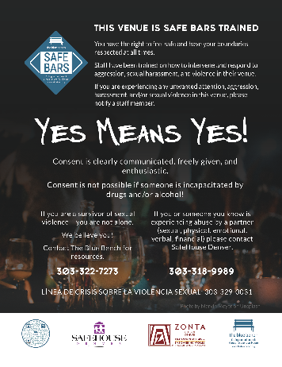

**Cerebral Brewing, Staff with ZCD members**

a) Category: Prevention of VAW.

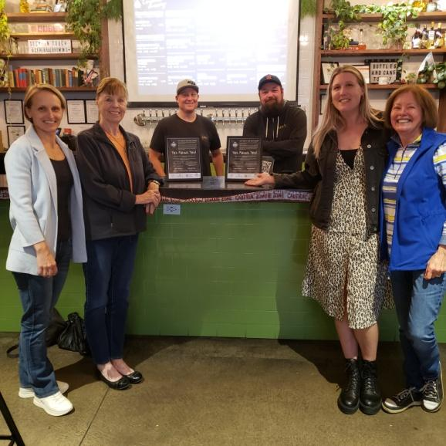

b This project coincides with the advocacy definition by influencing an attitudes regarding domestic/sexual violence.

c)  Three women (7% of club members) participated in this project.

d) The Blue Bench, Cerebral Brewing, and Novel Strand Brewing, along with eight other Safe Bars trained establishments that have received posters.

e) Visibility and credibility were definitely created by this project.  There is potential that most customers of the Safe Bars trained establishments will see the posters since they are posted in the restrooms.

Engaging in Civil Discourse Around Polarizing Issues Webinar

The Advocacy committee partnered with the League of Women Voters Colorado (LVWC) to present a two-hour webinar regarding the polarization this country faces and how to combat it. The webinar discussed how most of the key problems we face are very complicated issues with many varied solutions, how human nature affects the polarization, and how to build capacity for the kinds of conversations, processes, and institutions to address these complex problems. The presenter was Martin Carcasson, a professor at Colorado State University (CSU) and the head of CSU's Center for Public Dialogue and Deliberation. The webinar is available on YouTube currently.

a) Category: Improved the status of women in the political and professional areas.

b)  This project coincides with the advocacy definition by educating women how to express support for a cause, and how to influence attitudes.

c)  Nine women (22% of club members) participated in this project. Another 10-15 women from the League also attended.

d) The League of Women Voters of Colorado

e) Visibility and credibility were definitely created by this project.  The LWVC host of the webinar gave a very nice overview of Zonta at the beginning of the program.

Women Powering Change (WPC)

The Advocacy Committee planned to be an exhibitor at this event, which was held on March 9, at McNichols Civic Center in Denver. Over 500 people, activists, and others came together to create change around sustainability, social justice, gender equity and more. Unfortunately, the weather was so bad in Denver that day that the committee and other club members could not make it to the event.

a) Category: Improved the status of women in general.

b)  This project coincides with the advocacy definition by expressing our club's support to influence laws, and attitudes, and prevent VAW.

c)  Ten women (24% of club members) planned to participate in this project.

d) The Women Powering Change organization.

e) Visibility and credibility would have been created by this project as ZCD planned to be an exhibitor at the event.

Book Club

The Advocacy Committee with help from the Membership Committee started a book club in June of 2021. Monthly Zoom calls have been held to discuss the book read during the month.  Both fiction and non-fiction books have been read focusing on women's and current issues. The selections included: *A Woman is No Man, Sold on a Monday, White Fragility, and The Lincoln Highway.*

a) Category: Improved the status of women and prevention of VAW.

b)  This project coincides with the advocacy definition by influencing attitudes and advancing human rights.

c)  Approximately three women (7% of club members) participate in this project every month.

d) None.

e) Visibility and credibility were created by this project internally for the Advocacy Committee and the work that is done by the committee.

Truckers Against Trafficking (TAT)

A sub-committee of the Advocacy Committee worked with a representative from TAT who gave a presentation to the club at the September 2021 club meeting on his organization. The sub-committee has contacted seven truck stops in the Denver metro area to see if they needed more materials or training. Unfortunately, no return contacts were made by the truck stops. Consequently, this project has been put on hold until the fall.

a) Category: Prevention of VAW.

b) This project coincides with the advocacy definition by influencing attitudes regarding sexual violence.

c)  Three women (7% of club members) participated in this project.

d) Truckers Against Trafficking.

e) Visibility and credibility were definitely created by this project by contacting truck stop managers.

Advocacy Moments

Each month in our club meeting, a member shared an Advocacy Moment, which is a five-minute talk on a subject surrounding the education, economic, health, political, or professional well-being of women or regarding prevention of violence against women (VAW). This year's topics included:  Marian De Forest, Famous Veteran Women, Child Brides, and the Zonta International Statements on CSW66, Trafficking in Persons, Afghanistan and Girls' Education, Climate Change and Affirming Support for the Istanbul Convention.

(a) Category: Improved the status of women and prevention of VAW.

(b) All of the subjects discussed coincide with the advocacy definition.

(c)  Eleven women (27% of club members) presented topics.

(d) None.

(e) The Zonta Club of Denver demonstrates its credibility by presenting these topics every month.

Following Bills in the Colorado Legislature

The committee has been following bills in the Colorado Legislature this year that affect women and girls. They include:

* HB22-1055 Sales Tax Exemption Essential Hygiene Products
* HB22-1079 Abolishing Abortion in Colorado
* HB22-1169 Prohibit Sexual Act Without Consent
* HB22-1279 Reproductive Health Equity Act
* HB22-1288 Safe Reporting Assaults Suffered by Sex Workers
* SB22-003 Community College Nursing bachelor’s degree Eligibility

a) Category: Improved the status of women and prevention of VAW.

b) This project definitely coincides with the advocacy definition by increasing understanding of current legislation.

c) Four club members (10%) worked on this project.

d) None.

e) The Committee Chair will be contacting the sponsor of SB22-003 to better understand the bill. This will give visibility and credibility to ZCD with the bill's sponsor.

Area 3 Child Marriage Project

The Advocacy Committee Chair participated in an Area 3 Child Marriage project by contacting Lamar Advertising, Mile High Outdoor Advertising, and Outfront Media to determine if they had space for a Public Service Announcement (PSA) billboard regarding child marriage in the Denver Metro Area. Only Outfront offers a PSA opportunity, and they had no billboards available at the time. The committee will keep checking with them every couple of months. Apparently, the Denver Area is a highly sought after market so billboards can bring a high price and therefore, there was little appetite to offer PSAs.

a) Category: Prevention of VAW.

b)  This project coincides with the advocacy definition by influencing legislation and attitudes.

c)  One women (2% of club members) participated in this project.

d) None so far.

e) Visibility and credibility were created by this project as contacts with the billboard companies educated them on Zonta and child marriage.

Smaller Efforts

Several smaller efforts that are worth mentioning included a Zoom call with LVWC to discuss how ZCD could partner with them. Their Legislative Liaison gave a presentation at the October 2021 club meeting on upcoming November 2021 ballot issues. The Advocacy Chair made a weekly teen dating violence prevention post on Facebook each week during February 2022.

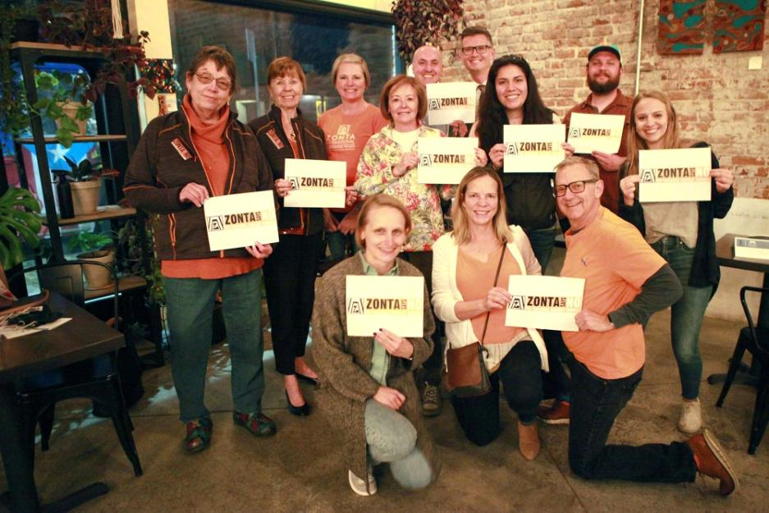

**Zonta Says No:**

Describe your club's Zonta Says No activities in 21 -21.

Seven club members (17%) were able to join The Blue Bench organization and Novel Strand Brewing Company in Denver on December 3, 2021, to promote Zonta Says No and educate patrons about violence against women. The “Yes Means Yes” posters were given to the Novel Strand Brewing staff to place in their restrooms.

The event was posted on the Zonta Says No website, ZI Share Your Story website, and the Advocacy section of the ZCD website.

**Other Advocacy questions:**

*What women’s issues have been identified as the most important in your club?*

* Child Marriage is decidedly a very important issue in the club especially since it's Zonta International's signature project.
* Another important matter for our club is women's education. $10,000 was given to the ZFW to fund one Amelia Earhart Fellowship for the past several years. In many years money has also been given to the International Jane M. Klausman (JMK) Scholarship, and the International Young Women in Public Affairs (YWPA) Award. The club funds $1,500 for our club's JMK Scholarship every year.
* Climate change and its effect on women is becoming a more important issue. Members were asked to visit the Zonta Says Now website and more work will be done next year on this topic.

*How have club members been made aware of legislation relevant to women in our country?*

The committee followed the ERA, the Violence Against Women Authorization Act of 2021, and the Victims of Crime Act (VOCA) in the US Legislature during this year. Emails were sent to club members to keep them up to date on these bills.

**Leadership & Leadership Development 2020-2021:**

If your club conducted training for board members, committee chairs or members please describe.

What training opportunities / workshops have your club leaders and members participated in through ZI website, District 12 online, at Area Meetings or District Conferences?

* ZCD President provided Social Media training at the District 12 Conference September 2021. Several ZCD members attended. This same training was provided to Denver II at their October 2021 meeting.
* All new members from 2020-2021 were provided Zonta 101 training by our trainers. This also includes providing a mentor.

Does your club have a long-range plan that includes succession planning for future leaders in club? Yes No

If yes, please describe (and provide copy to Governor and Area Director).

Denver’s plan at this stage is more informal. We have been trying to identify newer member interests, in order to find chair, director, and treasurer replacements.

*Describe any leadership challenges and needs that could be addressed by training.*

I think greater emphasis could be made on how each committee can collaborate for a multi-purpose event. This sort of activity could for example be both a membership drive, as well as an advocacy project. Furthermore, younger member recruitment needs to be made a priority. Zonta clubs need more community visibility, particularly as COVID restrictions have been lifted. Job recruitment fairs at local colleges, advocacy booths at local festivals, local Chamber of Commerce events.

**United Nations:**

Please describe how your club informed its membership of Zonta's work with the United Nations (i.e., CSW, Sustainable Development Goals, etc.)

Our March 2022 monthly meeting presentation was about CSW, including current events and its history.

**External Communications/Public Relations:**

*Please check box for the PR tools your club uses:*

Brochure      Newsletter    Club or Individual Business Cards     Website   Facebook

Information from ZI toolkits   Other (describe)

We also have a presence on LinkedIn and Instagram.

Did the club submit a “Share your Story” through the Zonta International Website this year? Yes No

If yes, briefly describe.

We shared our success with Blue Bench advocacy project.

**Internal Communications** (e.g., club newsletter, directory, website)**:**

Please describe how your club kept its membership informed & connected this year.

**Website:**

Does your club have a club website  Yes No Is it associated with the D12 website?  Yes No

If no, what is your club website address?

Is the information on your website updated regularly?  Yes No

When did your club last update your website? April 2022

**ZFW Ambassador:**

Does your club have a Foundation ambassador? Yes No It is also the responsibility of the President-Elect.

Does your club give an annual donation to Zonta International Service Projects? Yes No

How has your club encouraged individual donations this year to ZFW? Please describe.

We do this with our January meetings. We ask that members donate what they would have spent on dinner to the Foundation.

**Archiving & History:**

Does your club have an archivist/historian?  Yes No Is your club history current?  Yes No

Is your club history available on your website?  Yes No

Does your club send items to the District 12 historian for archiving (e.g. Board and Club minutes, newsletters, etc.)

Yes No

ZCD intends to budget for scanning services and move storage to the cloud. This was agreed upon this past year and will be put into motion, with the purchase of Google Workspace. This will provide both a productivity and a secure archiving capacity. We hope to donate hard copies, photos, and other memorabilia to perhaps the Colorado Women’s History Museum.

**Bylaws:**

Are your bylaws up to date in accordance with Zonta International bylaws?  Yes No

# Successes, Achievements and Challenges:

What have been your club’s successes and achievements in 2020 - 2021?

We worked hard this year on finding more “hands on” service projects. We really wanted to get out into the community more. Kathy Hyzer, our Service Chair, did a great job of finding and scheduling those for us. The Blue Bench Poster project was also great for us. Sheila Davis’s leadership kept the project going and made it a success.

What have been your club’s challenges in 2020 - 2021?

One challenge was when we realized that the name of our newsletter was offensive and cultural appropriation. What is acceptable in one era (Smoke Signal) is not acceptable in today’s climate.

How did you meet those challenges?

After much churn and discussion, we eliminated the title of “smoke Signal” and just called referred to it as the newsletter.

Are there specific areas for which your club needs help? Yes  No

If yes, what areas?

Is there anything else your club would like to address?

NO

**Thank You!**