Zonta International -- District 12
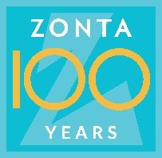
CLUB ANNUAL REPORT
Reporting Period: June 1, 2021—May 31, 2022

Please email to Governor Ann Hodgson (johnannhodgson@att.net) by May 15, 2022 with a copy to your Area Director.

Area 1 Director: Debbie Sundberg  (dsunnyone11@gmail.com) | Area 2 Director: Tasha Bauman (tlbauman84@gmail.com)
Area 3 Director: Deb Beatty  (debbeatty423@comcast.net) | Area 4 Director: Sonya Bergeron  (sjbergeron@comcast.net)

Club Administration 2021-2022:

Zonta Club of Fort Collins Today’s Date: May 10, 2022
Area: 2

President: Julie Trone President-Elect (if appropriate): __________________
Vice President: None Secretary: Judy Barth; beginning in May -Alyssa Umland
Treasurer: Judy Barth

Incoming Club Officers 2022-2023:

President: Julie Trone President-Elect (if appropriate): __________________
Vice President: _________________________ Secretary: Alyssa Umland
Treasurer: Judy Barth
Board of Directors: Julie Trone, Judy Barth, Rhonda Bolich-Lampo, Robyn Moore, Francy Lamb, Alyssa Umland

Membership:

Please describe your club’s recruitment and retention efforts for 2021-2022. Including new member orientation and mentors.
Membership looked different in our club as our Membership chair was unable to continue as chair yet served as a mentor while working on some personal business. We decided that the activity of engaging with community and encouraging new membership would become a ‘whole club’ activity. This idea improved the engagement of our club with potential new members as we had a steady stream of possibilities all year. We did lose two members at the end of last spring, 2021. One of them wanted to explore other options in the community and the other was selling her home and moving. However, they have remained Friends of Zonta to help us complete various projects throughout the year. We did attract two new members at the beginning of the Zonta year 2021/22 and added two new members at the end of our year, April 2022.

Our recruitment occurs in the form of fellowship opportunities, engaging with community members/friends/family/coworkers by everyone in the club, hosting two socials per year to just get to know one another, and talking about the great work that we do in Zonta. We have found that our newly adopted statement on climate change and gender equality has attracted interest by potential new members.

How does your club measure membership satisfaction?

To measure membership satisfaction, we check in with our members and ask them how they are doing a few times per year. As President of the Club, I reach out to individual members fairly often and also visit them at their home if they are having personal struggles. There have been more struggles as a result of Covid and we also have had one member lose close family members over the year. It is important to let them know we are supportive which usually transfers to a greater sense of belonging and satisfaction. In addition, one of our board members will meet a member for coffee and inquire whether the member is satisfied, needs any clarification on our projects and programs and helps the member decide whether our club is a good fit. Our mantra is for all members to feel safe to consult with any member with concerns and opinions that are related to our work.

Fundraising:

Please list the major fundraising events your club held during 2021-2022.
Rose Day: Sales of virtual roses = $1210
King Sooper Card income: $238
District 12 Conference basket fundraiser: $278
Dining Out/Partnering with Fine and Funky Clothing Shop fundraiser: $262

Total Funds Raised this year: $1988

Local Service & Scholarships Dollars Given:
Please list the contribution amounts given by your club during 2021-2022.

Local Service Organizations: Local Scholarships: $4000

Total Local: $4000

Zonta International Foundation (ZIF) Dollars Given:
Please list the total club & individual contributions given to the Zonta International Foundation during 2020-2021.
(Carol Leffler lefflergc@comcast.net can provide this information to you). ZI recommends that one third of the money your club raises be contributed to ZI to support the international service projects.

Total Club Contributions: $445. Total Individual Contributions: $250 plus monthly contributions from J. Barth directly to Foundation.

Total Club & Individual Contributions: $695.

The information below will be used to determine the District Service Award to be given out at the District 12 Conference.

Local Service: (Hands on work to help women & girls in the local community)

Please name and briefly describe your local service projects, including for each item:

(a) category: improved the status of women in general (legal, political, economic, educational, health and/or professional) or helped prevent and fight violence against women and girls (VAW).
(b) % of club members involved in the project.
(c) visibility and credibility to Zonta created by the project
(d) sustainability of the project (long lasting results, and could the project continue for a certain period of time)

The Zonta Club of Fort Collins participated in a variety of local service projects as follows:

- The Golden Z club at Colorado State University participated in the creation of birthing kits for Think Humanity, a nonprofit organization, which provides delivery of the kits to women in Uganda.

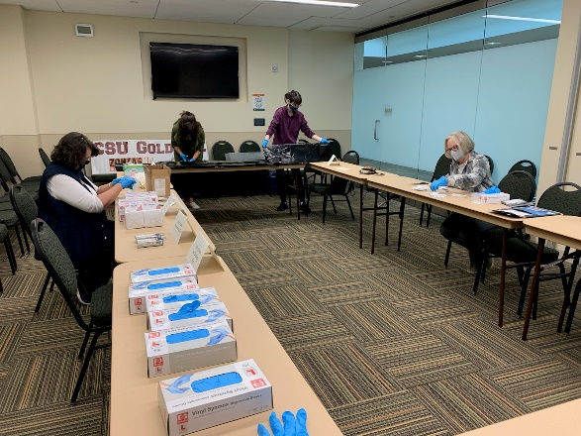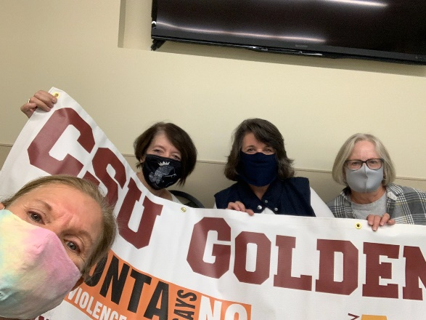

- Club members attended the Mayor’s Proclamation for domestic violence awareness alongside our partnership organization, Crossroads Safehouse. Both the Zonta Club of Fort Collins and Crossroads were recognized by the mayor.
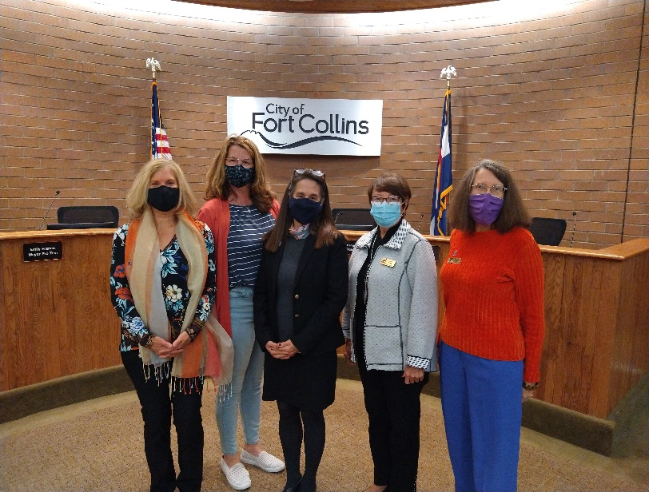

- To improve awareness of domestic violence and the work that we do with Zonta members engaged in creating an elevator speech to include domestic violence awareness and ‘about’ our club. We held a competition for the most speeches given.

- Members engaged in the Human Trafficking Webinar in October by the Colorado Springs Zonta Club

- During the 16 Days of Advocacy, we held a diaper and baby food drive for the Larimer Food Bank and Nappie Project. Both are housed in the same building. We collected 90 pounds of food and diapers.
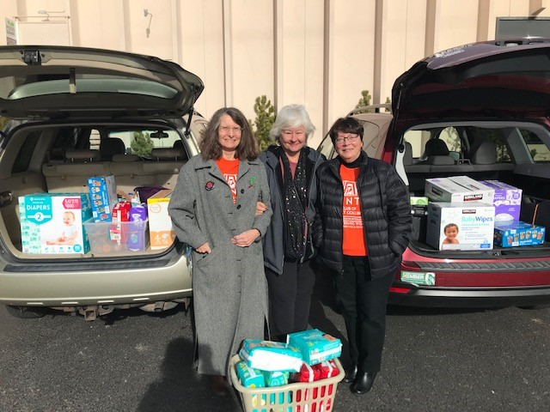

- The club President hosted a table at the Women Give luncheon. Women Give is a nonprofit arm of the United Way which provides scholarships and childcare opportunities for women. We filled a table with members and friends of Zonta. Many of our table mates donated to Women Give to support the great work that they are doing in our community.
- We added a Zonta Says NOW webpage to our website to bring awareness to climate change and gender equality in our community. It is a work in progress.
- Our Advocacy committee co-chair attended the advocacy meeting hosted by Denise Parish in February.
- For our club members we invited various guests as guest speakers during a few of the monthly meetings. We hosted Mark Door, former U.S. State Department employee who discussed human trafficking, Bridget Masters, who discussed membership, Julie Trone, who discussed climate change and gender equality, and Jeni Arndt, our city mayor, who discussed female leadership in our city and the pursuit of a cleaner, greener community.

Other Service Questions:

What like-minded organizations have you partnered with for service and/or advocacy? Please list and briefly describe how you partnered with them.

Fort Collins mayor, Jeni Arndt – she presented the Domestic Violence Awareness proclamation and was a guest speaker at a club meeting

Alternatives to Violence - They supported our ‘What Were You Wearing’ exhibit at Front Range Community college as the contact to gain approval for the exhibit by the University of Kansas, supplied us with brochures to display during the exhibit and hotline cards for the participating consignment shops in Loveland during Denim Day, April 27.

Crossroads Safehouse – We maintain an ongoing relationship with this domestic violence shelter in case of need.

SAVA (Sexual Assault Victims Advocates) – Similar to Alternatives to violence, SAVA supplied us with brochures and clothing donations for the What Were You Wearing exhibit and hotline cards for our participating consignments shops in Fort Collins during Denim Day, April 27

Living Her Legacy – We supported this nonprofit by attending various events for their donors and close partners. Our club supported this project until March 2021 when it became a stand-alone nonprofit organization. Our collaboration continues as we support each other’s efforts in bringing awareness of women’s issues to our community.

Z-Club or Golden Z-Club:
Does your club sponsor a Z Club? Yes No Does your club sponsor a Golden Z Club? Yes No
If yes, please describe key events held during the year.
The Golden Z club was advertised during the Colorado State University Club Fair where close to 40 students inquired about joining. The actual number of members was 5 and due to Covid and personal issues it lessened to 1 by the end of the spring semester.

Club activities included making birthing kits and regular monthly meetings. Unfortunately, the club membership dropped off greatly due to various factors like Covid, family emergency, and other issues.

Zonta International Scholarship Information:

- YWPA-Young Women in Public Affairs Awards

Did your club participate in the YWPA program? Yes No

Please list the name of the candidate(s) forwarded by your club to the district for this award.
No candidate for YWPA

- Jane M. Klausman Women-in-Business Scholarships (JMK)

Did your club participate in the Jane M Klausman program? Yes No
Please list the name of the candidate(s) forwarded by your club to the district for this award.
No candidate for JMK

- Amelia Earhart Fellowships
Did your club celebrate Amelia Earhart Day? Yes No
If yes, please describe how your club celebrated this year.
______________________________________________________________________________________________
______________________________________________________________________________________________

______________________________________________________________________________________________

- Women in Technology Scholarship (WIT)
Did your club participate in the Women in Technology program? Yes No
Please list the name of the candidate who received an award from your club.
______________________________________________________________________________________________
______________________________________________________________________________________________

Local Scholarship Information:
Local Scholarships awarded by your club
Name(s), description(s)and amount(s) of scholarship(s):

Our local scholarship:

Arlene Davey Scholarship for Single Moms returning to school - $1000 each

2021 Recipients*:

Iman Al Khafaji
Sarah Jensen
Elizabeth Post
Michelle Oberstar

*Each recipient is attending a different college/university.

Fundraising by the Foundation specifically for scholarships:
Donations $1696
On-line Auction $976
Sales of Gulley Cards (note the income is for FY20-21, but includes some card income from 19-20 and some from 20-21) $936

Total = $3608
________________________________________________________________________________________________
The advocacy information below will be used to determine the District Advocacy Award to be given out at the District 12 Conference.

Advocacy: The expression of support for or opposition to a cause, argument or proposal. Advocacy may include influencing laws, legislation, or attitudes. Zonta advocacy is an action taken in "the public interest" or for "the greater good" with respect to advancing the status of women and girls and their human rights.)

Does your club have an advocacy committee? Yes No

(Do Not Include Zonta Says No Activities Here - See Below)

Please name and describe your advocacy projects, including for each item:
(a) Category: improved the status of women in general (legal, political, economic, educational, health and/or professional) or helped prevent and fight violence against women and girls (VAW).
(b) How closely the project coincided with the advocacy definition above.
(c) % of club members involved in the project.
(d) Names of any community partners.
(e) Visibility and credibility to Zonta created by the project.

April 2022:
We offered two advocacy projects to the community during Sexual Assault Awareness month. Each one involved months of preplanning by our advocacy committee and enlisted the help of Zontians on event days.

- Category: Improve the status of women’s safety relating to sexual assault
Exhibit: What Were You Wearing
Exhibit location: Front Range Community College, Larimer Campus, Long’s Peak Student Center
60% of club members were involved with this project.

What Were You Wearing advocacy project explanation:
This project represents educational promotion to build awareness of assistance to sexual assault victims through an art exhibit. The reason is to debunk the myth that sexy clothing is the reason for sexual assault. As you can see from the photos the clothing represents gender equality. The paper on each of the dozen outfits are one line statements from the victim stating what he or she was wearing when the attack occurred. We chose statements (stories) and outfits that were visually relatable to the demographic, college student. The campus art department loaned student artwork to display that complemented the exhibit. Due to the sensitivity of the information and possible triggering of traumatic experiences this exhibit was shielded with curtains. At the entry a warning was posted to let viewers know that the subject matter can trigger trauma. The campus counseling office provided onsite counselors during the hours of operation (10 am until 4 pm) for any student needing support. It was open to the public. Tables of supportive written information to help victims was also available to the public.

The project began during the early winter the Advocacy Committee met with two of our partnership organizations to propose an exhibit called ‘What Were You Wearing’ to bring awareness about the myth that clothes attract sexual predators. It is an exhibit from the University of Kansas. Our partners include SAVA (Sexual Assault Victims Advocates) in Fort Collins, Alternatives to Violence in Loveland and the Front Range Community College committee ‘Bystander Intervention and Education’ (BIE). The BIE committee is part of the counseling team. It was a requirement of the University of Kansas to hold the exhibit on a campus.

Press release in North Forty News

At the end of the week, we moved ½ of the exhibit to the D12 Area 2 meeting to exhibit on Friday night and Saturday so other clubs attending could view and ask questions.

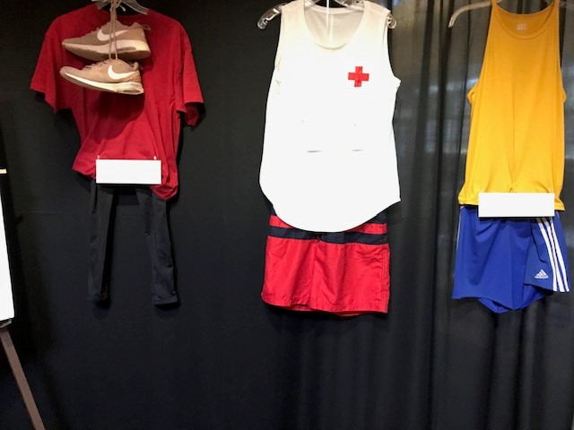

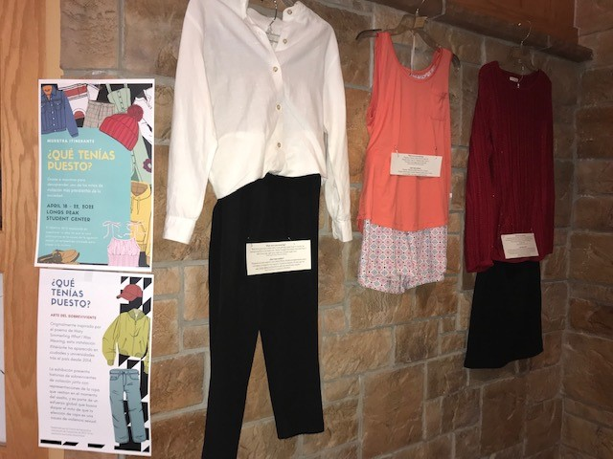

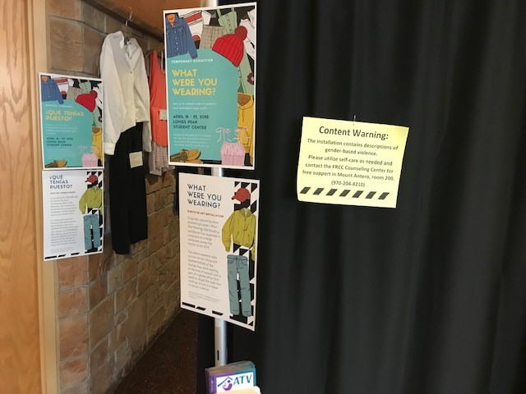 Note ‘Content Warning’

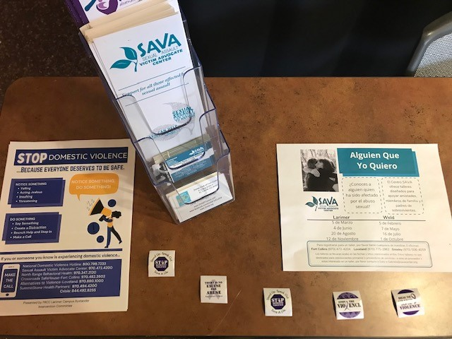 Example table resources

- Category: Improve the status of women’s safety
This project represents educational promotion to build awareness of help for sexual assault victims
50% of club members were involved in this project.

Denim Day advocacy project description:
The Advocacy committee created a new project for Denim Day, April 27, 2022, which is to contact local consignment shops to talk about Denim Day, encourage their staff wear denim, and receive permission to place sexual assault local hotline cards from SAVA and Alternatives to Violence at their register counters.

A total of nine consignment and boutique shops participated, six in Fort Collins and three in Loveland. The managers welcomed the idea which can serve both customers and staff members who may be victims of sexual violence. Our goal is to do this again next year.

This advocacy project served women, children and men in our community. Because nine stores participated we feel we were able to offer sexual assault victims assistance to diverse community. Those who shop at these stores represent a mix of economic levels, religions, gender identities, ages, and cultures. Staff in consignment shops were also encouraged to take supportive materials if they or someone they know needed help.

Photo of one of the Fort Collins participating stores where their staff wore denim:
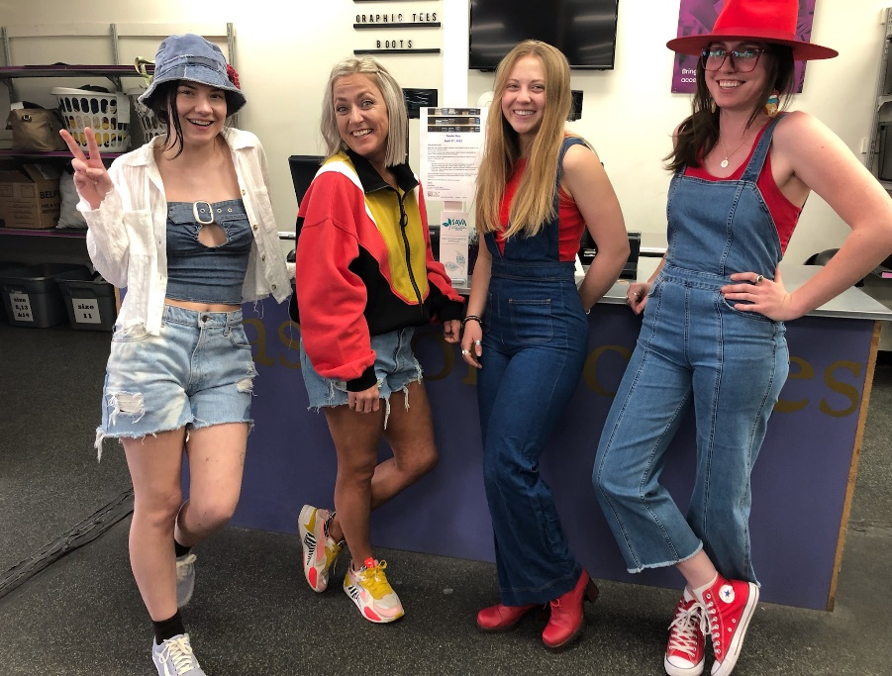 Denim Day 2022

In addition, our club honored Denim Day at the April meeting; see photo below. Every member present wore an article of clothing made from denim.

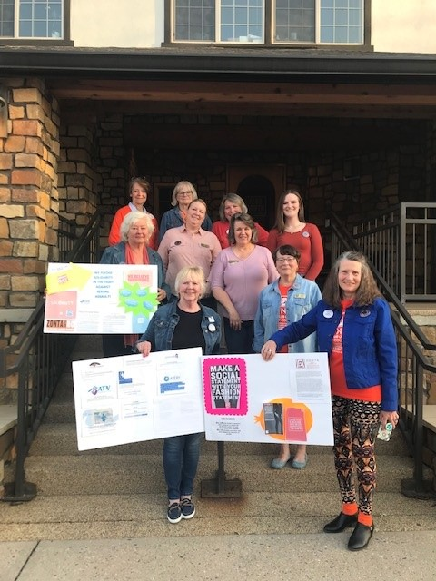
Zonta Says No:

Describe your club's Zonta Says No activities in 2021 - 2022.
70% of members and a few Friends of Zonta participated in this effort.

The Zonta Club of Fort Collins participated in a social media campaign during the 16 days of advocacy. We also ran a service project, a diaper and baby food drive, to provide more supplies to local women with infants and toddlers in our community who shop at the Larimer County Food Bank. We felt that supporting mothers with babies improves the lives of women and children. Relating to violence, being able to provide for the family sometimes serves as a filter to avoid domestic violence.

Zonta Says No diaper/baby food drive

Other Advocacy questions:

What women’s issues have been identified as the most important in your club?
Domestic and sexual violence, human trafficking, homelessness in our area, gender equality, and climate change

How have club members been made aware of legislation relevant to women in our country?
Yes, via the Zonta USA Caucus email stream Fast Action Friday, and directed by Governor Ann who sends state legislative action to the clubs. As a result of the D12 Action for Environment and Gender Equality committee work we receive notice also. Our club engages in social media platforms to encourage the public to act by supporting legislation that aligns with Zonta International both at the federal and state level.

Leadership & Leadership Development 2020-2021:

If your club conducted training for board members, committee chairs or members please describe.
We conducted an informal meeting for our new members to discuss the group. Two members worked individually with another member to train her to take a seat on the board.

What training opportunities / workshops have your club leaders and members participated in through ZI website, District 12 online, at Area Meetings or District Conferences?

The following are trainings and workshops attended by individual members. Some of the trainings and workshops were attended by multiple members.

District 12 Conference – Colorado Springs, Fall 2022
- Empower Women and your Club through Social Media workshop
- One member facilitated: ‘Managing Change: Surviving and Thriving in the midst of chaos’
- Leadership meetings (one member attended two meetings)
District 12 Advocacy Meeting – February 2022 with Denise Parrish

Area 2 meeting – April 2022 – One member is facilitating ‘Empowering You through Life’s Detours’

Area 3 meeting – January 2022 - Amelia Earhart Fellows presentation (attended by numerous members)

CSW66 Parallel Event – March 2022
- Zonta Says Now to Climate Action and Gender Equality
- Leading us into the future: Young Women’s Ideas for Climate
- Conversation on CEDAW
- The Women Collective
- ZI sponsored – Status on Ukrainian women

NGO CSW/NY –
- How Does the Climate Crisis Impact Peace and Security for Women and Youth
- Climate Change & Gender Equality
- Smog in the Air and in your Mind: A Look at the Climate Crisis and Mental Health in a Time of COVID

Zonta International –
- Remarkable Women Powerful Stories with Aviaja L. Hauptmann, Ph.D.
- Amelia Earhart presentation – ‘The Space Economy’
- Zonta Advocacy Series: Women in the Workplace

Miscellaneous trainings relevant to improving the lives of women and girls –
- Building Resilience for Women in Guatemala hosted by Namaste Direct Fundación
- COP26 presentations
- Southern Colorado Human Trafficking virtual meetings
- Public Health Perspectives on Sustainable Diets, Johns Hopkins University (summer 2021)

Does your club have a long range plan that includes succession planning for future leaders in club? Yes No
If yes, please describe (and provide copy to Governor and Area Director).

This is an area that is in development

Describe any leadership challenges and needs that could be addressed by training.

Our challenge has been inspiring our members to become leaders because many want to help not lead. Our club board is meeting prior to our annual planning retreat in June is focused on creating a plan to encourage leadership and membership.

United Nations:

Please describe how your club informed its membership of Zonta's work with the United Nations (i.e., CSW, Sustainable Development Goals, etc.)

Approximately 25% of our members listened to the NGO CSW66 Parallel events live. Approximately 70% of our members listened to the recorded presentation on Zonta Says NOW during the Parallel event. In January, Club President, Julie Trone, gave a presentation to provide information about Zonta’s work with the U.S. Women’s Caucus at the UN and their global and specific recommendations to improve the lives of women due to climate change and gender equality.

___________________________________________________________________-

External Communications/Public Relations:

Please check box for the PR tools your club uses:
Brochure Newsletter Club or Individual Business Cards Website Facebook
Information from ZI toolkits Other (describe)
_________________________________________________________________________________________________
_
Did the club submit a “Share your Story” through the Zonta International Website this year? Yes No
If yes, briefly describe.
We shared the exhibit project ‘What Were You Wearing’. This project took many months to plan along wiith many local partners and club members to curate. See more under ‘Advocacy’.

Internal Communications (e.g., club newsletter, directory, website):

Please describe how your club kept its membership informed & connected this year.

To keep our club members informed this year we continued to share social media posts, encouraged awareness of the most recent statement on climate change and gender equality by having discussions, and sent out email with relevant information such as; climate action, defending gender equality, legislation in our state, and human trafficking work that is done locally. The President of the club regularly sends email of upcoming events given by the district and Zonta International as well as local, state, and regional events that relate to our work.

Website:
Does your club have a club website Yes No Is it associated with the D12 website? Yes No
If no, what is your club website address? https://www.zontafcevent.com/
Is the information on your website updated regularly? Yes No
When did your club last update your website? January 2022

We have added a Zonta Says Now section to our webpage which will be updated again in 2022 to reflect our community action and build upon the educational aspect.

ZFW Ambassador:
Does your club have a Foundation ambassador? Yes No

Does your club give an annual donation to Zonta International Service Projects? Yes No

How has your club encouraged individual donations this year to ZFW? Please describe.

Each year we encourage donating to ZFW by individuals. We do not keep track of personal donations.

Archiving & History:

Does your club have an archivist/historian? Yes No Is your club history current? Yes No

Is your club history available on your website? Yes No

Does your club send items to the district 12 historian for archiving (e.g. Board and Club minutes, newsletters, etc.)
Yes No

Bylaws:
Are your bylaws up to date in accordance with Zonta International bylaws? Yes No

Successes, Achievements and Challenges:
What have been your club’s successes and achievements in 2021 - 2022?

With a small membership our successes are our robust service and advocacy projects, particularly the What Were You Wearing exhibit.

What have been your club’s challenges in 2021 - 2022?

Even though we have had seven women interested in becoming new members we have had the challenge of commitment. To date we have four new members yet our total membership is small.

How did you meet those challenges?

We decided to have a ‘New Z’s’ social which helped with getting to know potential new members and encouraging membership. During our annual retreat planning meeting in June 2022, we are going to have a workshop about membership and leadership. The membership portion will cover how every member can be recruiting and how to best recruit.

_
Are there specific areas for which your club needs help? Yes No
If yes, what areas?
Is there anything else your club would like to address?

This biennium our club has become incredibly interested in climate change and gender equality. It is with great appreciation to Governor Ann Hodgson that we have a robust district committee (AEGE) and are following the paths of the U.S. Women’s Caucus at the U.N. and Zonta Says Now. Our club President, Julie Trone, gave a presentation on Climate Change and Gender Equality and the work being done with the district committee. It was well attended by other Zontians in our district including Governor Ann, District Advocacy Chair Denise Parrish, and AEGE members. We are looking forward to creating community based advocacy plans addressing this issue next year and beyond.

Thank You!

