16 Days of Activism
Day 8
Globally, 21% of girls are married before they turn 18, robbing them of their childhood. Each year, another 12 million girls under the age of 18 are married around the world, even in the United States. In 2018, Delaware and New Jersey become the first U.S. states to outlaw child marriage without exceptions.

Child marriage is globally recognized as a human rights violation and a hindrance to national development. Evidence indicates that the practice of child marriage is closely associated with lower educational attainment, early pregnancies, intimate partner violence, maternal and child mortality, increased rates of sexually transmitted infections, intergenerational poverty, and the disempowerment of married girls. In committing to the Sustainable Development Goals (SDGs), the international community has vowed to end the practice of child marriage by 2030. Zonta International has actively supported ending child marriage since 2014 and continues its fight today, understanding that ending child marriage requires addressing, over a period of time, the complex sociocultural and structural factors underpinning the practice.

Research by UNICEF has found that, over the past decade, the proportion of young women globally who were married as children decreased by 15%, from nearly 1 in 4 to 1 in 5. This means that, over the last 10 years, the marriages of some 25 million girls have been averted. However, the harmful practice is still prevalent and affects 650 million girls and women around the world. UNICEF has also reported that the effort to change laws and cultural norms must continue at a faster pace, given that the global progress is not fast enough to achieve the SDG target of eliminating child marriage by 2030. What is equally important is that gains must not be lost.

What can you do to advocate for ending childhood marriage?

* Research the data relating to child marriage in your state or country and around the world. You may be surprised how many children are married each year in your community.
* Connect with organizations, such as Zonta International and Girls Not Brides, working to end child marriage.
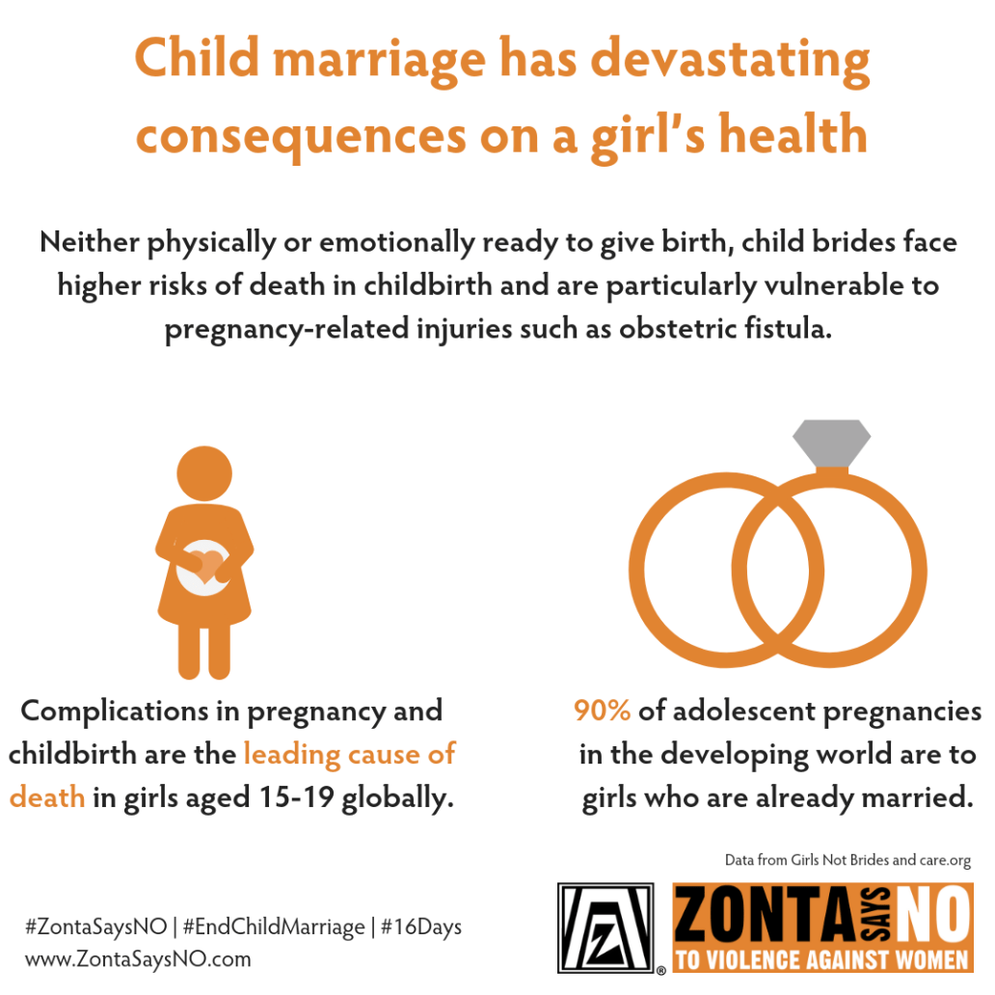
* Contact your local, state, and national governmental representatives and advocate for laws banning all forms of child marriage, without exception.

