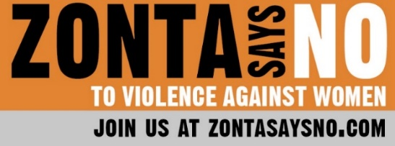
16 Days of Activism
Day 7
“Asking the question: ‘How many men raped women?’ rather than ‘How many women were raped?’ is much more likely to lead to actions that prevent rape, because it shines the spotlight in the direction of the source of the problem.”
Dr. Jackson Katz

Gender-based violence is a serious social problem that can only be fully addressed if men are involved in the discussion and the solution. Social norms of masculinity and gender norms imposed on men often contribute to gender-based violence. There is a growing number of men around the world showing men how to be allies and encouraging and inviting other men to get involved in the fight against gender-based violence. On November 30, 2021, Zonta International held an online summit to share how, as society, we can come together to say NO to violence against women and girls. One of the speakers at the summit was Dr. Jackson Katz, a pioneer in bringing men into the fight against gender-based violence. He has conducted extensive research and studies on the relationship between hyper-masculinity and gender-based violence and was one of the early architects of “bystander” approach to the prevention of gender-based violence. He is co-founder of
the multiracial, mixed-gender Mentors in Violence Prevention (MVP) program, one of the longest-running and most widely influential gender violence prevention programs in North America and beyond.

During the Zonta Summit, he explained how bystander training helps men and boys (and women and girls) to take a leadership role in showing that sexist attitudes and norms are not acceptable. Standing up to peers is often difficult, but if it is framed as a brave act, others may follow. His studies show that inviting men into the conversation can eliminate the “collective silence” and change the status quo.

Dr. Katz’s studies and other research has conclusively established that we need to get men onboard to fight gender-based violence, and we need to name and identify the causes of this violence. Male perpetrators of violence must be held accountable and brought to justice, but they also must be understood as people shaped by our patriarchal world. As Dr. Katz stated during the Summit, this change will not happen overnight, but we must keep up the fight. MVP Strategies lists 10 steps that men can take now to help prevent gender-based violence:

1. Approach sexual harassment and all forms of gender violence as a men’s issue involving men of all ages and socioeconomic, racial, and ethnic backgrounds. View men not only as perpetrators or possible offenders, but as empowered bystanders who can confront abusive peers.

2. Don’t remain silent. If a brother, friend, classmate, teammate, or colleague is abusing his female partner—or is disrespectful or abusive to girls and women in general —don’t look the other way. If you feel comfortable doing so, try to talk to him about it. Urge him to seek help. If you don’t know what to do, consult a trusted friend, parent, professor, or coworker. DON’T REMAIN SILENT.

3. Have the courage to look inward. Question your own attitudes. Don’t be defensive when something you do or say ends up hurting someone else. Try hard to understand how your own attitudes and actions might inadvertently perpetuate misogyny and violence, and work toward changing them.

4. Ask If You Can Help. If you suspect that a woman (or anyone else) close to you is being abused or has been sexually assaulted, gently ask if you can help.

5. Get help. If you are emotionally, psychologically, physically, or sexually abusive to women, or have been in the past, seek professional help NOW.

6. Join the cause. Be an ally to women who are working to end all forms of gender violence. Support the women whose courage and empowered voices have catalyzed the historic #MeToo and #TimesUp movements. Support Zonta International. Attend “Take Back the Night” rallies and other public events. Raise money for community-based rape crisis centers and battered women’s programs. If you belong to a team or fraternity, or another student group, organize a fundraiser.

7. Be an ally. Recognize and speak out against homophobia, gay-bashing, and violence against genderqueer and nonbinary people. Discrimination and violence against LGBTQ people are wrong in and of themselves. This abuse also has direct links to sexism (e.g. the “manhood” and sexual orientation of men who speak out against sexism are often questioned, a conscious or unconscious strategy intended to silence them. This is a key reason few men do so).

8. Educate yourself. Attend programs, take courses, watch films, TED talks, and YouTube videos, and read articles and books about multicultural masculinities, gender inequality, and the root causes of gender violence. Educate yourself and others about how larger social forces affect the conflicts between individual men and women.

9. Vote with your dollars and attention. Don’t fund misogyny. Refuse to consume misogynous porn, rent any video, subscribe to any website, or buy music that portrays girls or women in a sexually degrading or abusive manner. Speak out about cybersexism and misogynist attacks against women on social media such as Instagram, Snapchat, TikTok, Facebook, Twitter, Tumblr, Reddit, etc. Protest sexism in new and old media.

10. Mentor others. Mentor and teach boys and young men about how to be men in ways that don’t involve degrading or abusing girls and women (or anyone). Volunteer to work with gender violence prevention programs, including anti-sexist men’s programs. Lead by example.

We can all learn how to combat social norms and hyper-masculinity. Remember, gender-based violence is the enemy of gender equality.

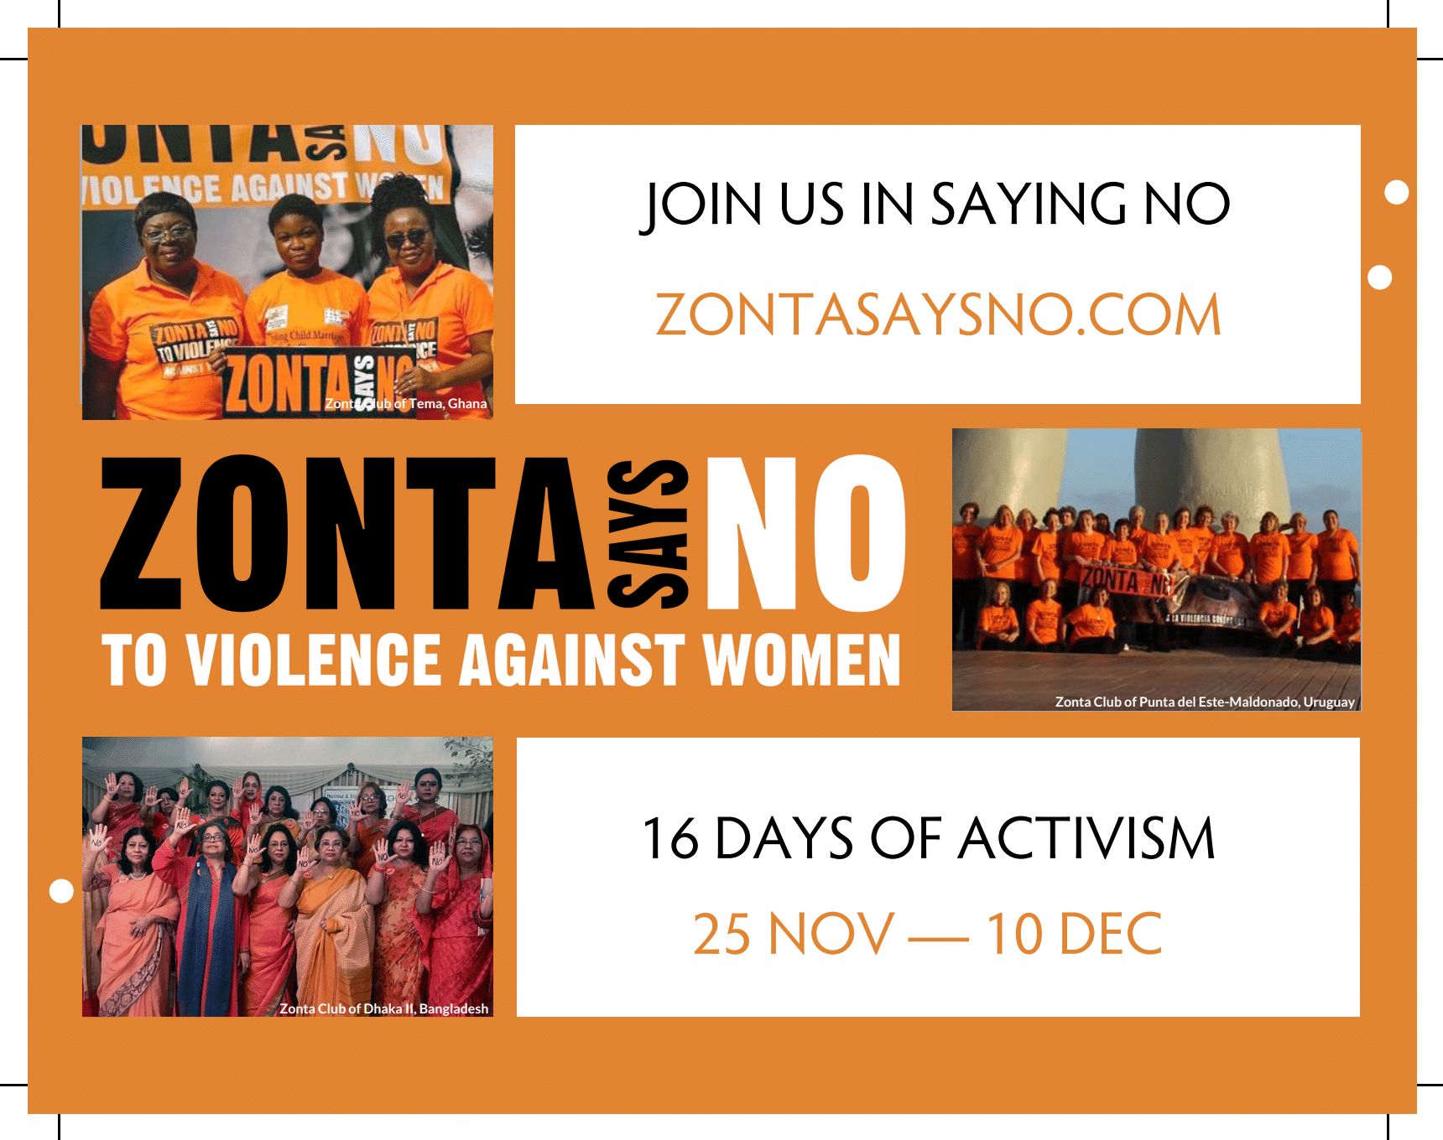
#ZontaSaysNO

