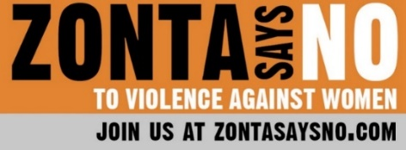
16 Days of Activism
Day 16
Today is International Human Rights Day, the last day of the 16 Days of Activism. Human Rights Day is observed every year on 10 December — the day in 1948 on which the United Nations General Assembly adopted the Universal Declaration of Human Rights (UDHR). The UDHR is a milestone document, which proclaims the inalienable rights that everyone is entitled to as a human being - regardless of race, color, religion, sex, language, political or other opinion, national or social origin, property, birth or other status.
"All Human, All Equal" is this year's slogan for Human Rights Day. The principles of equality and non-discrimination are at the heart of human rights. To achieve equality, we must first address and find solutions for deep-rooted forms of discrimination that have affected the most vulnerable people in societies, including women and girls, indigenous peoples, people of African descent, LGBTI people, migrants and people with disabilities, among others. Equality, inclusion and non-discrimination - a human rights-based approach to development -- is the best way to reduce inequalities.
We all need to take action to ensure EVERYONE has these rights, not just the privileged few. We need to demand fair and equal laws and policies. We need to support organizations that promote human rights. As Eleanor Roosevelt stated, “Where, after all, do universal human rights begin? In small places, close to home -- so close and so small that they cannot be seen on any maps of the world. [...] Unless these rights have meaning there, they have little meaning anywhere. Without concerted citizen action to uphold them close to home, we shall look in vain for progress in the larger world."
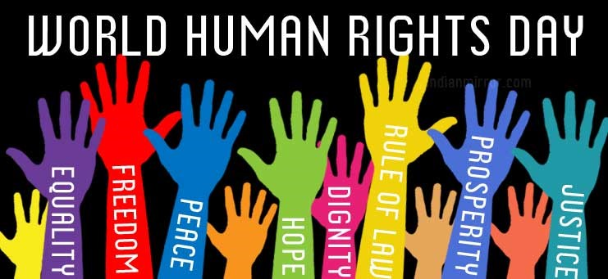
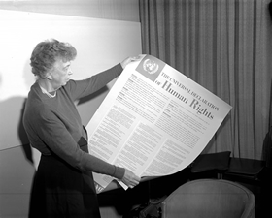
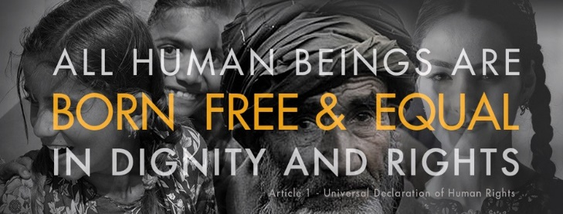
Take the time to reflect today on what you learned during the 16 Days of Activism and what changes you can make in the future reaffirm the importance of human rights in re-building the world we want and the need for global solidarity, as well as our interconnectedness and shared humanity.

