16 Days of Activism
Day 11

In 1995, Kimberly A. Collins wrote the poem, “Remember My Name,” in the hope that we will never forget the names or the lives of those lost to domestic violence. She also hoped that all those who have suffered loss resulting from gender-based violence continue to heal through shared connections and experiences and that everyone will remain committed to the efforts to end gender-based violence in our homes, families, and communities.

“REMEMBER MY NAME”
When you remember my walk upon this earth
Look not into my steps with pity.
When you taste the tears of my journey
Notice how they fill my foot prints
Not my spirit
For that remains with me.
My story must be told
Must remain in conscious memory
So my daughters won’t cry my tears
Or follow my tortured legacy.
Lovin’ is a tricky thing
If it doesn’t come from a healthy place,
If Lovin’ Doesn’t FIRST practice on self it will act like a stray bullet not caring what it hits
You may say:
Maybe I should’ve loved him a little less
Maybe I should’ve loved me a little more,
Maybe I should’ve not believed he’d never hit me again.
All those maybes will not bring me back– not right his wrong.
My life was not his to take.
As your eyes glance my name
Understand once I breathed
Walked
Loved
just like you.
I wish for all who glance my name
To know love turned fear – kept me there
Loved twisted to fear,
Kept me in a chokehold
Cut off my air
Blurred my vision I couldn’t see how to break free.
I shoulda told my family
I shoulda told my friends
I shoulda got that CPO
Before the police let him go
But all those shoulda’s can’t bring me back when I lied so well
To cover the shame
To hide the signs.
If my death had to show what love isn’t
If my death had to show that love shouldn’t hurt
If my death had to make sure another woman told a friend instead of holding it in
If my death reminds you how beautiful, how worthy you really are
If my death reminds you to honor all you are daily
Then remember my name
Shout it from the center of your soul
Wake me in my grave
Let ME know
My LIVING was not in vain.
By Kimberly A. Collins

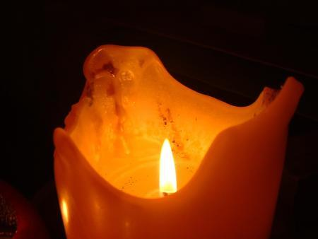
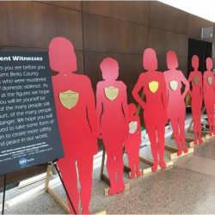
Whose name will you remember? Whose story will you tell?

