16 Days of Activism
Day 6
Today is Giving Tuesday, an international day of giving back; a day to give to charity and reflect how fortunate we really are. Right now, the world is marking Giving Tuesday a global generosity movement unleashing the power of people and organizations to transform their communities and the world. We all have something or someone for which we are thankful or about which we are truly passionate. It could be a cause, such as ending gender-based violence, or it could be a person who has been exceptionally kind, generous or supportive. When people are passionate about a cause, they are more likely to support that cause with money, time, or other tangible goods.

Statistics have shown that most people participate in Giving Tuesday in more than one way, with the majority of people giving back in non-financial ways. 37% of Giving Tuesday participants give time, goods, etc., 28% of participants give money, 35% did both. 52% of people participating in Giving Tuesday say that they are doing it because they want to be a part of something bigger, and it allows them to be part of larger group of people doing good.
No matter the reasons behind a donation of time and money, ultimately, making the world a better place requires generosity and a dedication to recognizing the important issues, formulating and setting goals, measuring impact, and gaining a better understanding of the problems that we are trying to solve. Take time to research organizations that support the causes about which you are passionate. Make your donation time and dollars count.
If you want to help end gender-based violence, give to reputable organizations that support equality, education for women and girls and programs and actions to stop the violence. On #GivingTuesday, donate to the Zonta Foundation for Women to support Zonta’s international service projects and help us end violence against women and girls (www.zonta.org/donate).
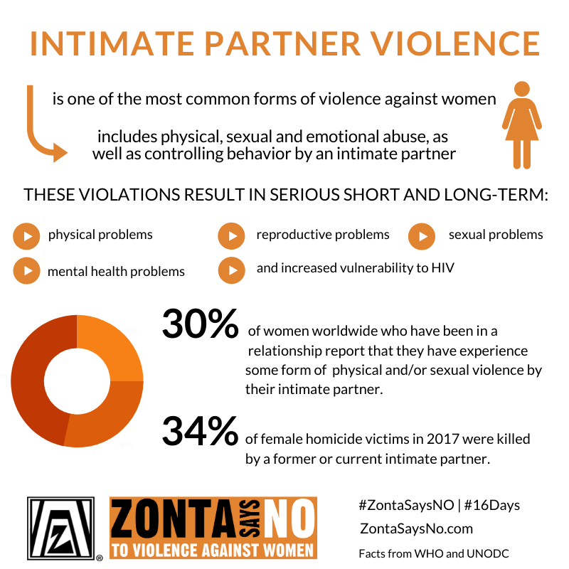
#ZontaSaysNO
