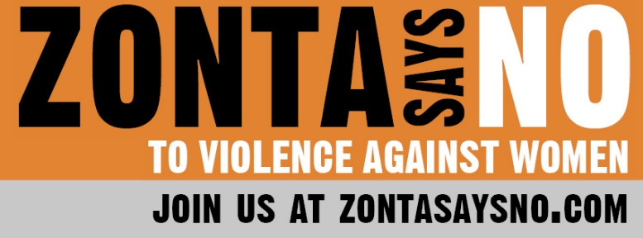
16 Days of Activism
Day 5

A world without violence is possible.
The time for change is now.

We all know someone lost to or a survivor of gender-based violence -- human trafficking, sexual assault, domestic violence, early childhood marriage or classified as a missing or murdered indigenous woman. Why have we not stopped these horrific crimes? With 1 in 3 women and girls worldwide still experiencing violence, the need for action is urgent. The time to act is now.

Wherever you are, take one simple action: Speak up. If you have experienced violence speak up about your own experience. Even if you have not personally experienced violence, speak up. Speak up when you hear someone's story of violence and ask what you can do to help and follow through. Speak up when you hear people joking about violence against women. It is not funny; it is a serious problem that involves basic human rights – the right to be free, safe, and respected. It affects everyone.

On this 5th day of the 16 Days of Activism Against Gender-Based Violence, let us remember those who have not been afforded the absolute rights guaranteed by the Declaration of Human Rights -- the right to life, liberty and security of person Who do you remember and honor today? The list is long. Let’s unite and stop the violence.

REDress Exhibit, bringing awareness to MMIW
