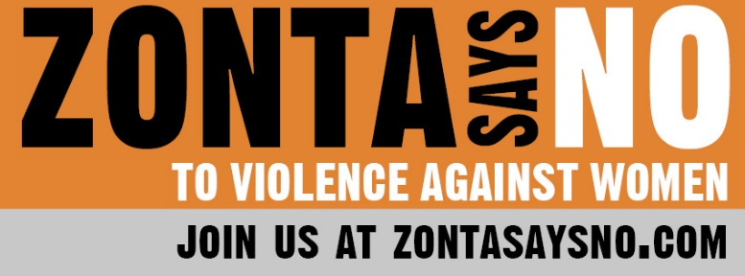
16 Days of Activism
Day 4

MMIW and MMIP are acronyms for Missing and murdered, Indigenous women and people. The acronyms grew out of a movement started in Canada as a result of extreme violence against Indigenous people and the lack of response by governmental authorities, the media, and the population as a whole. The movement has gained momentum, but the violence continues today.

Throughout history, Indigenous people have been disproportionately impacted by violence across the globe. The violence is not only an issue on reservations -- systemic issues persist in small towns, rural areas and large cities. The violence against indigenous women is everywhere and has been ignored for centuries. Today, 4 out of 5 Indigenous people have experienced violence, and Indigenous women are more likely to experience violence than any other demographic. Of those who have experienced violence, 97% of women and 90% of men had the violence perpetrated by a person who was not Indigenous. In North America, evidence shows that a disproportionate number of reported missing persons are Indigenous. The U.S. Department of Justice has estimated that Indigenous women are 2.5 times more likely to be victims of sexual assault when compared to the general population, with 1 in 3 indigenous women being a victim of sexual assault during her lifetime.

In response to this epidemic of violence, the #MMIW movement has drawn much-needed attention from law enforcement, legislators, and the general public. The #MMIW hashtag in social media has helped propel local and regional activism to a transnational scale. Unfortunately, however, we all may unknowingly, through inherent bias or failure to speak out against historic and continuing systematic injustices, be perpetuating the MMIW crisis. How can you become an ally of the #MMIW movement? Being a genuine ally involves a lot of self-reflection, education and listening. It means knowing that we are often coming from a position of power and privilege -- privilege was gained through unjust systems that marginalize Indigenous people. It is not enough to just show up in solidarity and speak out against the unjust system, we have to do what is within our power to dismantle that system and differentiate ourselves from the opponents of Indigenous rights. We have to change our own behaviors and be mindful that we are not contributing to keeping that system going. Remember, Indigenous groups do not need saviors to come in to fix everything on their behalf. They are leading the fight against the injustices they face, as allies we are there to follow their lead. Allies and advocates can:

- Use social media to spread the word about missing people. Those missing may be in the area from which they are missing or may have been transported across state or national boundaries. Share the photos that are posted on Facebook or other social media with all your contacts.

- Donate to families who are forced to search for their missing loved ones when governmental authorities are slow to start the process. They may need food, water and other supplies for those searching or to hire professionals with search dogs.

- Volunteer to search if someone is missing in your area and a community search is organized.

- Keep in contact with governmental authorities to let them know that laws must be passed and continually funded for education of government authorities and law enforcement, cooperation between jurisdictions, and assistance to families with missing persons.

- Raise awareness about MMIW issues in your community. Hold a walk or a community gathering with knowledgeable speakers.

Do what you can to help make a difference today.

