16 Days of Activism
Day 1

Today is the International Day Against Violence Against Women, the start of the 16 Days of Activism Against Gender-Based Violence. Zonta International and UN Women work non-stop around the clock, 365-days a year, to stop this senseless violence. For the next 16 Days, envision what you can do to help eradicate violence against women; envision a world in which no woman lives in fear of violence. Be the change we need in this world.

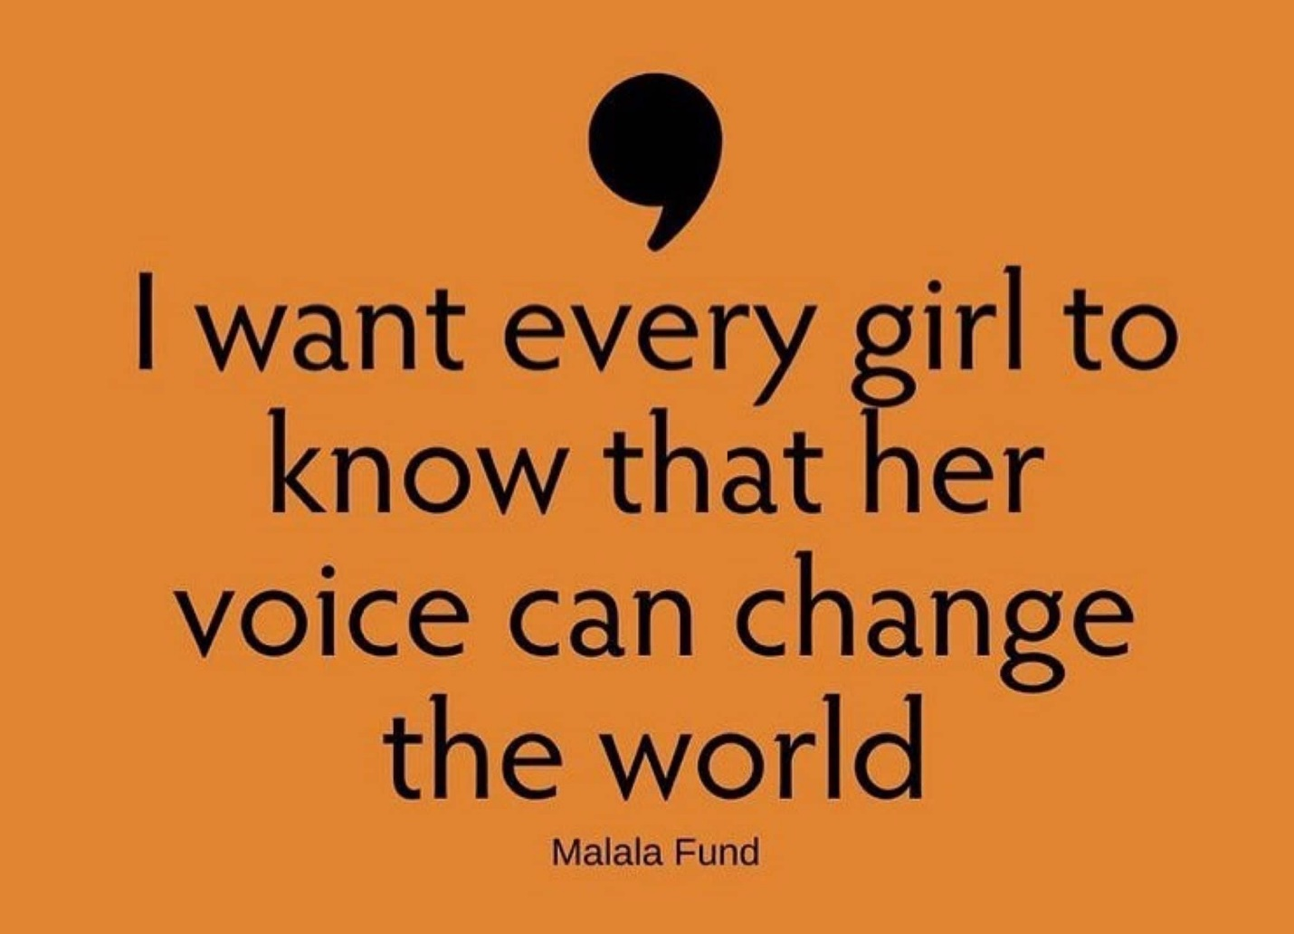

#ZontaSaysNo

