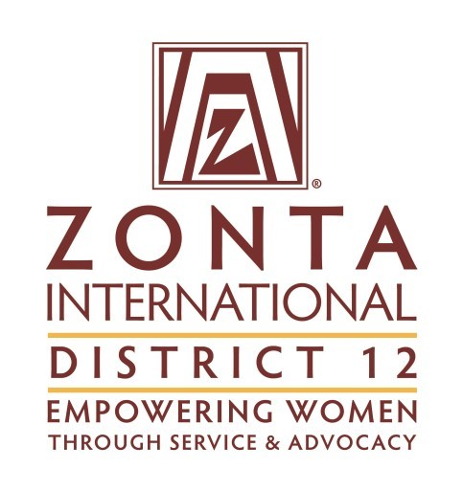
District 12 Rotation of District Conference,
Governor’s Seminar and Area Meetings
Updated 6/1/2021
Year | Governor’s Seminar | District Conferene
2012 | Area 3—Denver II
2013 |  | Area 4—Royal Gorge
2014 | Area 2—Cheyenne
2015 |  | Area 3—Foothills/Boulder County
2016 | Area1—Sturgis/Spearfish
2017 |  | Area 2—Ft. Collins and Greeley
2018 | Area 4—Prowers County
2019 |  | Area 1 — Billings
2020 | Area 2—Cheyenne
2021 |  | Area 4—Pikes Peak Area
2022 | Area 1—Pierre/Ft Pierre
2023 |  | Area 2—Laramie
2024 | Area 3—Douglas County
2025 |  | Area 3 Denver
2026 | Area 4—Royal Gorge
2027 |  | Area 1—Southern Black Hills
Area Meetings:
Area | 2019 |  | 2020 |  | 2021 |  | 2022
1 | Canceled—weather |  | Pierre/Ft Pierre |  | Black Hills |  | Billings
2 | Laramie |  | Greeley |  | Ft. Collins |  | Colorado North 40
3 | Denver |  | Denver II |  | Foothills |  | Foothills
4 | Pikes Peak Area |  | Powers Co. |  | Royal Gorge |  | Prowers Co
Area | 2023 | 2024 |  | 2025 |  | 2026
1 | Glendive | So. Black Hills |  | Spearfish |  | Pierre/Ft Pierre
2 | Cheyenne | Converse Co. |  | Laramie |  | Greeley
3 | Denver | Denver II |  | Foothills |  | Douglas Co.
4 | Pikes Peak Area | Royal Gorge |  | Prowers Co. |  | Pikes Peak Area

