Zonta International -- District 12
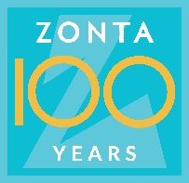
CLUB ANNUAL REPORT
Reporting Period: June 1, 2020—May 31, 2021

Please email to Governor Ann Hodgson (johnannhodgson@att.net) by May 15, 2021 with a copy to your Area Director.

Area 1 Director: Debbie Sundberg  (dsunnyone11@gmail.com) | Area 2 Director: Tasha Bauman (tlbauman84@gmail.com)
Area 3 Director: Deb Beatty  (debbeatty423@comcast.net) | Area 4 Director: Sonya Bergeron  (sjbergeron@comcast.net)

Club Administration 2020-2021:

Zonta Club of Fort Collins Today’s Date: May 1, 2021
Area: 2

President: Robyn Moore President-Elect (if appropriate): __________________
Vice President: Julie Trone Secretary: Judy Barth
Treasurer: Judy Barth

Incoming Club Officers 2021-2022:

President: Julie Trone President-Elect (if appropriate): __________________
Vice President: undecided at time of report disclosure Secretary: Judy Barth
Treasurer: Judy Barth
Board of Directors: Judy Barth, Julie Trone, Robyn Moore, Rhonda Bolich-Lampo, Karen Spruill

Vacancies are expected to be filled after filing this report.

Membership:

Please describe your club’s recruitment and retention efforts for 2020-2021. Including new member orientation and mentors.

The Membership Committee made their primary goal in 2020-2021 to support our current membership. We took a step back from our normal recruiting strategies to be contemplative considering the effects of COVID 19 and its deep and widespread shifts in the everyday lives of all of us. We felt we all needed to reflect more on our loved ones—the family dynamics and seeing those we love to change dramatically. We continued to remain available to those interested that we were currently in contact with and to those who contacted us.
It was a year to encourage our current membership to listen to one another and understand we all cope differently with the pandemic.
We wanted to ensure we listened to everyone and helped them through this difficult time and wanted to ensure we did safe projects such as:
- Delivering flowers to our membership on their birthday and keeping it a secret. The three membership committee members divided the list and started in August of 2020 and will continue through July 2021.

- Supporting a former club member who has endured significant issues in 2020
with the loss of her husband; loss of her sister; and she, herself, enduring a long
battle with cancer. Utilizing Sign Up Genius and with the help from club
members, we provided weekly dinners from September through January, including holiday meals;
provided transportation; sent cheerful cards; delivered birthday flowers, maintained ongoing contact, and visited in a COVID safe manner.

- Encouraged those who could not commit to joining due to personal reasons to be a Friend of Zonta (FOZ). Our FOZ program has begun to become more robust due to our continued efforts to reach out and have a conversation or invite them to join us to listen to our speaker series throughout the year.

- Coordinated with the Advocacy/Service Committee with new and continued events and projects to encourage FOZ and our members to engage and connect with each other, our club members, and the community.

- Worked to bring the outside in through obtaining a multitude of speakers to speak at selected annual meetings. This year our speakers included Training on the Logic Model for goal setting, speakers from the Colorado Adult Learner & Veteran Services; Crossroads Safehouse; Truckers Against Trafficking (TAT); and Sexual Assault Victim Advocate (SAVA) Center. Our club invited all of the district clubs to attend to hear Louie Greek from Truckers Against Trafficking. SAVA provided two aspects of their community work by providing us with two speakers, one to speak about advocacy and the other to speak on the topic of clinical therapeutic care. We invited some wellness classes from Front Range Community College to attend. We learned that our speaker series is interesting to many of our partners, community members and fellow district and area Zontians. We are going to continue to serve the community with our speaker series going forward. The response has been very positive.

- Book Club / Movie Critic Night was a concept from Membership that entailed two book club meetings and one movie critic night meeting through the course of the year. While not well attended by outside community members we are encouraged and inspired to continue this opportunity for membership building and retention. While the topics of the books and the movies from the Zonta Club of Denver LUNAFEST movie presentation were all aligned with Zonta’s mission and vision, which can be very difficult topics to discuss for some and especially during a pandemic, we found that it was a refreshing and casual event that was enjoyed by all who attended. We plan on continuing this endeavor.

Although recruitment efforts were difficult during the COVID pandemic our members maintained a new member who joined a few months before COVID occurred, a member transferred to our club, and there is another potential transfer member next year. New membership will grow next year with one confirmed new member and already two new possibilities. Two former members have informed us of their intent to rejoin in the fall.

Outside of the membership committee our club members have been working on recruitment by inviting others to look at our website, participate with virtual events and have preliminary meetings. There are at least two potential new members for 2021-2022 who fit this description.

How does your club measure membership satisfaction?

The membership committee and officers of the club reach out to members to inquire about satisfaction and create a plan for increasing satisfaction. Of the members who cannot renew due to other factors we have found very little evidence of dissatisfaction as the reason for leaving. Travel and relocation are the most common reasons that we lose members. The measurement is purely anecdotal. Using measurement tools, such as surveys, will be considered in the future.

Fundraising:

Please list the major fundraising events your club held during 2020-2021.
Fundraisers for 2020-2021:
- Bake-it-Forward Zonta Club of Fort Collins Easter bake sale - $200
- Copper Muse Distillery Zonta Club of Fort Collins week - $28.
- Rose Day – Sales of virtual roses netted $970.
- King Sooper Card Income $264.
- General donation $100
- District 12 Basket fundraiser $81
- Gulley’s Cards sales (for our local Arlene Davey Scholarship fund) – estimate $1360
- Anonymous Donor matching Gulley’s Cards sales profit - estimate $1360

Total Funds Raised this year: $4303*
*Estimated total by May 31, 2021

Local Service & Scholarships Dollars Given:
Please list the contribution amounts given by your club during 2020-2021.

Local Service Organizations: $300 Local Scholarships: $5000

Total Local: $5300

Zonta International Foundation (ZIF) Dollars Given:
Please list the total club & individual contributions given to the Zonta International Foundation during 2020-2021.
(Carol Leffler lefflergc@comcast.net can provide this information to you). ZI recommends that one third of the money your club raises be contributed to ZI to support the international service projects.

Total Club Contributions: $200 Total Individual Contributions: $110

Total Club & Individual Contributions: $310

The information below will be used to determine the District Service Award to be given out at the 2021 District 12 Conference.

Local Service: (Hands on work to help women & girls in the local community)

Please name and briefly describe your local service projects, including for each item:

(a) category: improved the status of women in general (legal, political, economic, educational, health and/or professional) or helped prevent and fight violence against women and girls (VAW).
(b) % of club members involved in the project.
(c) visibility and credibility to Zonta created by the project
(d) sustainability of the project (long lasting results, and could the project continue for a certain period of time)

For advocacy/service projects, we managed a positive volunteer effort in multiple effective ways such as utilizing social media platforms and individual porch deliveries for donations. After donations were raised, either one person or a few would deliver the donations while wearing masks and following social distancing recommendations.
The organizations greatly appreciated our donations, but with the downsizing and losing employees, they were less demonstrative with emails or letters. Social media platforms, newspaper articles, and photos were used to record our activities and events.

- The Nappie Project – Club members and our friends of Zonta donated 738 diapers and sent $200 in donations to this non-profit organization who distributes free of charge diapers to children in our local communities with 14 partner agencies. The Nappie Project is a non-profit in our community and surrounding communities which supplies diapers to children and their families to help the babies and toddlers remain healthy, clean and dry as well as removing the difficult decision of putting food on the table or purchasing diapers for families in need.

Quote from Jan Touslee, Founder of The Nappie Project, taken from the thank you letter our club received:
‘Thank you so much for your generosity to The Nappie Project! Please convey our gratitude to all of your members! The impact of COVID-19 will be with our families for a long time and now many are facing new challenges from the devastating fires, so please know that your gift is having an immediate, direct, and positive impact on the physical, emotional and financial health of babies and families in our communities’

  - Improved the status of women by providing diapers to their children free of charge ensuring that children have an adequate supply of diapers to remain clean, dry and healthy.
  - 100% of club members involved in project.
  - Visibility and credibility given to club by letter from the Founder of organization.
  - Project can be done annually.

- Days for Girls – Club members continued supporting DfG by utilizing porch drop off of needed supplies for menstrual kits at DfG Fort Collins Chapter leader’s home allowing for safer giving to an organization we have partnered with for 2 years. Days for Girls International provides menstrual kits and health education to communities globally. Zonta Club of Fort Collins members are providing time working on the projects, cash or gift card donations, and donations of needed supplies to the Fort Collins chapter. The DfG Chapter leader, Nancy Petolan, spoke at one of our meetings to fill us in on the work they do as well as attended our Truckers Against Trafficking special presentation.

  - Improved the status of women internationally by providing sewing supplies to the Fort Collins chapter team who is committed to advancing menstrual equity, health, dignity and opportunity to women and girls by providing menstrual kits, thereby “Transforming periods into pathways.”
  - 100% of club members involved in project.
  - Visibility and credibility given to club by phone call from charter leader to committee chair. DfG noted that 700 kits from their local FtCo team had been sent to Beirut after explosion, 600 bags were prepared for Nuevo Todo Santos, Guatemala, and masks were prepared with DfG supplies as a result of community donations.
  - Project can be done annually or semi-annually.

- Crossroads Safehouse – Club members and our friends of Zonta donated personal hygiene items that were desperately needed by this non-profit organization which provides advocacy, service and shelter to women and single parent (female) families who are victims of domestic violence. The hygiene items were noted by the organization as very needed. The club provided dozens of shampoos, conditioners, toothpastes, soaps and more to support their needs. Crossroads Safehouse, as well as domestic violence shelters around the globe, has seen an upsurge in domestic violence cases therefore our continued support to provide necessities has provided much financial and emotional relief to the sheltered victims at this location.
  - Improved the status of women and children’s health.
  - 100% of club members involved in project.
  - Visibility and credibility given to club by email from organization development director.
  - Project can continue periodically throughout the year.
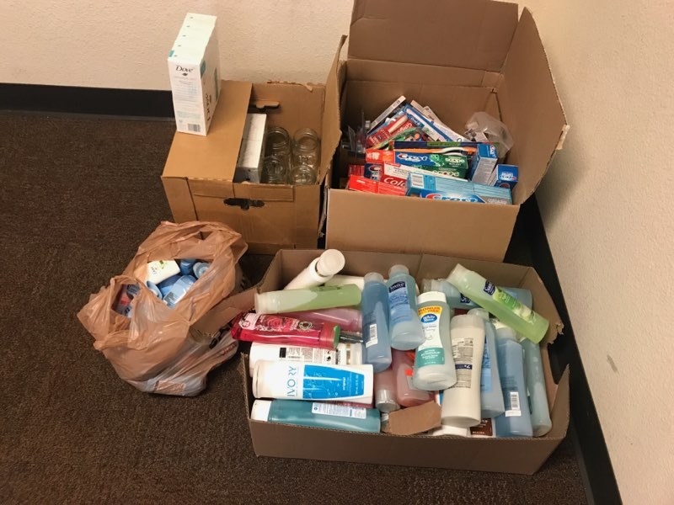

- Homeward Alliance – Here
  - Improved the status of individuals and families who face homelessness to survive move forward ad thrive
  - 100% of club members involved in project.
  - Visibility with photos and credibility with email to and from Distribution Coordinator. Photos attached.
  - Project has lasting results with blankets, coats and clothing donations. Project can continue during seasonal needs of the homeless.
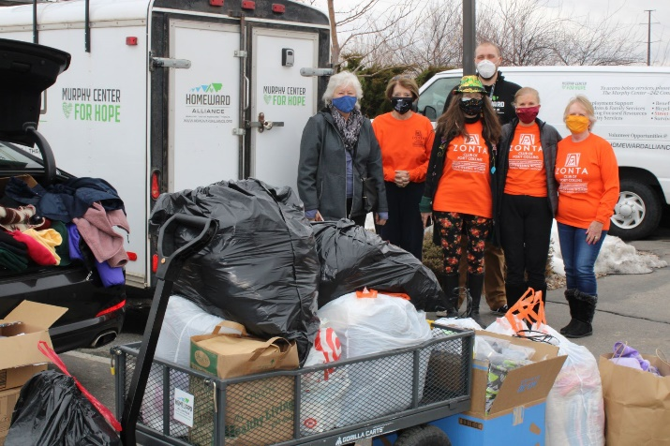

Other Service Questions:

What like-minded organizations have you partnered with for service and/or advocacy? Please list and briefly describe how you partnered with them.

- Alternatives to Violence – partnered with our club during a Live Facebook event in October for Domestic Violence Awareness month

- Ashley Doolittle Foundation - partnered with our club during a Live Facebook event in October for Domestic Violence Awareness month

- Bake-It-Forward – partnered as a fundraiser and one member assists in providing baking assistance

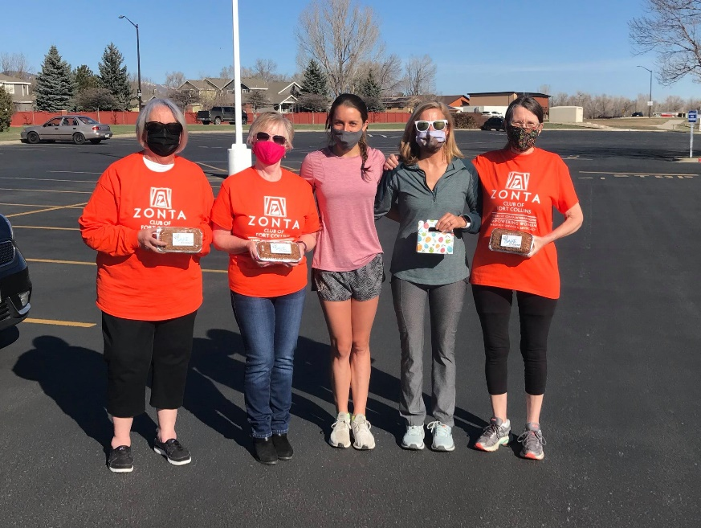

- Colorado State University – Adult Learner & Veteran’s Services – informational speaker presentation

- Crossroads Safehouse – long time partner to support service projects and advocate locally throughout the year. This year their Executive Director participated in our Live Facebook event

- Days for Girls Fort Collins Chapter – partnered with this organization to provide donations and created a drive for supplies

- Homeward Alliance – partnered with this organization to provide outerwear and socks for homeless children as well as join together on presentations such as their volunteer building presentation in April.

- Human Trafficking Task Force – Club members attended meetings and trainings throughout the year

- Front Range Anti-Trafficking - Club members attended meetings throughout the year

- Front Range Community College Foundation – Our club is partnering with this organization which provides a matching scholarship award to recipients of our local scholarship (Arlene Davey’s Scholarship award).

- Global Village Museum – continued partnership with this organization since 2019-2020 where our club curated an exhibit ‘Inspirational Women – Rising through Adversity’ and a special presentation in 2020 to honor the Zonta Centennial. This year our partnership maintained our community relationship so our club can consider partnering on future art presentations representing our mission and vision.

- Northern Colorado Human Trafficking Task Force – Club members maintained contact with this organization in preparation for the upcoming HT symposium. Our club has participated by renting a booth to promote Zonta over the past few years. With COVID – 19 the symposium was cancelled. Meetings were attended by club members.

- SAVA – Sexual Assault Victims Advocates – partnered with our club to provide information for our Live Facebook event in October and provided a special presentation from staff who work in Advocacy and Clinical Therapy. This event was opened up to some of our partners in the community as well as students in Wellness classes at Front Range Community College Department of Integrated Holistic Practices.

- Project Self-Sufficiency – Partner with this organization whose clients are single mothers in the community who are attending college. Our partnership includes annual conversations to encourage their clients to apply for scholarships and provide deadlines. Club members have also offered time to help with their own scholarship application evaluations.

- Truckers Against Trafficking – Special presentation by Louie Greek, former officer and partner in this Denver based organization. Our club invited all of our district clubs to attend the presentation. Close to thirty Zontians from around the district attended as well as a few members of our partnering organizations. Our club is pursuing educational and awareness building support for next year.

- Zonta Club of Denver – LUNAFEST fundraiser – Our club hosts a book club that is open to members and guests. The final meeting was a movie critic night with members attending and supporting LUNAFEST hosted by the Denver club.

- Zonta North Forty Club – Our club invited this club to attend human trafficking presentations as well as join our scheduled speaker series throughout the year.

Z-Club or Golden Z-Club:
Does your club sponsor a Z Club? Yes No Does your club sponsor a Golden Z Club? Yes No
If yes, please describe key events held during the year.

Due to the COVID pandemic we did not have any events this year. Our Golden Z Club members are students at Colorado State University which held most classes online during Fall 2020 and Spring 2021 semesters. All events on campus were also cancelled.

Zonta International Scholarship Information:

The pandemic caused an extremely difficult school year for all students everywhere. Many were unable to continue studies, many struggled, and others were able to complete one or two semesters online. This posed an incredibly challenging task to reach out for scholarship recipients. We contacted many of our local partners and community organizations throughout the year with these opportunities. Our club is expected to continue efforts and create new approaches to inspire young women to participate in these Zonta International scholarship programs.

- YWPA-Young Women in Public Affairs Awards

Did your club participate in the YWPA program? Yes No

- Jane M. Klausman Women-in-Business Scholarships (JMK)

Did your club participate in the Jane M Klausman program? Yes No

- Amelia Earhart Fellowships
Did your club celebrate Amelia Earhart Day? Yes No

- Women in Technology Scholarship (WIT)
Did your club participate in the Women in Technology program? Yes No

Local Scholarship Information:
Local Scholarships awarded by your club

Arlene Davy Memorial Scholarship:
Our club provides a local scholarship called ‘The Arlene Davey Memorial Scholarship’ to local single mothers. We maintain our partnerships with community organizations and the local colleges so their staff is aware of this opportunity and the logistics for providing scholarships. Over the past two years one of our college partners, Front Range Community College Larimer Campus, has awarded the recipient of our Arlene Davey Memorial Scholarship with a matching scholarship. The combination can provide a full semester of tuition. During 2020/21 our previous scholarship recipients (2019-20) were able to continue to attend online classes during the Covid pandemic despite some losing their source of income. Another casualty of the pandemic is our applicants are low in number although we are hopeful more arrive before the May 1 deadline.

Fundraising for local scholarships have come to our club via a fundraiser and cash donations. The former, fundraiser, is our annual Gulley’s cards (garden center in Fort Collins) sales. We sell the cards for their cash value and the garden center gives back to us 20%; i.e., $4 per card valued at $20. This year we had an anonymous donor matching the funds earned from this fundraiser. It has been our best year for sales earning close to $1400 for scholarships and a matching donation.

Name(s), description(s)and amount(s) of scholarship(s) Spring 2020:

We awarded 6 Arlene Davy Memorial Scholarships of $1,000 each in the 2020/2021 year. We had no applications for the other Zonta scholarships.

Front Range Community College:
- Portia Cook: Portia was a second year recipient of this scholarship. She was unable to enroll for the fall 2020, so her scholarship applied to spring and fall of 2021. Her goal is an associate of arts at FRCC then transfer to CSU to get a bachelor’s in media communications and Journalism.
- Iman Al Khafaji: Iman is pursuing a bachelor’s degree in nursing and taking classes at both UNC and Front Range. The BSN at FRCC is not yet accredited, so she has to take classes at UNC.
- Brisa Simmons: Brisa will get an Associates of Arts from FRCC and transfer to CSU and get a bachelor’s degree in accounting. She wants to be a CPA.
- Ashley Romance: Ashley wants to be a nurse and is enrolled in the BSN program at FRCC.

Iman, Brisa and Ashley each received the matching $1,000 from the FRCC Foundation.

Aims Community College:
- Latina McCoy: Latina’s goal is to receive an Associate in Science Ag Business and Psychology, then transfer to CSU to complete a Bachelor of Science in Horticultural Therapy. Would like to also get a master’s degree.

Adams State University:
- Rosa Padilla: Rosa was taking online classes with the goal of getting a MA Clinical Counselor. $1,000 was sent to the school, but never enrolled in the fall 2020 or spring 2021. Adams State returned the money to Zonta.

The advocacy information below will be used to determine the District Advocacy Award to be given out at the 2021 District 12 Conference.

Advocacy: The expression of support for or opposition to a cause, argument or proposal. Advocacy may include influencing laws, legislation, or attitudes. Zonta advocacy is an action taken in "the public interest" or for "the greater good" with respect to advancing the status of women and girls and their human rights.)

Does your club have an advocacy committee? Yes No

(Do Not Include Zonta Says No Activities Here - See Below)

Please name and describe your advocacy projects, including for each item:
(a) Category: improved the status of women in general (legal, political, economic, educational, health and/or professional) or helped prevent and fight violence against women and girls (VAW).
(b) How closely the project coincided with the advocacy definition above.
(c) % of club members involved in the project.
(d) Names of any community partners.
(e) Visibility and credibility to Zonta created by the project.

- Be Aware and Beware of Domestic Violence: This two hour Live Zonta Club of Fort Collins Facebook awareness and educational event was held October 24, 2020 for Domestic Violence Awareness Month. The live event hosted speakers including a member of the North Forty Zonta club, our current club President, a local college employee who works in disability services (which serves students traumatized by domestic violence, sexual assault and homelessness) and speakers from four of our local partner organizations who work exclusively with victims of domestic violence or sexual assault. Our live event attracted over 100 people. It was our first live Facebook event so there were some challenges however the event went smoothly.

  - Improves the status of women’s and girl’s health and safety in the community
  - Closely coincides with Zonta’s mission statement to build awareness to relieve women and girls of violent situations
  - 100% of club members were involved in this project from planning to execution to reporting
  - Alternatives to Violence, SAVA, Crossroads Safehouse, North Forty Zonta Club, and The Ashley Doolittle Foundation
  - Both the promotion of and the production of this event used Zonta branding, mission goals and its vision to provide education and build awareness in our local communities.

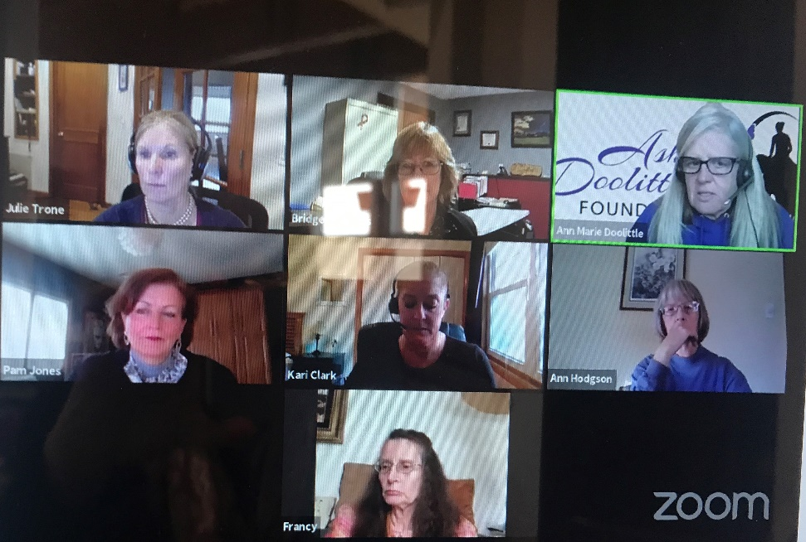 Screen shot of our Live Facebook event

- Donation of Human Trafficking survivor bags: Our club has been a provider of survivor bags for the local Fort Collins and Loveland police departments over the past four or more years. This year we were able to provide bags to Crossroads Safehouse. This partnering organization provides shelter and advocacy for victims (women and families) of domestic violence.

- Improves the status of women’s general health.
- Closely coincides with the Zonta advocacy mission statement.
- 100% of the club members were involved with the project
- Crossroads Safehouse
- Highly visible with the Crossroads staff and recipients. Executive Director, Pam Jones stated how thankful they are to our club for our generosity and support. Photos attached.

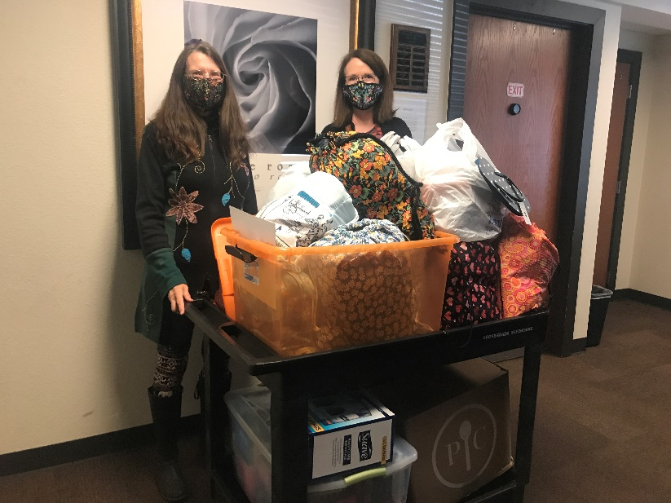 Delivering human trafficking survivor bags

- Donations supporting survivors of human trafficking: With another partnering organization, The Avery Center, which is a shelter and training center for victims of human trafficking in Colorado where they can temporarily live and learn through counseling and programs to become members of a community outside of human trafficking, we provided donations of both cash gifts and household items.

- Improves the status by supporting victims and survivors of human trafficking to find healing and empowerment. The Avery Center provides them with direct services including financial literacy classes, job training, support groups and access to basic needs.
- Closely coincides with the Zonta advocacy mission statement.
- 100% of the club members were involved with the project.
- The Avery Center
- Highly visible with the director of services, administrator of job center and executive administrator to the founder.

- Speaking engagement and presentation: In order to build awareness and provide more education to our local community and our district club partners we invited members from D12 clubs and local partners to attend our speaker series by Truckers Against Trafficking (TAT) and SAVA (Sexual Assault Victims Advocate Center). The former was very well attended. The efforts of TAT require community partnerships thus having many clubs represented at this presentation increased the likelihood of promoting and educating about human trafficking throughout Colorado and parts of Montana and Wyoming.

- Improves the status of women by educating communities and trainings with bus and truck services. This event was used as an awareness, educational platform on human trafficking.
- Closely coincides with the Zonta Advocacy mission statement.
- 100% of the club members were involved with the project.
- Truckers Against Trafficking
- Presentation was a successful event setup on Zoom. It was well attended by our Zonta club, District and Area 2 club members. Social Media helped in raising awareness and advertising the event. We had new prospective members reach out to us about this event from Facebook posts.

- Denim Day 2021: This recognition of female rape victims helps break the stigma that it does not matter what a woman or girl is wearing for a perpetrator to attack and rape. Our club members along with community members from Alternatives to Violence, Crossroads Safehouse and SAVA employees posed in denim on this day. The photos will be posted on social media as an awareness building campaign for April – Sexual Assault Awareness Month.

- Improves the status by providing awareness to sexual assault in our U.S. communities and the world.
- Closely coincides with the Zonta advocacy mission statement.
- 100% of the club members were involved with the project
- SAVA, Alternatives to Violence Safehouse, Crossroads Safehouse, Think Humanity, The Ashley Doolittle Foundation
- Highly visible using social media Facebook and Instagram to bring awareness and education to the forefront. Photos posted and story sent to Zonta International.

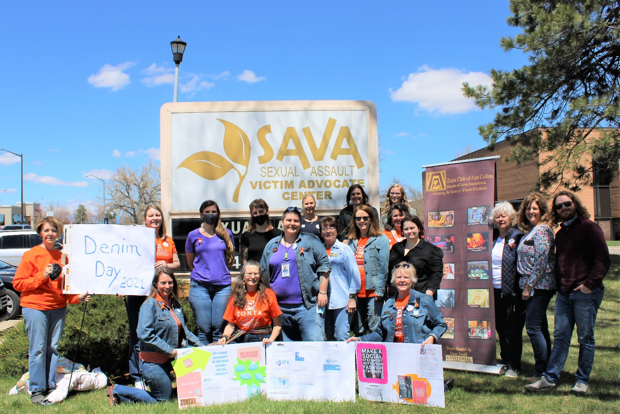
Building awareness on Denim Day 2021

- Department of Homeland Security Blue Campaign – Wear Blue Day represents building awareness of human trafficking in the USA and is held in January, National Human Trafficking Month. Members wore blue, took a selfie and posted on our social media platforms.

  - Improved the status of women and children who are potential human trafficking victims
  - 100% of club members were involved in this project.
  - Visibility and credibility of this project were illustrated by social media contact
  - This project continues annually during January.

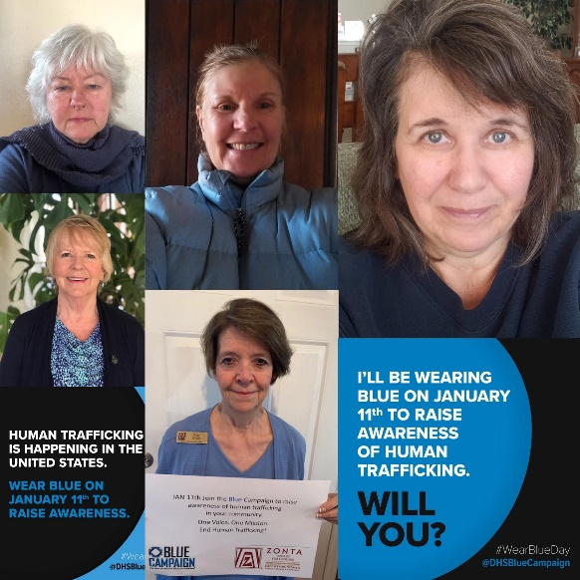 Zonta Club of Fort Collins members – Blue Campaign

Zonta Says No:

Describe your club's Zonta Says No activities in 2020 - 2021.

Zonta Says No media campaign: November 25th – December 10, 2020
Due to the pandemic limiting our club from physically going out into the community, we utilized the tool kit from Zonta International and Zonta Says NO sites to post flyers, statistics and information to post for 16 days on social media bringing awareness and education to the Zonta Says NO to Violence Against Women campaign.

We had each member hold up a sign at our November Zoom meeting and had a collage of everyone on the meeting where the signs came together stating “Zonta Says NO to Violence Against Men, Women and Girls”. We posted the collage photo on social media.

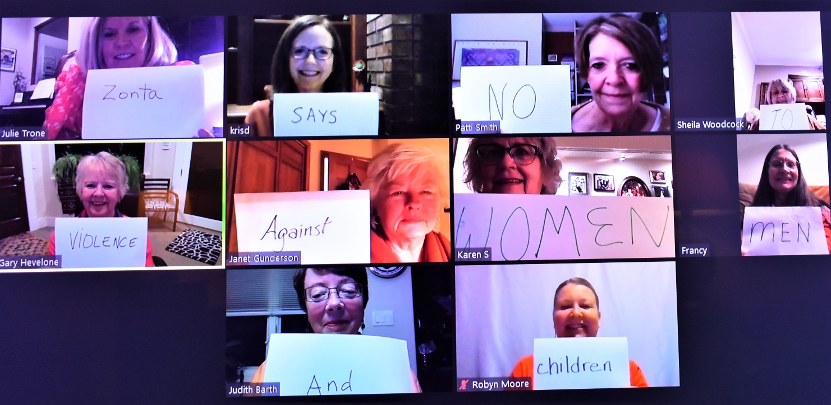

City Proclamation against gender violence: December 1, 2020 – Proclamation on “16 Days of Activism Against Gender Violence” was proclaimed by Mayor Wade Troxell, City of Fort Collins via online only presentation. Our club has participated in this proclamation for many years. This year we welcomed the North Forty Zonta club to join in the proclamation. Our Mayor held this event virtually due to the pandemic.

Other Advocacy questions:

What women’s issues have been identified as the most important in your club?

Gender Equality – for the past few years, our club has engaged in building awareness of gender based violence and the need for gender equality. We have supported the Women’s March by marching, the right to vote in 2019, and engaged with our community with events geared to learning about women’s issues.

Human Trafficking – This is both a local and global issue. Our Advocacy/Service Committee Chair spent nearly 100 hours attending trainings and meetings over the past year. She and club members have enthusiastically participated in events, created events, and partnered with organizations in the state of Colorado advocating to end human trafficking. Our club has built up more and more focus in this area through the past few years and are planning on continued support in this area next year.

How have club members been made aware of legislation relevant to women in our country?

Our club members are made aware of legislation through our Advocacy Chair and Committee members and by utilizing newsletters, websites and contacts. Utilized several entities for information on women and children’s rights, human trafficking, gender equality and ending child marriage. The sites below helped keep us informed:
Zonta USA Caucus, Zonta District 12, Zonta International, ACLU Colorado, Colorado Human Trafficking Council, Denver Anti-Trafficking Alliance, Human Trafficking Task Force of Southern Colorado, Front Range Anti-Trafficking Coalition, Unchained at Last

Leadership & Leadership Development 2020-2021:

If your club conducted training for board members, committee chairs or members please describe.

No formal club generated trainings occurred this year due to the COVID pandemic.

What training opportunities / workshops have your club leaders and members participated in through ZI website, District 12 online, at Area Meetings or District Conferences?

Various members took part in numerous trainings as follows.

- Zonta trainings:
- Convention 2020 Training
- Area Director Training
- Virtual CSW Training (multiple members included)
- Led training by one member ‘Managing Change’
- Attendance of the Area meetings (Areas 1, 2, 3, and 4)
- President’s training
- District Advocacy Training
- Retention Training
- CSW/UN Forum training pre-forum

- Related trainings from outside organizations:
- Introduction to Human Trafficking by Colorado Human Trafficking Council
- Public Awareness Human Trafficking 101 by Laboratory to Combat Human Trafficking (LCHT)
- Our incoming President enrolled in a 10-week certified Coursera course, ‘International Women’s Health and Human Rights’ taught by Anne Firth Murray at Stanford University
- Zoom meeting app training
- Training to produce a Live Facebook event
- Women Empowering Women Forum workshops by G.L.O.B.A.L. Justice, Loveland, CO

Does your club have a long range plan that includes succession planning for future leaders in club? Yes No
If yes, please describe (and provide copy to Governor and Area Director).

Describe any leadership challenges and needs that could be addressed by training.

The challenges that our club faces and would benefit from leadership training to become more comfortable with making presentations, becoming a committee chairperson or officer of the club. Our members are very active in hands-on event planning and execution, advocacy, service, and fundraising. In the upcoming year we plan on offering leadership training to create more confident leaders who can move into leadership positions with greater ease.

United Nations:

Please describe how your club informed its membership of Zonta's work with the United Nations (i.e., CSW, Sustainable Development Goals, etc.)

During a monthly meeting under ‘new business’ our club members learned of the UN/CSW Forum. Subsequently, members of our club registered for and participated in the UN/CSW Forum virtual event. We began to partner with some members of the UN Women of Fort Collins club in 2019 before the pandemic hit. Next year we plan on increasing awareness of CSW and the U.N. Women’s organization.

Some of our members have attended the live U.N. Forum in the past and are looking forward to attending a live forum; hopefully 2022.

___________________________________________________________________-

External Communications/Public Relations:

Please check box for the PR tools your club uses:
Brochure Newsletter Club or Individual Business Cards Website Facebook
Information from ZI toolkits Other (describe)

Additional external communications/public relations included Instagram (social media), Facebook (social media, and newspapers – The Coloradoan (Fort Collins and Windsor editions) and North Forty News. The Zonta Club of Fort Collins has also received external public relations on websites from partners in the community. For example, Think Humanity, a non-profit organization which provides education, advocacy and transportation means for the birthing kits our club provides each year with the help of local college and high school students. Our club is on their website: http://www.thinkhumanity.org/sponsors

Did the club submit a “Share your Story” through the Zonta International Website this year? Yes No
If yes, briefly describe.

We submitted a story about our October 2020 Live Facebook event ‘Be Aware and Beware of Domestic Violence’ and a story about our photo op event at SAVA for Denim Day, April 28th.

Internal Communications (e.g., club newsletter, directory, website):

Please describe how your club kept its membership informed & connected this year.

Our club hosted virtual meetings throughout the year. The meetings consisted of board meetings, club meetings, Foundation meetings, and committee meetings. We used email to connect throughout the year.
Website:
Does your club have a club website Yes No Is it associated with the D12 website? Yes No

If no, what is your club website address?_ http://www.zontafcevent.com/

Is the information on your website updated regularly? Yes No

When did your club last update your website? Our latest big update was January, 2021. Otherwise, we perform regular updates monthly or as needed.

ZFW Ambassador:
Does your club have a Foundation ambassador? Yes No

Does your club give an annual donation to Zonta International Service Projects? Yes No

How has your club encouraged individual donations this year to ZFW? Please describe.

Each year we remind everyone of the ZI service projects and verbally encourage members to donate. The Club also donates on behalf of each members a small amount of the money we raise through our fund raisers.

Archiving & History:

Does your club have an archivist/historian? Yes No Is your club history current? Yes No

Is your club history available on your website? Yes No

Does your club send items to the District 12 historian for archiving (e.g. Board and Club minutes, newsletters, etc.)
Yes No

Bylaws:
Are your bylaws up to date in accordance with Zonta International bylaws? Yes No

Successes, Achievements and Challenges:
What have been your club’s successes and achievements in 2020 - 2021?

Successes:
- Building community awareness during Domestic Violence Awareness Month, Sexual Assault Awareness Month and Human Trafficking Awareness month through virtual events and social media.

- Attracting new membership during a pandemic.

- Providing necessities to our local homeless population and local sheltered victims of domestic violence.

- Maintaining enthusiasm, drive, and participation in our meetings and events both regularly scheduled and impromptu events.

- Building a reputation for our club that we reach out to other clubs and include them in our programming or support their programming.

- Supporting a former Zontian who needed support while going through cancer treatment after losing her husband and sister to cancer.

- Updating our website with a more professional visual appearance – there is more to do but the result has driven more people with questions about our club.

- Building a stronger relationship with our local newspaper editors.

What have been your club’s challenges in 2020 - 2021?

- The absence of personal connection due to the pandemic.

- Delaying or cancelling live events or programs due to the pandemic.

- Not being able to have a Golden Z club

- Reaching out to students, who are learning virtually from home, about our scholarship opportunities.

- Virtual meetings. Some of our members who have electronics that do not fully support new meeting applications although they persevered successfully.

- Dues are not affordable to some current and possible members due to job and income loss due to the pandemic.

- We have heard our District leadership is interested in forming another new club within a 10 to 15 minute drive or within 10 miles from our club. This creates a membership conundrum the two clubs already sharing a 10 mile radius. The adjoining city, Loveland, is home to some of our current and potential members. To begin a new club within a 15 minute drive takes away from our ability to fundraise and attract members. We find this to be a great challenge for our club and don’t feel we have a voice in this decision making.

- Promotion to attract a more diverse population for membership. We feel it important for us to represent women, all women, and have not, as yet, become a diverse membership.

How did you meet those challenges?

- Affordability – we have begun a more robust ‘Friends of Zonta’ program to attract new members.

- Creating new clubs geographically close to other clubs – We have not had an opportunity to voice our opinion to our District representative about this issue but would like to engage in conversation.

- Diverse population – As a new tool for membership we are planning on connecting with our partners in the community and other community organizations to give presentations about Zonta. In 2019 we presented at a museum which yielded a new member and a closer partnership with the U.N. Women of Fort Collins club.

- Shared a story and successfully uploaded photos to the ZI website while writing this report.

- Pandemic related cancellations will resolve with the resolution of the pandemic.

Are there specific areas for which your club needs help? Yes No
If yes, what areas?

We request information about membership tools for creating a diverse population from other clubs which have done the same.

Is there anything else your club would like to address?

We are grateful for our local District and Area leaders for offering continued virtual opportunities for training and meetings. Our club co-hosted the Area 2 meeting this year with a Friday night virtual Trivia night and set up a special guest speaker for the Saturday meeting. The meeting went very well and yet, we are very much looking forward to meetings in person safely.

Thank You!

