Zonta International -- District 12
CLUB ANNUAL REPORT
Reporting Period: June 1, 2020—May 31, 2021

Please email to Governor Ann Hodgson (johnannhodgson@att.net) by May 15, 2021 with a copy to your Area Director.

Area 1 Director: Debbie Sundberg  (dsunnyone11@gmail.com) | Area 2 Director: Tasha Bauman (tlbauman84@gmail.com)
Area 3 Director: Deb Beatty  (debbeatty423@comcast.net) | Area 4 Director: Sonya Bergeron  (sjbergeron@comcast.net)

Club Administration 2020-2021:

Zonta Club of Cheyenne (Club # 0372) Today’s Date: May 14, 2021
Area: 2

President: Denise Parrish (2020-2022) President-Elect (if appropriate): N/A
Vice President: Dr. Michelle Aldrich (2020-2022) Secretary: Belinda Sawyer (2020 – 2022)
Treasurer: Kathy Cathcart (2020-2022)

Incoming Club Officers 2021-2022:

President: Denise Parrish (2020 – 2022) President-Elect (if appropriate): N/A
Vice President: Dr. Michelle Aldrich (2020-2022) Secretary: Belinda Sawyer (2020 – 2022)
Treasurer: Kathy Cathcart (2020-2022) (with Dasa Robertson in training for next biennium)
Board of Directors: In addition to the officers listed above, the elected directors are: Betty Abernethy (2020-2022), Ilaine Brown (2020-2022), Rebecca Reid (2021-2023), Audra Gagnon (2021-2023), and Kristy Williams (2021-2023)

Membership:

Please describe your club’s recruitment and retention efforts for 2020-2021. Including new member orientation and mentors.

The Membership Committee has been doing great work. At our last major fundraising event (in early March 2020) we received a list of names of people who were potentially interested in membership. The Membership Committee stayed in touch with these people throughout the pandemic (sending cards saying thinking of you, etc.). Then, when it was safe to do so, our membership committee held a series of small group meet-and-greets where people could meet a few current members and learn more about the Club. This drew in several new members.

The Membership Committee meets monthly (either video or in-person, as appropriate). It is our most active and functional committee. They are continually discussing ways to engage members and offering suggestions for the Club. Additionally, a calling subcommittee has been created where a few people call each of the Club members in advance of a meeting and remind them of the meeting and what is expected to be discussed. Furthermore, if a member is not at a Club meeting, a “we-missed-you” card is sent. Birthday cards are also sent to each Member during their birthday month.

We also have an informative, readable monthly newsletter that is emailed to each of the members informing them of upcoming activities.

We had a couple of purely social activities throughout the year which helped people get to know each other. One was an outdoor picnic in July and one was an on-line happy hour in December.

How does your club measure membership satisfaction?
Generally, we try to chat with a member when they leave or at least try to understand the reason they did not renew their membership(s). The Membership Committee developed an exit survey that is sent to each former member for whom we have contact information. We also try to take into account comments made at meetings or comments made to and shared with individual members.

Fundraising:

Please list the major fundraising events your club held during 2020-2021.

In July, 2020 and November, 2020, the Club sold Eileen’s Cookie Dough to raise some funds for the Club. We raised nearly $1,300 and about $700, respectively. These funds were put toward the operation and activities of the Club.

At our September, 2020 Club Meeting (held in-person), we held our annual Club Auction (where members donate and purchase goods and services). As a result of this auction, we raised about $240 which were put toward operation and activities of the Club, including setting aside funds to support members’ attendance at seminars and conferences.
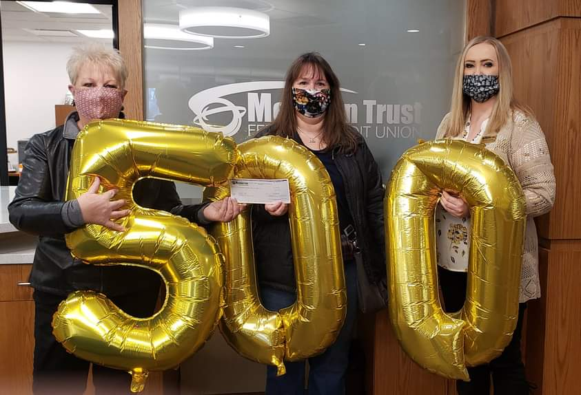
In January, 2021, Meridian Trust Federal Credit Union made a generous donation of $500 to the Club in support of our (Zonta’s) mission.

In January, 2021, the Zonta of Cheyenne Foundation applied for a $4,000 grant from the Laramie County Community Charitable Relief Program. (The program was funded from federal Covid-19 relief money.) Our application for $4,000 was granted. This amount was reimbursement, pursuant to the grant program, for a donation the Foundation had made to the Greater Cheyenne Covid-19 Emergency Relief Fund.

In February, the Club received a $25 donation from one of the local church women’s groups, as an honorarium for the speaker provided by the Club to discuss human trafficking. (More information provided in Service section of report.)

Total Funds Raised this year: Approximately $6,740 (Zonta Club of Cheyenne and Zonta of Cheyenne Foundation)

Post Annual Report Filing – The Zonta Club of Cheyenne is to be the beneficiary of a fundraiser put on by our local Black Tooth Brewery where a donation will be made for each pint of beer sold on May 20, 2021. The Club will also have an opportunity to distribute information about its mission during this fundraiser.

Local Service & Scholarships Dollars Given:
Please list the contribution amounts given by your club during 2020-2021.
Local Service Organizations:
Laramie County Library Foundation: $423.24 was donated for books to complete the D12 Service Project
Greater Cheyenne Covid-19 Emergency Relief Program: $4,000 was donated
Note: both of these donations were made by the Zonta of Cheyenne Foundation on behalf of the Club.

Local Scholarships:
YWPA Scholarship: $1,500 was awarded to Kylie Schelhaas.

JMK Women in Business: $1,000 was awarded to Keely Cleveland

Laramie County Community College Non-Traditional Student(s): About $500 each to Teri Meredith and Briana Moyte (funds come from earnings established at the college many years ago)

Women in Technology: Budgeted but none given in 2020

Women in Aviation / Women in Flight: New Scholarship being Developed by the Club to assist woman working to obtain her pilot’s license

Total Local: approximately $7,923

Zonta International Foundation (ZIF) Dollars Given:
Please list the total club & individual contributions given to the Zonta International Foundation during 2020-2021.
(Carol Leffler lefflergc@comcast.net can provide this information to you). ZI recommends that one third of the money your club raises be contributed to ZI to support the international service projects.

Total Club Contributions: $9,000** Total Individual Contributions: $1,432 (through April)

Total Club & Individual Contributions: $10,432

**NOTE: A check for $4,000 was mailed to the Zonta International Foundation for Women on May 4, 2021. That $4,000 has been added to the amount of $5,000 sent in June, 2020. This amount was from the Zonta of Cheyenne Foundation but was sent on behalf of the Cheyenne Club.

The information below will be used to determine the District Service Award to be given out at the 2021 District 12 Conference.

Local Service: (Hands on work to help women & girls in the local community)

Please name and briefly describe your local service projects, including for each item:

(a) category: improved the status of women in general (legal, political, economic, educational, health and/or professional) or helped prevent and fight violence against women and girls (VAW).
(b) % of club members involved in the project.
(c) visibility and credibility to Zonta created by the project
(d) sustainability of the project (long lasting results, and could the project continue for a certain period of time)

This year, partly because of Covid-19, our Club did a series of smaller, generally one-time service projects. In general, each project involved between 1 and 8 Zontians, with different people working on different projects.
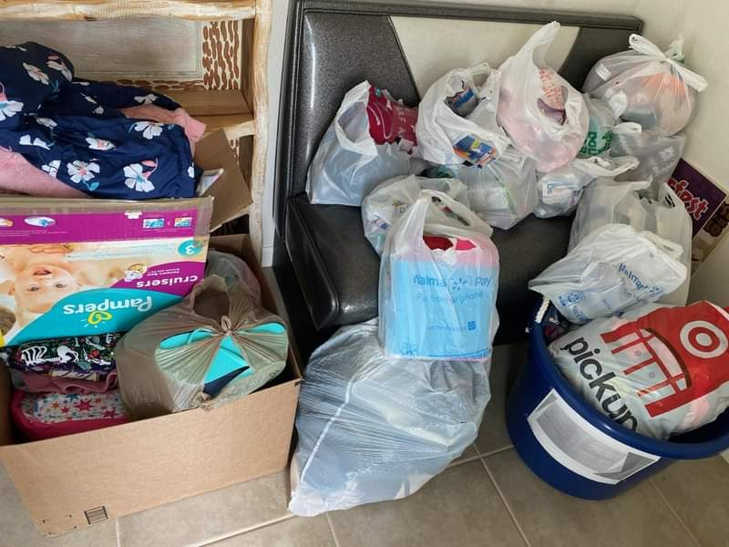
Hope Bags (On-going throughout the year)
For the past few years, including 2020 – 2021, our Club has gathered items to make and fill Hope Bags. These are backpacks filled with clean clothes and personal items given to the forensic nurses at the hospital and law enforcement agencies. The bags are distributed to victims of assault after their forensic exams so they may have clean clothes to go home after their clothes have been taken for evidence. 75% of the Club members either gave items for the bags, sewed bags, or helped stuff the bags. The Club also provided some children’s bags for victims of child abuse. We also involved the community by having boxes to gather items or money at various commercial establishments.

Awareness Wednesdays (January, February, March, April, May) – (Combined Community Service / Awareness as part of Advocacy)
In January, the Club began a new effort of hosting an on-line discussion, one Wednesday of each month, with each focused on a different topic and each with a guest speaker. These discussions are on-line with an open invitation for anyone to join the discussion. Several Zontians from other Clubs joined some of the conversations, especially when we focused on human trafficking. Two Zontians) were key in arranging the events, while participation has ranged from about 5 to 13 participants (including up to 25% of the Club members.) The topics have been:
January: Human Trafficking
February: Financial Abuse Within the Context of Domestic Violence
March: Arranged Marriage
April: Needs of Immigrants in the Community
May: Missing and Murdered Indigenous Women (upcoming at the time of this report)

Shatter the Silence Art Contest (March) – (Combined Community Service / Awareness as start of Advocacy)
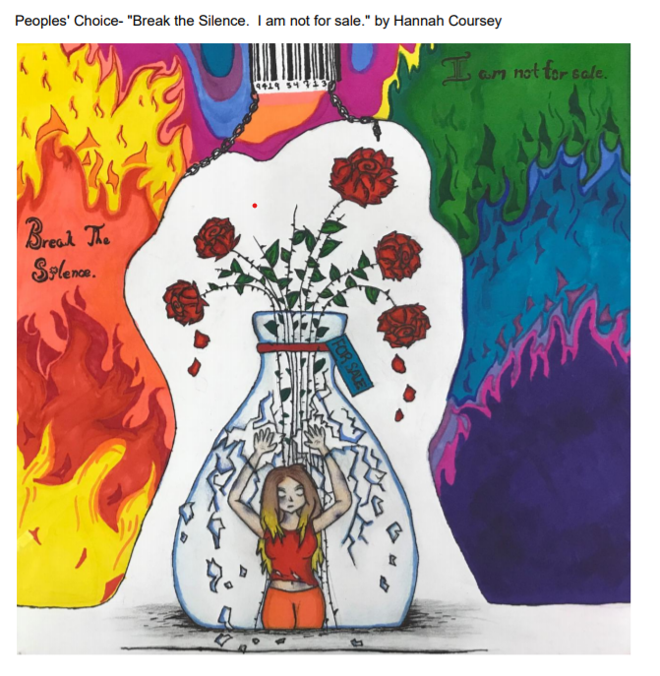
For several years, the Zonta Club of Cheyenne has hosted an art contest as part of its campaign to raise awareness about human trafficking. This year, the contest was broadened to the overall theme of Shatter the Silence, where artists were asked to focus on their impressions regarding human trafficking, interpersonal violence, and child marriage. Due to Covid-19 restrictions, the contest was also moved to on-line where it can be viewed at https://www.artsteps.com/view/6012f342ed395e191e620b36 or via the Zonta Club of Cheyenne website. Having the contest on-line allowed us to broaden our art viewing audience. Two of our Zontians were primary in promoting and operating the contest but many of the Club members were active in viewing the on-line gallery and voting for the people’s choice. (It is hard to know how many since it was on-line.) Through this project, Zonta is able to raise awareness about issues – and in particular, has made a point of including a prize category for younger artists in order to engage school children in the awareness campaign.

Water Station for Human Trafficking Awareness 5-K Run (August)
Each August, one of the churches in town holds a 5-K run to raise awareness about human trafficking. For the past few years, and again this year, our Club hosted a water station along the run route. We were able to help in the efforts to raise awareness and were able to speak to some of the church members about Zonta. About 15% of the Club members participated.

Prepared a Primer on Human Trafficking (August)
Due to its reputation in raising awareness about human trafficking in the community, our Club was contacted by a member of the local Kiwanis Club about putting together some basic material on human trafficking that could then be used to discuss with other Kiwanians the concept of making this a Kiwanis’ global project. This primer was prepared August, 2020 and was shared not only with Kiwanis but also with other Zonta advocates. This was the primary effort of one person (3% of the Club members).

Zontian made a Presentation on Human Trafficking to Church Women’s Group (February)
Again, given our prior efforts on human trafficking awareness, our Club was contacted by a Women’s Group at one of the local churches with questions about how much it really occurs in our community. One of our Zontians was familiar with some of the local statistics and offered to make a presentation to the group. Her presentation was well received and provided an opportunity to raised additional awareness about the issue.
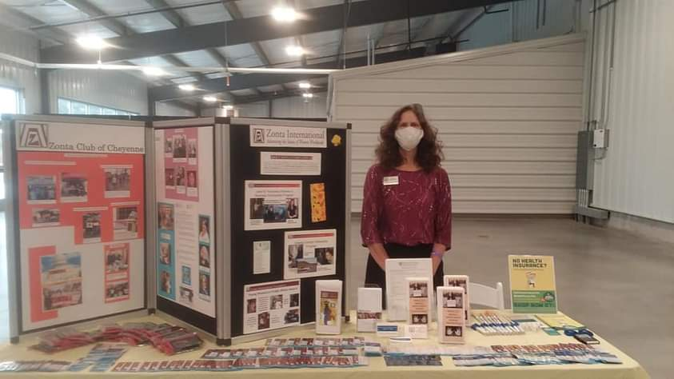
Hosted a Booth at Fundraiser for Laramie County Grief Support Group (January)
The second annual fundraiser was help to raise funds for the Laramie County Grief Support Group. Our Club was asked to participate by hosting a booth at the event. We were able to provide information about human trafficking as well as Zonta itself by participating in this event. Two Zontians hosted the booth (about 6% of the Club).

Blood Donation Contest (February)
For the second consecutive year, our Club participated in a contest where Zonta, Lions, Kiwanis, and Rotary Clubs competed to see which Club had the highest percentage of its member donate blood during February. While we did not win the contest 2-3 members of our Club did donate blood. This event provides an opportunity for Zonta to raise its profile within the community and to help people in need.

Speaking Engagement to Junior Leadership of Laramie County (February)
Our Club, along within several other service clubs in Cheyenne, was asked to speak on Volunteerism Day. This provided an opportunity to tell 8 high school students and one adult about Zonta’s work in the community and around the globe. One member of the Club spoke at the event and distributed spy-cam covers and Zonta literature to the participants.

Provided information about Zonta and Spy-Cam Covers to Financial Wellness Symposium (May)
Zonta was able to provide information about its mission and some spy-cam covers with the human trafficking hotline phone number to the organizers of a Financial Wellness Symposium being conducted by our local community college. The material was to be shared with about 40 participants of the symposium. Again, while not a hands-on service project, it did give Zonta some additional exposure to members of the community.

Other Service Questions:
What like-minded organizations have you partnered with for service and/or advocacy? Please list and briefly describe how you partnered with them.

We prepared a primer on Human Trafficking that was shared with the local Kiwanis Club. (See above for more info)

We worked on activities with a couple of the local churches to raise awareness about human trafficking. (See above)

We engaged in a blood drive contest with other service groups (Lions, Kiwanis, Rotary) in our community. (See above)

Z-Club or Golden Z-Club:
Does your club sponsor a Z Club? YES Does your club sponsor a Golden Z Club? NO
If yes, please describe key events held during the year.
We sponsored a Z-Club for the first half of the fiscal year at Triumph High School. This Z-Club disbanded mid-year when the last member of the Club graduated. We are in the process of starting a Community-wide Z-Club. We have begun the organizing meetings and hope to have the initial meeting of the Club sometime during the Summer of 2021.

Zonta International Scholarship Information:
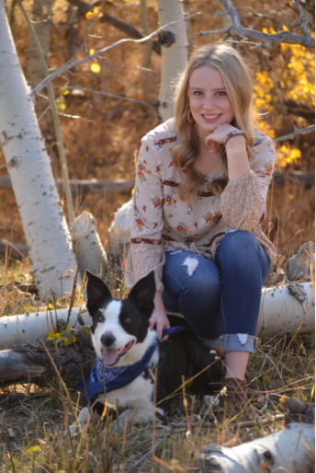
- YWPA-Young Women in Public Affairs Awards

Did your club participate in the YWPA program? YES

Please list the name of the candidate(s) forwarded by your club to the district for this award.

Kylie Schelhaas

- Jane M. Klausman Women-in-Business Scholarships (JMK)

Did your club participate in the Jane M Klausman program? YES
Please list the name of the candidate(s) forwarded by your club to the district for this award.

Keely Cleveland

- Amelia Earhart Fellowships
Did your club celebrate Amelia Earhart Day? YES
If yes, please describe how your club celebrated this year.
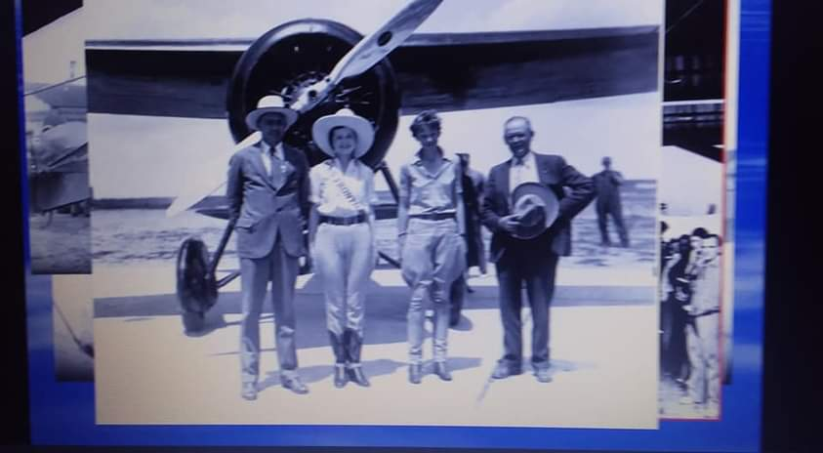
At our January Club on-line meeting, we had guest speaker Michael Kassel share stories about early flight in Wyoming. Mr. Kassel is the Curator of Collections and Co-Director of the Cheyenne Frontier Days Old West Museum and co-author of Wyoming’s Friendly Skies: Training America’s First Stewardesses. He provided an engaging presentation on early flight in Cheyenne including showing a picture of Amelia Earhart on a stop she made in Cheyenne.

- Women in Technology Scholarship (WIT)
Did your club participate in the Women in Technology program? YES
Please list the name of the candidate who received an award from your club.
Our Club has authorized a Women in Technology Scholarship (up to $2,000). No one was awarded the scholarship this past year – partly due to the confusion of changes in the scholarship at the Zonta International level. Whie Zonta has changed this scholarship to one offered only at the international level, the intention of the Club (at this time) is to still offer some sort of technology scholarship at the local level.

Local Scholarship Information:
Local Scholarships awarded by your club
Name(s), description(s)and amount(s) of scholarship(s):

Zonta of Cheyenne has a scholarship for a non-traditional student attending Laramie County Community College. The amount of this scholarship is around $1,000 although the amount may vary since it is based on the amount earned on an endowment. This past year, $500 each was given to Teri Meredith and Briana Moyte.

At the beginning of this fiscal year, the members of Zonta of Cheyenne authorized the concept of a Women in Flight / Women in Aviation type scholarship. This scholarship would be to help a woman with the cost of learning to fly an airplane. No scholarship was given this year, but members have been working out the details of qualifying for this scholarship and what the amount to be offered would be.

The advocacy information below will be used to determine the District Advocacy Award to be given out at the 2021 District 12 Conference.

Advocacy: The expression of support for or opposition to a cause, argument or proposal. Advocacy may include influencing laws, legislation, or attitudes. Zonta advocacy is an action taken in "the public interest" or for "the greater good" with respect to advancing the status of women and girls and their human rights.)

Does your club have an advocacy committee?
YES although the Committee has a very loose structure. We are in the process of formalizing more of our Advocacy discussions.

(Do Not Include Zonta Says No Activities Here - See Below)

Please name and describe your advocacy projects, including for each item:
(a) Category: improved the status of women in general (legal, political, economic, educational, health and/or professional) or helped prevent and fight violence against women and girls (VAW).
(b) How closely the project coincided with the advocacy definition above.
(c) % of club members involved in the project.
(d) Names of any community partners.
(e) Visibility and credibility to Zonta created by the project.

Improving the Status of Women in General (Combined Community Service / Awareness as Part of Advocacy)

Tracking Wyoming Legislation Session (February, March,)
A couple of members of our Club tracked the everchanging status of legislation of interest proposed during the Wyoming legislative session. While no one testified before the session on behalf of Zonta on any of the bills (many of which had to do with women’s reproductive rights), one of our members regularly sent out emails to the Club updating the status of the bills as they progressed, or died, during the legislative session. Two or three members of the Club actively tracked and involved themselves in watching the Wyoming legislature. (9% of the Club members)

Actively Advocating for Passage of the Equal Rights Amendment (January – April)
One of the Club members, writing as a Zontian, had a couple of opinion pieces published in two Wyoming newspapers advocating for passage of S.J.1 which would lift the ratification deadline imposed on the Equal Rights Amendment to the U.S. Constitution. In addition, one of our members was on call with the staff of Wyoming’s Senator Lummis, asking her to support S.J. 1. Furthermore, several of our members contacted their Senators, asking them to vote for women’s equal rights. It is estimated that 10-20% of the Club engaged in this activity.

Awareness Wednesdays (January, February, March, April, May)
In January, the Club began a new effort of hosting an on-line discussion, one Wednesday of each month, with each focused on a different topic and each with a guest speaker. These discussions are on-line with an open invitation for anyone to join the discussion. Several Zontians from other Clubs joined some of the conversations, especially when we focused on human trafficking. Two Zontians) were key in arranging the events, while participation has ranged from about 5 to 13 participants (including up to 25% of the Club members.) The topics have been:
January: Human Trafficking
February: Financial Abuse Within the Context of Domestic Violence
March: Arranged Marriage
April: Needs of Immigrants in the Community
May: Missing and Murdered Indigenous Women (upcoming at the time of this report)

Working to End Violence Against Women

Zonta Says No:

Describe your club's Zonta Says No activities in 2020 - 2021.
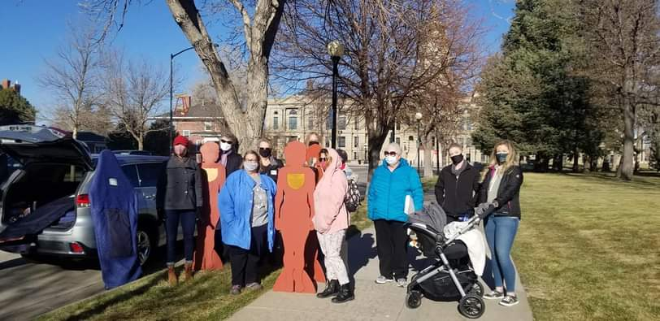
As we have for many years, our Club did a silent witness march during 16 Days of Activism. This included marching through downtown Cheyenne while carrying silhouettes of victims of domestic violence. The march ended at the public library where they stayed for a couple weeks with the stories of the victims – a location where the community can see them and understand the impact of the violence. Several members of the community joined in the event.
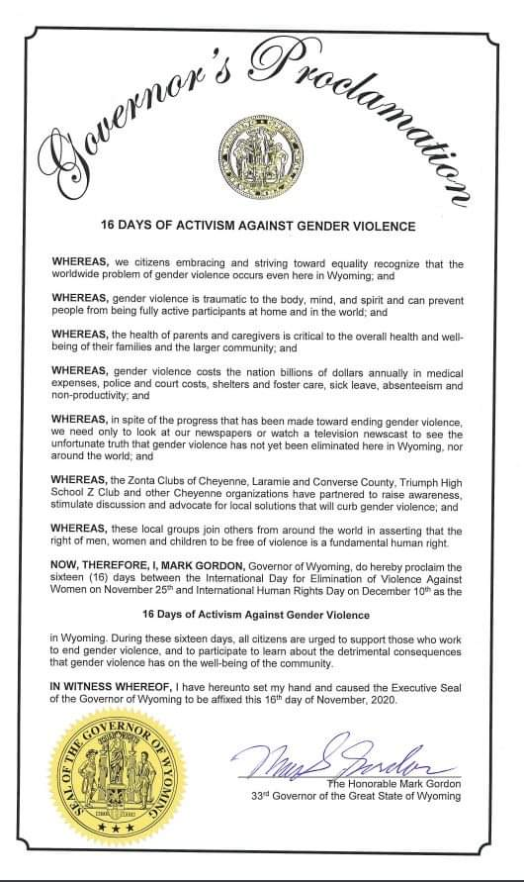
Wyoming’s Governor Gordon also signed a proclamation declaring the 16 days between November 25th and December 10th as the 16 Days of Activism Against Gender Violence. It is estimated that about 40% of the Club members attended the on-line signing ceremony with the Governor.

One of the members of the Club, writing as a Zontian, had an opinion piece published in the local paper, It’sTime to Break the Cycle of Domestic Violence. This was published during 16 Days of Activism.

Looking at all the steps involved in these activities, it is estimated that more than 50% of the Club members participated in these specific Zonta says No activities.

The Club has also begun to start getting organized to work on the recommended District 12 project of working to prevent violence against women by raising awareness about domestic violence in the community.

Other Advocacy questions:

What women’s issues have been identified as the most important in your club?

Preventing Violence Against Women
Ending Human Trafficking
Making the Equal Rights Amendment Part of the U.S. Constitution

How have club members been made aware of legislation relevant to women in our country?

Club members were specifically advised of the Zonta Advocacy USA Caucus’s website and Fast Action Friday during at least one of the regularly scheduled Club meetings.

Information about Fast Action Friday and signing up for notices of key issues was discussed at each of the 4 area meetings during 2021 during the District Advocacy presentation.

Leadership & Leadership Development 2020-2021:

If your club conducted training for board members, committee chairs or members please describe.

No specific training other than that offered by District 12 or Zonta International was offered. However, for the upcoming year, our Treasurer is having one of the Club members shadow her work and train as a Treasurer, anticipating she will step in as Treasurer in 2022 – 2023.

What training opportunities / workshops have your club leaders and members participated in through ZI website, District 12 online, at Area Meetings or District Conferences?

Two of our Club members offered training sessions through District 12: one on Advocacy and one on Succession Planning. Our Treasurer took the D12 Treasurer training. The President took the President’s Training, Succession Planning Training, and Women & Courage Leadership Training (each offered by D12) I am unaware of training others may have taken.

We had quite a few members – including newer members – attend the Governor’s Seminar, since it was held in Cheyenne. We had a handful of members attend the Area 2 meeting which was held on-line (but not as many as usual when the meeting is held in-person.)

Does your club have a long-range plan that includes succession planning for future leaders in club? No, not really.

If yes, please describe (and provide copy to Governor and Area Director). N/A

Describe any leadership challenges and needs that could be addressed by training.
None come to mine.

United Nations:

Please describe how your club informed its membership of Zonta's work with the United Nations (i.e., CSW, Sustainable Development Goals, etc.)

In October, there was a presentation at the Club’s on-line meeting about Zonta and the United Nations. It provided some background about Zonta’s status and the history of how the UN developed its offices to focus on women.

In our February newsletter, there was an article about the Commission on the Status of Women and how to register to be an advocate and how to participate. In March, at the Club’s on-line meeting, members were informed about the CSW and how to register as an advocate and participate in side and parallel events. The links for these matters were included on the written agenda provided by email to each member.

External Communications/Public Relations:

Please check box for the PR tools your club uses:
Brochure YES (We have a trifold that describes the Club that we give out at various events)

Newsletter YES/NO (We have a well-done monthly electronic newsletter that goes to members. It is not really used for the purposes of promotion)

Club or Individual Business Cards YES, we have business cards with the Club info, some individual members have created/printed their own cards (not done consistently as a Club)

Website YES, we have a website that we pay an outside firm (Jub-Jub) to update for us at our direction

Facebook YES, we have several members of the Club who are Administrators of our Facebook page and we try to post on a regular basis to our page (We have recently discussed opening an Instagram or other Social Media account for the Club)

Information from ZI toolkits NO, not yet

Other (describe)

We have a brochure about the signs of human trafficking that we distribute at a number of events. Our business card also includes the human trafficking hotline phone number on the back of it.

Did the club submit a “Share your Story” through the Zonta International Website this year? NO
If yes, briefly describe.

Internal Communications (e.g., club newsletter, directory, website):

Please describe how your club kept its membership informed & connected this year.
In terms of being connected, it was a difficult year. We had an outdoor picnic in July, 2020 which was nice as people could see each other and visit informally and socially. On-line visits didn’t seem to be as successful.

As to keeping the Club informed, we have a newsletter that come comes out (electronically) around the first of each month that contains a lot of information on upcoming (or recently past) events. Also, the monthly Club agenda always contains a section on upcoming event dates. The agenda is emailed out generally a day or so before the meeting.

We have a group of members who call others a day or two before each meeting to remind them of the upcoming Club meeting.

Website:
Does your club have a club website YES Is it associated with the D12 website? NO

If no, what is your club website address? https://www.cheyennezonta.org/

Is the information on your website updated regularly? YES (as needed – although it could use some review and updating)

When did your club last update your website? It is updated nearly every month to add events, post press releases, etc. We have a contract with a company named Jub-Jub who posts the updates that we provide. The biggest problem is that we add events and information without taking down some of the old, dated information.

ZFW Ambassador:
Does your club have a Foundation ambassador? YES. Our Foundation Ambassador was Karen Pacheco. However, Karen is taking a break from the Club and not renewing her membership for 2021-22, so a different member will need to take that role.

Does your club give an annual donation to Zonta International Service Projects? YES

How has your club encouraged individual donations this year to ZFW? Please describe.
At the November meeting, we included on our Club agenda a presentation from our UN Ambassador information about the Zonta Foundation for Women and the ZI Service Projects. We then encouraged individuals to give, and included the donate now web link on our agenda.

Also, early in the year, the Club President provided each member a piggy bank shaped like the world with the label Zonta International Foundation (before the name change of the Foundation). Members were encouraged to save up so we could collect the funds in November for Every Member, Every November. But, with Covid, we did not have an in-person meeting in November, so individuals were left to give on their own.

Archiving & History:
Does your club have an archivist/historian? YES, Linda Bogart. Is your club history current? YES (I think so)

Is your club history available on your website? YES, a basic history is on our website.

Does your club send items to the District 12 historian for archiving (e.g. Board and Club minutes, newsletters, etc.)
NO. However, we have informed the D12 historian of our process and she seems okay with it.

According to our retention policy, the following items are donated to the Wyoming State Archives after ten years: Minutes of the Board, Minutes of General Meetings, Minutes of Committee Meetings, Annual Reports, Membership and Officer Lists; Incorporation Documents, ByLaws, Special Project or Significant Activities Documents, Scrapbooks, Photos, Oral Histories, Newletters, Brochures, Other Publications, List of Presidents, List of Zontians of the Year, Written History of the Club. The documents are then accessible for viewing at the Wyoming Archives. Furthermore, our General Meeting Minutes, and much of the other information on the above list are included in our monthly newsletter which is available on our Club website for the past several years.

Bylaws:
Are your bylaws up to date in accordance with Zonta International bylaws? NO, but it is on our to-do list and is being actively reviewed.

Successes, Achievements and Challenges:
What have been your club’s successes and achievements in 2020 - 2021?
We have a phenomenal Membership Chair who faithfully holds a meeting each month and encourages people on her committee to engage in discussions and ideas. She also followed up with leads we had for new members, and has brought in a number of new members by staying in touch and follow-up. So far, we are net positive on membership, in spite of Covid-19 – although a few members who are taking a break will be sorely missed.

What have been your club’s challenges in 2020 - 2021?
It has been quite difficult to figure out how to carry out some of the advocacy items we discuss doing during times of social distancing and Covid restrictions and people’s nervousness. So many of the things we want to do seem to be matters that work best in-person. We do many things on Zoom but people just get tired of it. We have worked to find a balance, especially the past few months, between in-person and on-line activities.

Also, we had members who were ready to engage in specific activities and those who had ideas. But, getting people to organize and implement (especially during Covid) was sometimes difficult, so a lot of things just didn’t happen. This then became a challenge itself because there were members who thought we didn’t do enough for the mission or enough hands on that they became frustrated.

How did you meet those challenges?
Not well during this past year. However, we are taking what we learned and revamping our volunteer assignments. Rather than just asking for general volunteers on committees, we are going to break down the various tasks we do on our five main committees (Membership, Finance, Communications, Advocacy, Service) and make sure that each one of the activities has a lead person who knows they are in-charge of getting things done. We will work to have stronger committee leaders and make sure each person has one job to do and that they are empowered to do it.

We are also trying to find a balance for the Club meetings by having one month’s meeting on-line at noon and the alternative month’s meeting in-person in the evening. (Our in-person meetings will begin in May, 2021). We are trying to lock down a consistent place for our evening meetings rather than moving them all around the City.

Are there specific areas for which your club needs help? Not at the moment.
If yes, what areas?
Nothing specific comes to mind. We have lots of ideas for how to improve and what to do better. Actually implementing is the big problem. There never seems to be enough time or energy.

Is there anything else your club would to address?

Not at this time.

Thank You!

