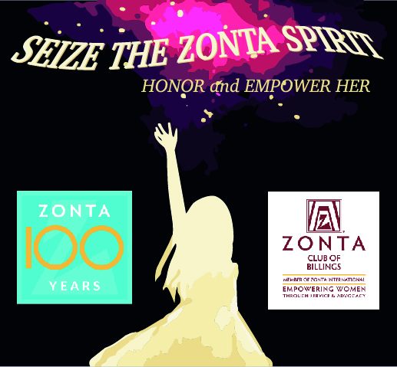

ZONTA INTERNATIONAL
CENTENNIAL
LIGHT UP THE NIGHT
Worldwide & In BILLINGS

Friday, November 8, 2019
5:30 – 8:00 pm
ROCKCREEK COFFEE ROASTERS &
At the BILLINGS SKYPOINT - Downtown

As we celebrate the ZONTA International Centennial
we invite you, your family and friends to
“Light Up the NIGHT” to celebrate all that is good in Billings.
We will be hosting a special gathering
With Cupcakes, Coffee, Live Music
and a Free tote bag for all.

*If you can’t join us please celebrate the GOOD in our
community by leaving on your Porch light
on November 8th*

ZONTA INTERNATIONAL
CENTENNIAL
LIGHT UP THE NIGHT
Worldwide & In BILLINGS

Friday, November 8, 2019
5:30 – 8:00 pm
ROCKCREEK COFFEE ROASTERS &
At the BILLINGS SKYPOINT - Downtown

As we celebrate the ZONTA International Centennial
we invite you and your family and friends to
“Light Up the NIGHT” to celebrate all that is good in Billings.
We will be hosting a special gathering
With Cupcakes, Coffee, Live Music
and a Free tote bag for all.

*If you can’t join us please celebrate the GOOD in our
community by leaving on your Porch light
on November 8th*

