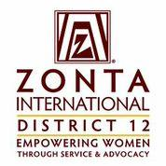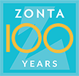
DISTRICT 12 CONFERENCE- Sept 20,21,22, 2019 – Billings Hotel & Convention Center
PLANNING COMMITTEE: Debbie Sundberg, Kelly Christy, Renee Coppock, AnnMarie Wade,
Anna Brewer, Ann Hefenieder, Debbie Willis, Connie Camino,
Kathie Riggs, Ginnie Burgess, Stella Fong, Twyla Best, Lara Guercio,
Melanie Tripp, Janet Sharon
THEME
Soar from the Past into the Future with ZONTA

ZONTA Soars from the PAST to the FUTURE

ZONTA Zoars from the PAZT to the FUTURE

Embrace the Past for Empowerment in the FUTURE

Embracing Zonta’s Past to Empower our FUTURE

ZONTA – EMBRACE the PAST – EMPOWER the FUTURE

ZONTA – EMBRACE the PAST for FUTURE Empowerment

Empower and Honor

Catch the ZONTA Spirit – Honor and Empower

Onward and Upward with ZONTA

ZONTA Onward and Upward

______________________________________________________
______________________________________________________
______________________________________________________
______________________________________________________
______________________________________________________
______________________________________________________
______________________________________________________
______________________________________________________

