

**Zonta Leadership Opportunities**

Hey! Zonta Member! What’s next?  Have you thought of Zonta as a resume builder? A leadership learning opportunity?  Zonta *indisputably* can be.

Opportunities abound in leadership positions at the Club, District and International level.

Before you answer the question:

* “Will you join our club Board?” “Will you be our club President, Vice President, Treasurer, Secretary?”
* “Will you accept a nomination for a District level role of Secretary, Treasurer, Vice Area Director, Area Director, Committee Chair, Vice Governor, Governor?”
* “Will you accept an International nomination?”  Come learn about what is expected and the support that will be there to help you succeed!

Then, you don’t wait for someone to ask!  You volunteer!

What keeps you from offering to lead?

What should you consider regarding your personal responsibilities?

What should you consider regarding your professional responsibilities?

<https://www.zonta.org/Web/My_Zonta/Governance/Manuals>

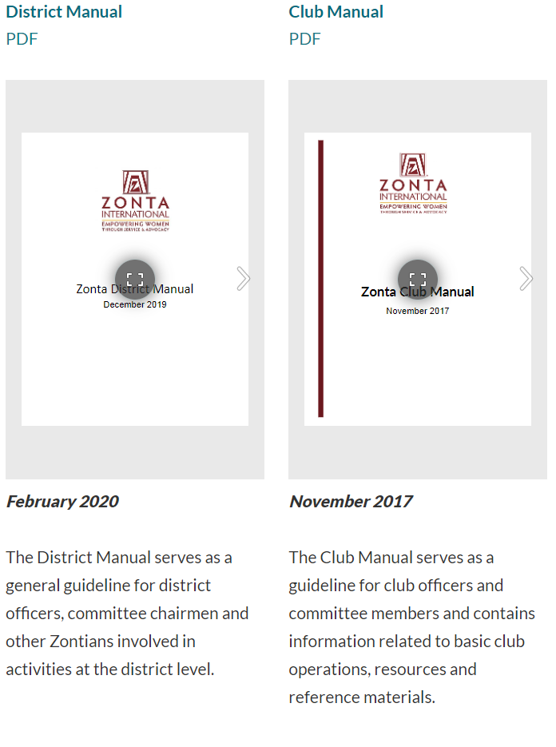

<https://www.zonta.org/Web/My_Zonta/Tools/Leadership%20Development%20Tools%20Home#ZontaLeadershipProgram>

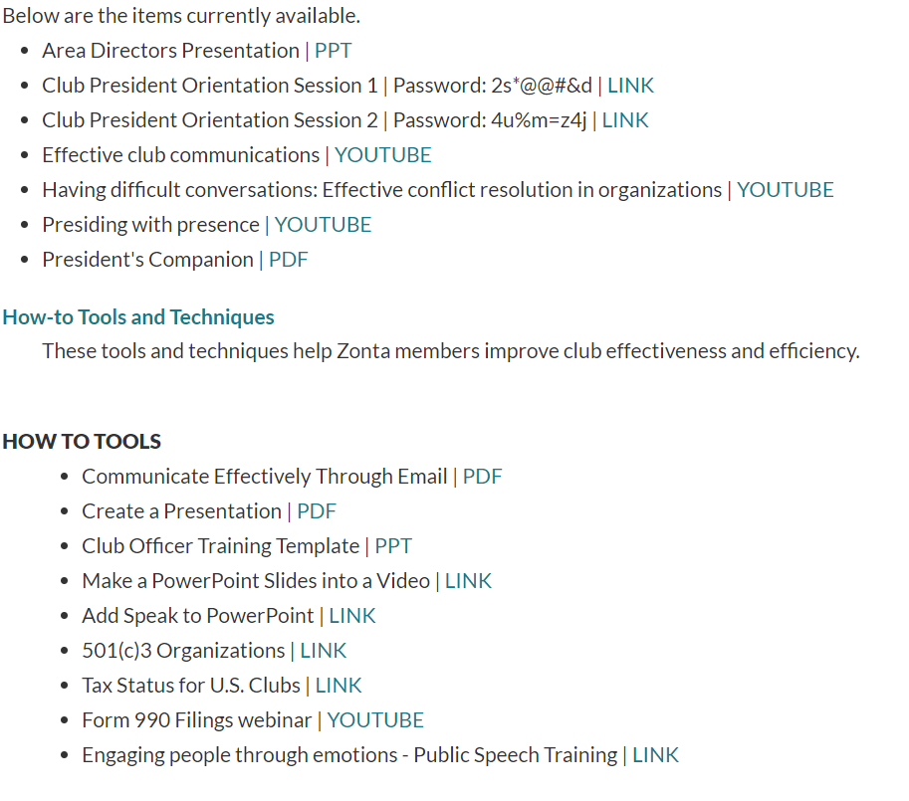

**Take Action! What you willing to do to prepare?**

Examples: Seek out the person fulfilling the position now. Can you shadow them as they do their duties? Will they train you? Be available for questions?

My Action Steps: