:

Zonta Area 1 2019 Meeting Registration Form
Celebrating Our Past, Embracing Our Future
Name: |  |  | Club or District Office:
Address: |  | Phone: |  |  |  | Email:

Events:
☐ Friday, April 12, 2019
6:30 - 8:00 pm South Dakota Discovery Center
$15 – Includes Drinks, Appetizers, Social Networking

☐ Saturday, April 13, 2019
7:30 - 3:00 pm Redrossa Restaurant
$35 – Includes Breakfast and Lunch

☐ I have Special Dietary Needs
Details: __________________________________________________

☐ Full Registration
$50 – by March 31, 2019

☐ Late Registration
$60 – After March 31, 2019
Make check out to Zonta Club of Pierre-Ft Pierre and mail to:
PO Box 111, Pierre, SD 57501-0111

Any Questions – Contact Jacque Storm (605-280-6336) or
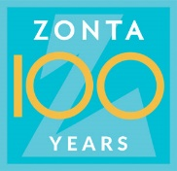
Kelli Buscher (605-280-1511)

