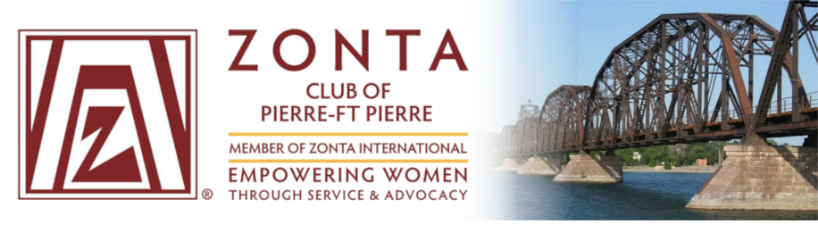
Zonta International District 12
Area 1 Meeting

Celebrating Our Past – Embracing Our Future
Hosted by the Zonta Club of Pierre-Ft Pierre
Redrossa Italian Grille
Friday, April 12, 2019
6:30 – 8:00 pm Friday Night Social & Registration
SD Discovery Center (805 W Sioux Ave / Pierre, SD)
Saturday, April 13, 2019
7:30 am – 8:30 am Registration and Breakfast
8:30 am Welcome: Vonni Kallemeyn, President of the Zonta Club of Pierre-Ft. Pierre
Introductions: Kelli Buscher, Area 1 Director
8:45 am District 12 Message, Governor Deedee Boysen
9:00 am United Nations and the Commission on the Status of Women, Renee Coppock & Samantha Hynes
9:30 am Service, Julie Bradley
10:00 am BREAK & Networking
10:30 am Club Reports
12:00 pm LUNCH
A Movement of Many: Stories of Women's Suffrage in South Dakota
From 1868 to 1920 and beyond, women and men in South Dakota worked to pass state and national constitutional amendments to give women the right to vote. Their civic and political work paved our way. Historian Liz Almlie will share a selection of their stories from her research.
1:15 pm Breakout Roundtable Discussions
- Advocacy
- Centennial Celebrations
- Membership
- Social Media
2:00 pm Scholarships
- Women in Technology, Denise Luckhurst
- Young Women in Public Affairs, Debbie Sundberg
2:15 pm ZI Foundation, Mary Benoit
2:30 pm Wrap-Up and Send-Off

