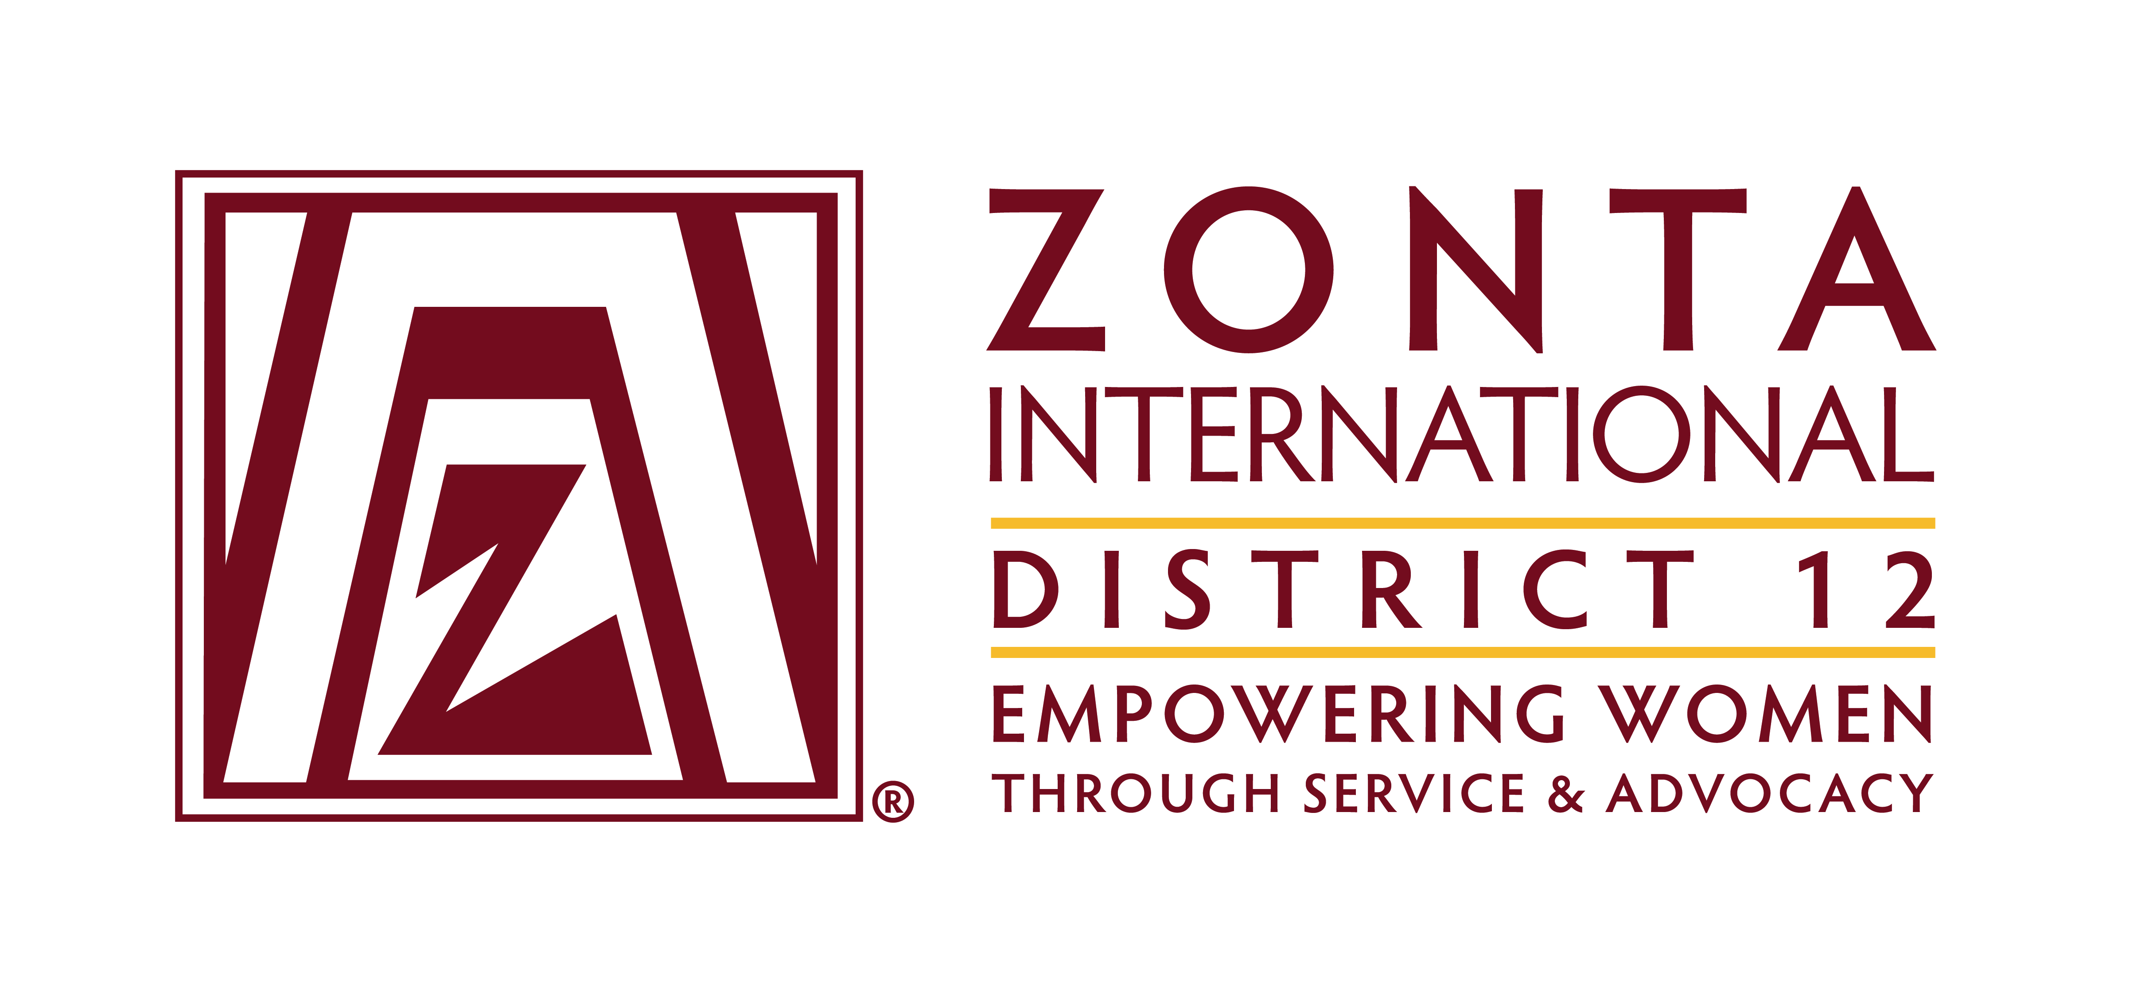
Zonta International -- District 12
CLUB ANNUAL REPORT
Reporting Period: June 1, 2017—May 31, 2018

Please email to Governor Reneé Coppock (rcoppock@crowleyfleck.com) by May 21, 2018 with a copy to your Area Director.

Area 1 Director: Andrea Hovey  (tcufrog@hotmail.com ) | Area 2 Director: Kim Frazier (frazier.kim@hotmail.com )
Area 3 Director: Michelle Médal (michellemedal@hotmail.com ) | Area 4 Director: Mindy Minor (melinda.minor@gmail.com )

Club Administration 2017-2018:

Zonta Club of Boulder County Today’s Date:
Area: 3

President: Kathy O’Neal
President-Elect (if appropriate): Kathy O’Neal
Vice President: Jackie List

Secretary: Carole FitzSimmons
Treasurer: Carole FitzSimmons

Incoming Club Officers 2018-2019:

Name E-Mail Telephone

President: Kathy O’Neal
President-Elect (if appropriate): Kathy O’Neal
Vice President: Jackie List

Secretary: Carole FitzSimmons
Treasurer: Delores Wenzel
Board of Directors: Toni Lorgan, Jan Stokes, Helen Coffey

Leadership & Leadership Development 2017-2018:

Describe the leadership training conducted for officers, board members, committee chairmen and members.
Previous leaders mentor the new coming officers, etc.

What training opportunities / workshops have your club officers participated in at area & district levels?
Area 3/Amelia Earhart. Attended the District 12 conference in Greeley Colorado.

Does your club have a long range plan that includes success planning for future leaders in club? X Yes No
If yes, please describe (or provide copy to Governor and Area Director).Mentoring for new officers and board members coming in. Our August meeting is set aside to brains storm about the coming year’s goals and activities.

Describe any leadership challenges and needs. Just an ongoing problem for recruiting new members.

Nominating:

Did the club suggest nominees for area, district and international office? Yes X No

Please describe the process used by the nominating committee to prepare a slate of officers for 2018-2019.
We meet at our monthly meeting and we ask members to run for office.

Fundraising:

Please list the major fundraiser(s) your club held during 2017-2018. (Feel free to add additional fund-raisers.)
Holiday Wreath Sales $732.00
King Sooper Gift $784.00

Total Funds Raised this year: $1,516.00 $

Did you have any donations of $100 or more that were not associated with a fundraising event? Yes x No
If yes, what was the total amount of such donations for the year? $

Do you have a “best practice” you would like to share relating to fundraising? Yes x No
If yes, please share: _________________________________________________________
__________________________________________________________________________

Local Service & Scholarships Dollars Given:
Please list the contribution amounts given by your club during 2017-2018.

Local Service Organizations: $ Beth Haynes Award $1,500.00
Local Scholarships: $ Safe Shelter of St. Vrain Valley $500.00
Other (Identify:__Adopt a Future through Boulder UNA $250.00, YWPA, $500.00, Amelia Earhart, $200.00.__________________) $

Total Local: $2,950.00 $

Zonta International Foundation (ZIF) Dollars Given:
Please list the total club & individual contributions given to the Zonta International Foundation during 2017-2018. (Mary Benoit at mary@mathiaslockandkey.com can provide this information to you)

Total Club Contributions: $455.00

Total Individual Contributions: $

Total Club & Individual Contributions: $ 455.00

Was a contribution made to the Zonta International Foundation in an amount at least 1/3 of the dollars raised this year? X Yes No

Zonta International Scholarship Information:

- YWPA-Young Women in Public Affairs Awards

Did your club participate in the YWPA program? X Yes No

Please list the name of the candidate(s) forwarded by your club to the district for this award. Cristal Sarmiento

- Jane M. Klausman Women-in-Business Scholarships (JMK)

Did your club participate in the Jane M Klausman program? Yes X No

Please list the name of the candidate(s) forwarded by your club to the district for this award.

- Amelia Earhart Fellowships

Did your club celebrate Amelia Earhart Day X Yes No

If yes, please describe how your club celebrated this year. We attended the Colorado Science and Engineering Fair and chose two students to receive awards Lily Rae Martinez, and Kjersti Moritz with their study on rocketology. We gave each student $100.00 each.

Local Scholarship Information:

- Local Scholarships awarded by your club Beth Haynes Award given to Detective Brian Dean from the Longmont police department in the amount of $1,500.00. Boulder District Atty. awards a local officer who has done exceptional work with domestic violence.

Name(s) & description(s) of scholarship(s), including dollar amounts:
$1,500.00

Membership:

Please describe your club’s recruitment and retention efforts for 2017-2018 in order to meet the increase in membership goal as of June 1, 2018.

If your club currently has fewer than 20 members, what plans do you have in place to increase membership in 2018 - 2019? Our club has a meet and greet every fall and invites women from the community to the event to explain Zonta’s mission and purpose.

Does your club have a membership committee?X Yes No

Does your club have a new member orientation program?x Yes No If yes, how many sessions did you hold this year? Give a brief explanation of what you do: _All members of our club are on the membership committee. __________________________________
_____________________________________________________________________________________

Does your club have a new member mentor program? XYes No If yes, describe

Yes we spend time with our new members and explain the structure of Zonta and what we do.

How does your club measure membership satisfaction?

Did your club utilize the membership tools available on the District 12 and Zonta International websites?
X Yes No
If yes, which ones?

The information below, along with the donations to ZIF (based on the percentage of funds raised), will be used to determine the District Service Award to be given out at the 2018 District 12 Governor’s Conference.

Local Service: (Hands on work to help women & girls in the local community)

Please name and briefly describe your local service projects, including for each item:

(a) category: improved the status of women in general (legal, political, economic, educational, health and/or professional) OR helped prevent and fight violence against women and girls (VAW)
(b) % of club members involved in the project
(c) visibility and credibility to Zonta created by the project
(d) sustainability of the project (long lasting results, and could the project continue for a certain period of time)

1. Safe Shelter of St. Vrain Valley provides shelter and a safe place for women who are involved in a violent situation. Our club has provided various services and items to the safe shelter including painting and decorating existing rooms that needed updating, bedding, art, furniture and accessories. We also put together survival back packs that are provided to the women and children upon arrival to the shelter. Our club also put together fundraiser baskets for the Safe Shelter’s Legacy Dinner Fundraiser. We also participated at their Symposium on Domestic Violence. The Executive Director of the Safe Shelter is the Vice President of our Club, Jackie List. Abby’s Voice is a foundation for the prevention of relationship violence and our club works with Abby’s Voice for fundraising and awareness. Kathy O’Neal the president of our club is the Founder of Abby’s Voice.

2.

3.

4.
(Feel free to add additional projects)

Other Service Questions / Linking Service and Advocacy:

Do all club service projects relate to Zonta’s mission (advancing status of women / empowering women through service and advocacy)?
XYes No If no, describe

What like-minded organizations have you partnered with for service and/or advocacy? Please list and briefly describe how you partnered with them. Our club partners with the Boulder DA Office when they have their Beth Haynes award ceremony, we offer refreshments and various other items to the ceremony and we give a $1,500.00 scholarship.

Mention examples of club service activities focused on “Prevention of Root Causes” of inequality and violence against women through education: Our service activity is partnering with St. Vrain Safe Shelter and work with them on what their needs are.

Did your club participate in the District Service Project (Silent Witness)?x Yes No

The information below will be used to determine the District Advocacy Award to be given out at the 2018 District 12 Governor’s Conference.

Advocacy: Advocacy is the expression of support for or opposition to a cause, argument or proposal or education relating to a cause or issue. Advocacy may include influencing laws, legislation or attitudes or educating the public or group. Zonta advocacy is an action taken in "the public interest" or for "the greater good" with respect to advancing the status of women and girls and their human rights.

Does your club have an advocacy committee? X Yes No

(Do Not Include Zonta Says No Activities Here - See Below)

Please name and describe your advocacy projects, including for each item:
(a) category: improved the status of women in general (legal, political, economic, educational, health and/or professional) or helped prevent and fight violence against women and girls (VAW)
(b) how closely the project coincided with the advocacy definition above?
(c) did the project reflect one of the District 12 Platform for Advocacy issues? The Advocacy issues are:
  - Achieving pay equity
  - Supporting measures to oppose gender based violence such as trafficking, rape & domestic violence
  - Ensuring equal rights under the law
  - Supporting Goal 5 of the Sustainable Development Goals
(d) % of club members involved in the project

(e) names of any community partners
(f) Did any other Zona clubs that participate?
(f) visibility and credibility to Zonta created by the project

1. Our work with the St. Vrain Safe Shelter and our work with the Beth Haynes scholarship.

2.

3.

4.
(Feel free to add additional projects)

Zonta Says No:

Describe your club's Zonta Says No activities in 2017 – 2018: Beth Haynes award ceremony and scholarship.

Other Advocacy questions:

What women’s issues have been identified as the most important in your club? Domestic Violence

How have club members been made aware of legislation relevant to women in our country? We email our membership about legislation and other issues relevant to women.

Have statements/letters, etc. been sent to law-makers or government/officials at national/state/community levels? If yes, please send copy to rcoppock@crowleyfleck.com (and copy your Area Director). Our members email their local leaders as needed.

Did your club encourage men to join in any advocacy efforts or the HeForShe campaign? Yes x No
If yes, please describe.

United Nations:

Please describe how your club informed its membership of Zonta's work with the United Nations.

List topics shared with club members regarding the UN (& Zonta’s engagement) (i.e., Zonta International projects, CSW, Sustainable Development Goals, etc.) Each year we partner with the Foothills Club in Boulder to celebrate UNA’s birthday in October. We provide the cake and have a table with information on Zonta.

Did any of your club members attend the Commission on the Status of Women this year? Yes X No
If yes, how many? Did the club help with expenses?

External Communications/Public Relations:

Please check box for the PR tools your club uses:
BrochureX Newsletter Club or Individual Business CardsX WebsiteX FacebookX Information from ZI toolkits Other (describe)

Did the club submit a “Share your Story” through the Zonta International Website? YesX No
If yes, describe

Internal Communications (e.g., newsletter, directory, website):

Please describe how your club kept its membership informed and connected this year. We communicate through email, phone and one on one gatherings.

ZIF Ambassador:
Does your club have a foundation ambassador? Yes X No

Please describe how your club encouraged individual donations this year to ZIF.

Z-Club or Golden Z-Club:
Does your club have a Z or Golden Z Club? Yes X No
If yes, please describe key events held during the year.

If no, please describe what steps taken or plans to add a Z or Golden Z Club.

Archiving & History:
Does your club have an archivist/historian? X Yes No
We plan to meet this summer and organize and house our information at the local library.
Please describe your club's progress to date in:
(a) finding & listing your club archives.
(b) arranging for safe storage of materials.

Bylaws:
Does your club have a bylaws committee or chair? Yes X No

Are your bylaws up to date in accordance with Zonta International bylaws? X Yes No
If no, do you need the District Bylaws Chair to assist you? Yes No

Centennial Anniversary Committee:

Does your club have a Centennial Anniversary Chair or Committee? Yes X No

If yes, please provide the name and contact information: ______________________________________
____________________________________________________________________________________

What is your club planning to do to celebrate Zonta’s Centennial? ___We will participate in whatever the district is doing.______________________________
_______________________________________________________________________________________

Successes, Achievements and Challenges:
What have been your club’s successes and achievements in 2017 - 2018? We successfully hosted the Area 3 meeting. We partnered with the Safe Shelter on their various projects. We partnered with the Boulder DA for the Beth Haynes award.

What have been your club’s challenges in 2017 - 2018? Membership.

How did you meet those challenges? It is an ongoing process

What guidance or information is needed from the District or Zonta International level for your club to achieve the ZI biennial goals? (For example: 100% club projects focus on women and girls, Women Empowerment Principles are supported, advocacy is occurring at national level, men are engaged in the community, membership growth will be achieved, relevant leadership training is happening, fundraising goals are being achieved/surpassed….) The International and District 12 website and leadership are instrumental in helping us achieve our goals.

Are there specific areas for which your club needs help? Yes X No
If yes, what areas?

Is there anything else your club would like to address?

2018 District Governor’s Seminar:

What programs or training would you like to see at the upcoming Governor’s Seminar? Membership ideas.

Would someone from your club be willing to make a presentation or conduct training at District Conference?
X Yes No

If yes, please provide the name and contact information for the person and the subject matter for the presentation or training.

Kathy O’Neal
Founder and President of Abby’s Voice
Relationship Violence
720-232-5896

THANK YOU.

