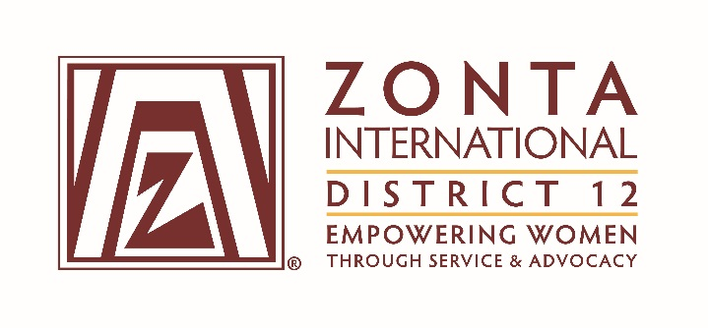
September, 2017 Leadership Team Reports
Name: Susie Nulty
Position / Committee: Webmaster
Goals:
- Provide current Board training on and tour of Members Only web section AND on updating the D12 Google calendar during the 01/2017 Board meeting.
- Assist clubs hosted under D12 with web site updates as needed. Attempt to complete requested changes and additions within 7 days of request.
- Update D12 web site and hosted clubs with relevant information based on current events and maintain historical pages
- Verify all clubs are using new logos and themes with on-line materials by August 1, 2016.
- At the beginning of each Zonta year (by August 1st), contact each club hosted under the District for updates regarding meetings, officers and any other information that needs to be reviewed and changed.
- Accomplishments (to date) & plans for next 6 months.
1, 2, 3, 4, 5, completed. 2, 3 & 6 ongoing.
1)May need to update Google calendar maintenance instructions based on new Google security requirements.
2)All D12 hosted clubs (14) without recent updates were contacted in July and asked for updates.
4) all clubs in District now using new logos on web.
5) Plan to contact the clubs that have not recently updated their meeting, officers, etc.
6) Would like to reorganize some sections of the D12 site
7) Would like to get another Zontian involved in maintaining the District and the 13 clubs maintained by District. 14th club (Royal Gorge) may be added soon. Emailed Janet several times re maintenance & Hosting the Royal Gorge club.

- What have been your most satisfying successes / achievements since the beginning of the biennium?
Adding relevant content and responding quickly to requests.

- What challenges have you encountered since the beginning of the biennium?
Unable to get another Zontian involved in maintenance and set up.

- What do you need from the District Team to achieve your goals?
Help finding another Zontian who has html, WordPress and web experience to help with maintenance.

