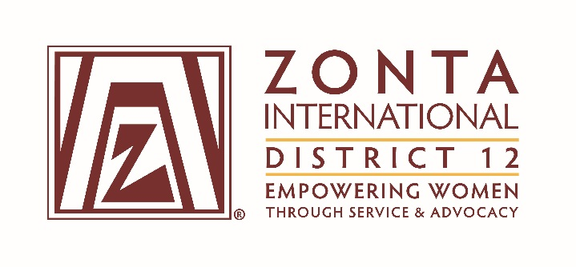
Leadership Team Reports

Name: Denise Luckhurst
Position / Committee: Service

It has been a productive and history making time for District 12 and its clubs since our last District Conference in Boulder in 2015. Here are some highlights:

- In June of 2016, the Zonta Foothills Club of Boulder County was awarded 5th place for the Club Zonta Service Recognition Award for their Zonta EducateZ project at the ZI Convention in Nice. http://zontadistrict12.org/what-we-do/service/foothills-club-of-boulder-county
- In June of 2016, Zonta District 12 was awarded 2nd place for the District Zonta Service Recognition Award for our Silent Witness campaign at the ZI Convention in Nice. http://zontadistrict12.org/what-we-do/service/district-12-submission-2016
- In September 2016, the Zonta Club of Denver II was awarded the District Service Award at the Governors Seminar in Deadwood, SD
- In the Fall of 2016, Zonta International released a Service Project Guide to assist Clubs and Districts to ensure their service projects contribute to fulfill Zonta’s mission and are in line with ZI’s goals. This information was distributed to clubs and they were encouraged to use the tool in planning new projects and evaluating current projects. https://membership.zonta.org/service-tools
- In the Fall of 2016, the Clubs of District 12 again conducted a successful Silent Witness campaign.
- In September of 2017, the Zonta Club of Prowers County was awarded the District Service Award at the District Conference in Greeley, CO.
- In September of 2017, the planning for the 2017 Silent Witness campaign started.
- In September of 2017, Clubs started planning nominations for the 2018 Zonta Service Recognition Award.

But there is more to come. Here are some highlights of the plans for the remainder of the 2016-2018 Biennium:

- Conduct another successful Silent Witness campaign
- Select 3 club project nominations to submit to Zonta International for consideration for the Zonta Service Recognition Award
- Provide more information and training for clubs to evaluate service projects using the ZI Service Project Guide
- Move forward with plans to change the name of the District 12 Service Award to honor Past Governors no longer with us.

Below is the progress on the District Service Committee 20216-2018 Biennium Goals:

Goal: Zonta's service programs, scholarships and awards reflect & enhance its mission.
Objectives & Indicators:
- Local projects are in line with Zonta International’s mission and vision.
- 100% of all local projects focus on women’s and girl’s issues.
- Research service project assessment tools used by Clubs by January, 2017
- Develop a District 12 service project assessment tool by September, 2017
- Develop training materials and train clubs on the assessment tool by May, 2018
- Partner with Area Directors to have presidents work with clubs to complete service project assessments by June, 2018

- Accomplishments:
- Distributed a ZI developed Local Service Project Guide to Clubs in October 2016.
- Presented information on the ZI developed Local Service Project Guide at the Area 1 meeting in April 2017.

- Cooperative projects will be undertaken only with like-minded organizations.
- Create a list of examples of like-minded organization for the clubs by September 2017
- Develop a tool to validate like-minded organizations by April, 2018

- Select a District Service Award winner to be given out at the 2016 Governor's Seminar and the 2017 District Conference.

- Accomplishments:
- Selected and Awarded the District Service Award winner to the Zonta Club of Denver II at the 2016 Governors Seminar
- Selected and Awarded the District Service Award winner to the Zonta Club of Prowers County at the 2017 District Conference

- Coordinate District-wide “Silent Witness” Project.
- Partner with the District Advocacy and Public Relations Committees by September, 2016
- Distribute the Project goals and templates to clubs by September, 2016

- Accomplishments:
- Presented information about the Silent Witness Project at the Governors Seminar in September 2016
- Distributed Silent Witness information to clubs in October and November 2016
- Presented information about the Silent Witness Project at the District Conference in September 2017

- Change the name of the District Service Award to differentiate it from the ZI Service Recognition Award (SRA).
  - Research possible names by September, 2017
  - Present names to District Board for selection by January, 2018
  - Research changes to the District 12 Policies and Procedures Manual by June, 2018

- Accomplishments:
- Discussed possible names for the District 12 Service Award at the Summer Board meeting in June 2017. It was decided to rename the award Governors Memorial Service Award to honor all District 12 Governors that are no longer with us.

- Coordinate ZI Service Recognition Award (SRA), per guidelines from Zonta International (assume similar to previous biennium).
- Submit 1 service project sponsored by a club for the ZI Service Recognition Award at the Convention in 2018 by November, 2017
- Submit 1 service project sponsored by the district for the ZI Service Recognition Award at the Convention in 2018 by November, 2017

- Accomplishments:
- Presented information about the Zonta Service Recognition Award at the Governor’s Seminar in September 2017

