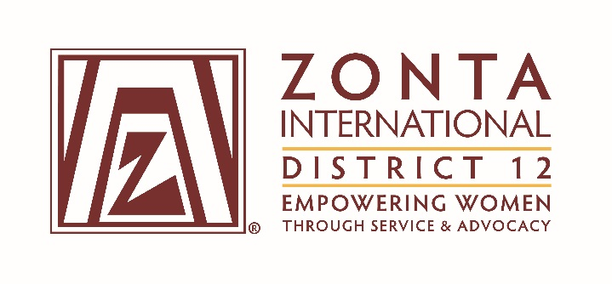

October 1, 2017 Leadership Team Reports

Name: Mindy Minor
Position / Committee: Area Director of Area 4

Goals:
- To find more ways to engage the clubs and their members.
- To visit the other two clubs.
- To provide a means for the clubs to share their ideas and network throughout the year, not just at Area Meetings and District Conferences.
- Continue to recruit new and retain existing members.

Accomplishments (to date) & plans for next 6 months.

I have assisted the Royal Gorge Club with an unexpected transition following the resignation from president by Jeanne Ledbetter for personal reasons. My plans include attending meetings in Lamar and Colorado Springs and scheduling regular conference calls with club presidents. All clubs have new presidents now as Prowers and Pikes Peak changed according to their schedules. I am also beginning to work with the Royal Gorge club to plan the next Area Meeting.

- What have been your most satisfying successes / achievements since the beginning of the biennium?
Working with the team from Prowers County to host a well-attended, enriching meeting.

- What challenges have you encountered since the beginning of the biennium?
Mostly family health challenges that have limited the time I have available for Zonta.

3. What do you need from the District Team to achieve your goals?

