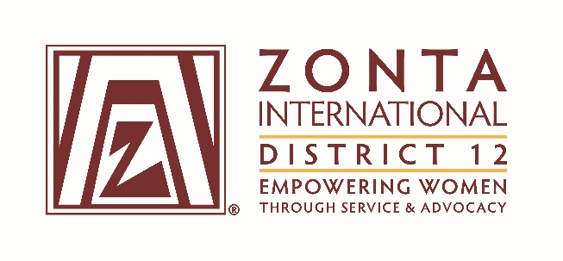
Candidate Information Form for Nominations from the Floor
for District 12 Elected Offices for the 2018-2020 Biennium

Please send completed form and photo to: Marcy O’Toole
Motoole48@comcast.net
303-956-6304

Deadline for receipt of information: September 18, 2017

Office: Governor Lt. Governor Treasurer
(Please check one box) Area Director Which Area? _____
Vice Area Director Which Area? _____
Nominating Committee

Name: ____________________________________________________________________________
Address: __________________________________________________________________________
Telephone: Home Work _________________Cell_______________
Email___________________________________________________________________
Business or Profession: ___________________________________________________
Title or Position:
Club ___________________________________________________________________
How long have you been a Zontian?

Present Position(s) in Zonta:
Club:
Area:
District: ______________________________________________________________________
International:

Past Position(s) in Zonta:
Club:
Area:
District: ______________________________________________________________________
International:

Candidate’s theme for term of service, if elected (one sentence):
Please submit a recent picture with this completed form.

Signature: ____________________________________________ Date: ________________________

Signature of Nominator: ____________________________________________ Date: _____________

