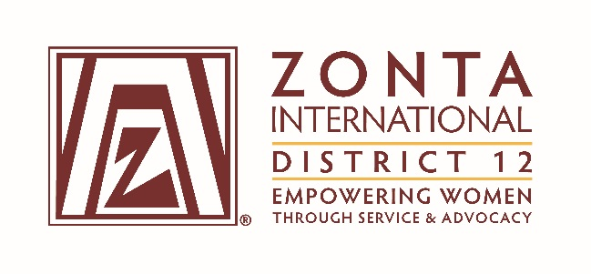

Nominations from the Floor at

2017 District Conference

District 12 Members,

Candidates by floor nomination have always been welcome at District 12 Conferences. At the 2015 District 12 Conference, a procedure for floor nominations was approved and used. We will be using this same procedure for floor nominations at the upcoming September 2017 District 21 Conference. The procedure is as follows:

Nominations may be offered from the floor during the District Conference when nominations are called for by the Governor. Candidates to be nominated from the floor shall possess the qualifications required for the position for which they are running. They shall submit to the Chairman of the District Nominating Committee, at least five days (5) prior to the first business session of the Conference (September 18, 2017), a completed Candidate Information Form for Nominations from the Floor and a photograph. The form must also be signed by the nominator, who must be a Zontian in good standing. The form can be found on the District 12 website in the Members Only Area, under District 12 Conferences. Upon review of all submitted nomination forms and a determination that the candidates meet the qualifications required, the Chairman of the District Nominating Committee shall inform the Governor of the potential floor candidates.

All candidates will give a two (2) minute speech at the District Conference stating why they should be elected to the position for which they are running.

A Candidate Information Form for Nominations from the Floor is attached.

