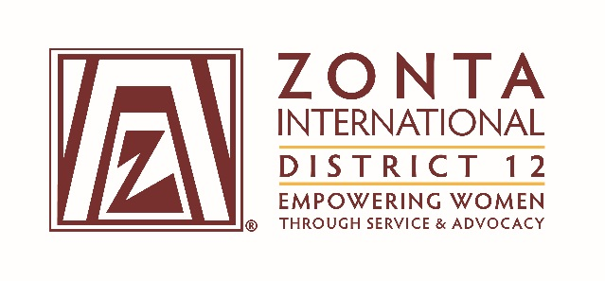
Greetings, District 12 Zontians!

There will be several voting items at the 2017 District 12 Conference to be held September 22 – 24, 2017, at the Doubletree Hotel at Lincoln Park, Greeley, Colorado.
Included in this email are the instructions for delegates, alternates and proxies and all the voting items. The voting attachments are:

1. Slate of proposed District 12 officers and board members.
2. Nominating procedures and candidate form for nominations from the floor.
3. Proposed 2018-2020 District 12 budget and financial statements.
4. Suggested revisions to the District 12 Policies and Procedures Manual and proposed Zonta International Bylaw amendments.
5. Minutes from the 2015 District Conference and 2016 Governor’s Seminar.

These documents can also be found on the District 12 website (http://zontadistrict12.org). The financial statements are in the Members Only section, which requires a user name and password. If you do not know these, please contact Susie Nulty at 719-337-3888.

The voting items are available before the District Conference for your review and consideration. If you have questions on the slate of officers or the procedure for nominations from the floor, please contact Marcy O’Toole at motoole48@comcast.net.

Questions on the financial statements, including the proposed 2018-2020 budget, should be addressed to Terri Otley at t_otley@q.com.

Please direct questions relating to the Policy and Procedures Manual or the proposed amendments to the Zonta International Bylaws to Ann Hefenieder at ann.hefenieder@gmail.com.

Plan to attend this year's Conference, even if you are not a delegate—we would love to hear your voice! I look forward to seeing you in September!

Cheers,

Reneé L. Coppock

Reneé L. Coppock
Zonta International District 12 Governor
2016-2018

