Hello District 12 Zontians!
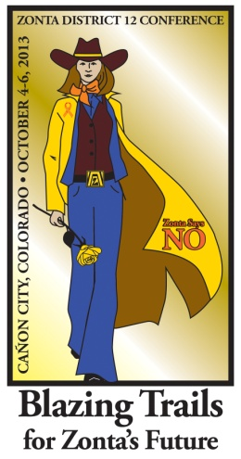
You should have received a previous email announcing the 2013 District 12 Conference to be held on October 4th through 6th at the Abbey Event Complex in Cañon City Colorado. That email included registration and accommodation information. This email includes the items that will be voted on by delegates at the conference.

Included here is a slate of proposed District 12 officers, several financial statements, and changes to the District 12 Policies and Procedures manual, both in "redlined" format and in an updated format.

These voting items are for your review and consideration. If you have questions on the slate of officers please contact Nikki Headlee at nheadlee@solucian.com.

Questions on the financial statements should be addressed to Bridget Masters at bmasters@m-n-cpapc.com, and questions on the Policy and Procedures manual should be sent to Deb Beatty at debbeatty423@comcast.net.

Please contact these Zontians prior to the conference, as the efficiency of our business meeting will hinge on addressing any issues prior to the meeting if possible.

These documents can also be found on the District 12 website. The financial statements will be in the Members Only section which requires a user name and password. If you do not know these, please contact Susie Nulty at (c) 719-337-3888.

Plan to attend this year's conference even if you're not a delegate. It will be a fun, educational, and energizing event! I hope to see you there!

Sheila
Sheila Davis
Zonta District 12 Governor
2012-2014

