Hello District 12 Zontians!
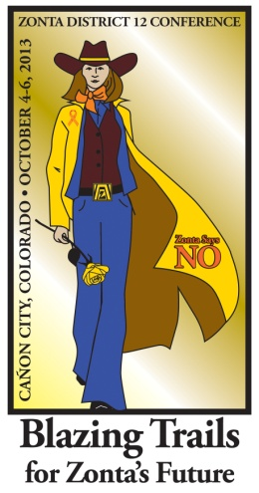
This is your official Call to the 2013 District 12 Conference to be held on October 4th through 6th at the Abbey Event Complex in Cañon City Colorado, and hosted by the Zonta Club of Royal Gorge. All District 12 Zontians are invited to attend!
The theme for this year's conference is Blazing Trails for Zonta's Future, and we'll be blazing trails with a fun, educational, and energizing event.

Attached to this email is a registration form, accommodation information, an agenda, instructions for delegates/alternates/proxies, and maps of the Cañon City area and the Abbey Event Center. These documents can also be found on the District 12 website.

Following are some highlights of the conference weekend:

Friday at 3:45 p.m. there will be an optional tour of the Monastery and Chapel at the Abbey (cost $3).

Friday at 6:00 p.m. there will be wine tasting and heavy hors d'oeuvres at the Winery at Holy Cross Abbey, just east of the Event Center. Wear your Blazing Trails inspired western wear.

Saturday at 8:30 a.m. a packed business session will begin. Voting will be held on a Slate of Officers for 2014-2016, a revised & updated District 12 Policies and Procedure manual, Financial Statements, and the 2014-2016 Budget. Another email will be sent with these items included.

Saturday at 6:00 p.m. there will be a reception, dinner, and awards ceremony. The dinner will have a Zonta Says No theme, so wear your best orange outfit and/or orange accents to help honor this campaign. Zontians of the Year will be recognized and awards will be given out for membership, service, advocacy, travel, and first time attendees. Each club will also have the opportunity to show one item from their archives representing how their club blazed Zonta trails in its past.

Sunday at 8:00 a.m. the conference will begin with a memorial service to honor our district's Zontians who have passed away this year.

Sunday at 10:30 a.m. five Leadership Training sessions will be held. (See the attached agenda for details). The conference will conclude at noon.

Please contact Stacey Cline at cline.stacey@yahoo.com for questions regarding this year's event.

I look forward to seeing everyone at the 2013 district conference so we can Blaze some Trails for Zonta's Future together!

Sheila
Sheila Davis
Zonta District 12 Governor
2012-2014

