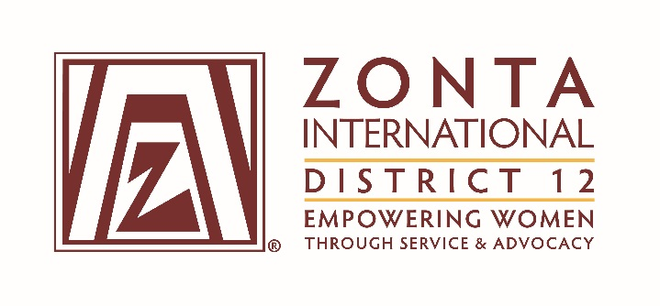
January 7, 2017 Leadership Team Reports

Name: Denise Luckhurst
Position / Committee: Service
Goals: [cut and paste from what was submitted]

Goal: Zonta's service programs, scholarships and awards reflect & enhance its mission.
Objectives & Indicators:
- Local projects are in line with Zonta International’s mission and vision.
- 100% of all local projects focus on women’s and girl’s issues.
- Research service project assessment tools used by Clubs by January, 2017
- Develop a District 12 service project assessment tool by September, 2017
- Develop training materials and train clubs on the assessment tool by May, 2018
- Partner with Area Directors to have presidents work with clubs to complete service project assessments by June, 2018

- Cooperative projects will be undertaken only with like-minded organizations.
- Create a list of examples of like-minded organization for the clubs by September 2017
- Develop a tool to validate like-minded organizations by April, 2018

- Select a District Service Award winner to be given out at the 2016 Governor's Seminar and the 2017 District Conference.

- Coordinate District-wide “Silent Witness” Project.
- Partner with the District Advocacy and Public Relations Committees by September, 2016
- Distribute the Project goals and templates to clubs by September, 2016

- Change the name of the District Service Award to differentiate it from the ZI Service Recognition Award (SRA).
  - Research possible names by September, 2017
  - Present names to District Board for selection by January, 2018
  - Research changes to the District 12 Policies and Procedures Manual by June, 2018

- Coordinate ZI Service Recognition Award (SRA), per guidelines from Zonta International (assume similar to previous biennium).
- Submit 1 service project sponsored by a club for the ZI Service Recognition Award at the Convention in 2018 by November, 2017
- Submit 1 service project sponsored by the district for the ZI Service Recognition Award at the Convention in 2018 by November, 2017

Accomplishments (to date) & plans for next 6 months.

- Accomplishments:
  - Recruited Service Committee members from all 4 areas.
  - Selected and Awarded the District Service Award winner at the 2016 Governor’s Seminar
  - Presented a Service Committee Update at the 2016 Governor’s Seminar.
  - Distributed the Silent Witness information to clubs and sent reminders in October and November 2016. Found information on Facebook that 7 clubs participated. Some unique activities included: Billings – float in Holiday Parade, Cheyenne – Silent Witness March, Foothills – partnered with ZClub to do silhouettes with students, Culture of Respect Pledge.
  - Distributed a ZI developed Local Service Project Guide to Clubs in October 2016. Requested local assessments from clubs. Haven’t received anything yet.
  - Had the 2016 ZI Service Recognition Awards club and district nomination materials posted to the District 12 website.
  - Conducted Secretary Training for several Club secretaries on November 15 and 17, 2016.
  - Wrote a newsletter article for the November 2016 Outreach.
  - Distributed information created by District 12 PR Chair (Pam) on the ZI Service Project to Clubs and posted to the District 12 website in December 2016.
  - Corresponded with Alison Martin, ZI Service Committee Chair and Denise Quarles, ZI Service Committee Liaison for District 12.

- Plans:
  - Created a list of like-minded organizations from club annual reports and will distribute to clubs in Spring of 2017.
  - Will have the ZI Local Service Project Guide and list of like-minded-organizations posted to the District 12 website in Spring of 2017.
  - Prepare additional information and training guide on the ZI Local Service Project Guide.
  - Start researching possible names for the District 12 Service Award.

Questions for Governor report: (Respond if apply to you. You may delete the parts that don’t apply to you.)
- What have been your district’s successes / achievements since the beginning of the biennium?
Completed a successful Silent Witness Project

- What challenges have you encountered since the beginning of the biennium?

- What guidance or information is needed from the ZI level for your district and clubs to achieve the biennial goals that concern them?

- What do you, your district or club members need help with? (Can be from liaison, board, HQ.)

- Is there anything else you would like to address?
Thanks to ZI for creating the Local Service Project Guide for clubs to use for evaluating local service projects.

