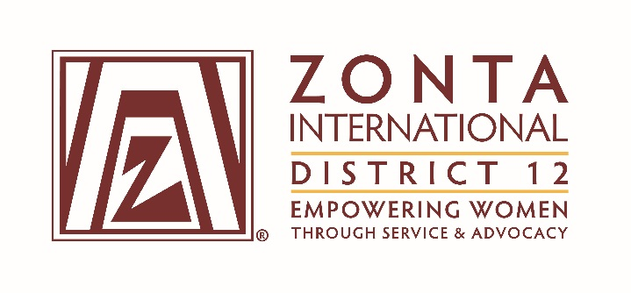

January 7, 2017 Leadership Team Reports

Name: Marcy O’Toole
Position / Committee: Chair, Nominating Committee
Goals:
Recruit committed and skilled Zontians to serve on the District 12 and Zonta International Boards and Nominating Committees.
- Identify potential candidates for each district position by February 28, 2017.
- Ensure there is at least one candidate for each district nominating committee from each Area and one additional candidate.
- Complete a draft for all district positions by May 1, 2017.
- Complete a final slate and ensure nominations document that will be included in the 2017 Call to Conference is ready for printing per the District 12 Guidelines by July 1, 2017.
- Nominations for ZI Officers, Directors, and Nominating Committee members must be submitted directly to ZI by August 31, 2017 (to validate date).

Accomplishments (to date) & plans for next 6 months.

Accomplishments:
- Received all documents from previous biennium.
- Started list of potential candidates from all Areas.
- Received correspondence from ZI nominating committee: District 12 contact is Kerry Dixon.

Plans:
- Schedule a conference call for the D12 nominating committee in January, 2017.
- Identify potential candidates for each district position by February 28, 2017.
- Create a draft for all district positions by May 1, 2017.
- Pull the current ZI campaigning policy by January 31, 2016.
- Write an article for February, 2017 Outreach on nominating committee responsibilities and campaigning policy.

Questions for Governor report: (Respond if apply to you. You may delete the parts that don’t apply to you.)

- What have been your district’s successes / achievements since the beginning of the biennium?

- What challenges have you encountered since the beginning of the biennium?

- What guidance or information is needed from the ZI level for your district and clubs to achieve the biennial goals that concern them?

- What do you, your district or club members need help with? (Can be from liaison, board, HQ.)

- Is there anything else you would like to address?

