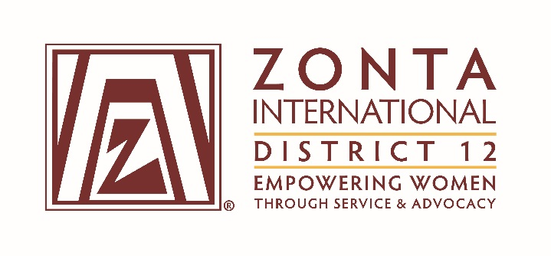

January 7, 2017 Leadership Team Reports

Name: Johnna French
Position / Committee: Z & Golden Z Club Coordinator (2016-2018)
Goals: [cut and paste from what was submitted]
- Annually promote/encourage all ( 5) District 12 Z Clubs & Golden Z Clubs to apply for Emma L. Conlon Service Award 2017
- Organize Sunday morning Z Cub & Golden Z Club tract at District 12 Conference in Fort Collins, September 2017
- Establish monthly contact with District 12 Z Club & Golden Z Clubs about club activities through e-mail or phone calls with club presidents and or their advisors

Accomplishments (to date) & plans for next 6 months.
Goal | Accomplishment | Plans
Promote ELC Service Award | Organized ELC application packet (2017 Application, ELC biography, 2016 ELC Recipient Descriptions, example application) to be sent 1/16/17 to District 12 clubs | - E-mail ELC application packet by 1/16/17 to each club.  - Follow up phone call or monthly e-mail to check club eligibility or progress on application.  - Support clubs as needed.
Organize Sunday tract for District 12 Conference in 9/2017 | Slow start establishing contact & interest with clubs. | Plan to promote idea at D12 Area 3 meeting on 1/28/17
Monthly Contact with Z & Golden Z Clubs | Established contact via e-mail in Nov/Dec with 4 out of the 6 Z Clubs and 1 out of 1 Golden Z Club | - Work to update D12 Z & Golden Z Club contact list.  - Create spreadsheet to log club information & accomplishments.

- What have been your district’s successes / achievements since the beginning of the biennium?
Successful creation on Z Club for Palmer HS in Colorado Springs (11/14/2016), sponsoring Zonta Club is Pikes Peak Area (Area 4). Pam Sufak is the Z Club Advisor.
Greeley Zonta Club is making strides in establishing a Z Club with the support of Loretta Scott (Z Club Chair) & Bert Speyer. In Mid-October the Greeley school district approved Z Club creation within their district and a school advisor (Claudia Koesler - Greeley Central) has been named the liaison.
In December, Regis University expressed an interest in establishing a Golden Z Club and contacted the Zonta Club of Denver as their sponsor.

- What challenges have you encountered since the beginning of the biennium?
Lack of communication from a few of the Z Club advisor’s about this year’s club accomplishments and goals.

- What do you, your district or club members need help with? (Can be from liaison, board, HQ.)
Assistance finding 2016 statistics on current Z Club & Golden Z Club participation numbers.

- Is there anything else you would like to address?
Not at this time.

